Warning against a dangerous bicycle Alpina Rocky!
(Prague, August 8, 2012) The CTIA warns against potential purchases of the Alpina Rocky bicycle. There are several reasons for such recommendation: the bicycle doesn’t have two independent brakes; pedals do not provide enough space for pedaling and the child may hit the mudguard with the toe-caps of his shoes; the handles are not efficiently fixed to the handlebar. Thus it is not possible to effectively stop the bicycle before a barrier; the child loses balance and falls when his shoe’s toe-cap gets hooked by the mudguard as well as when the handles unexpectedly pull off from the handlebar. The CTIA banned selling of this bike and the distributor withdrew the product from the market.
The Czech Trade Inspection Authority found that in the inner market a product which poses risk to its users is offered.
Kolo dětské Alpina Rocky 12“ (Children’s bicycle Alpina Rocky 12’’)
Manufacturer: China
Importer: Tinaco s. r.o. Bratislava

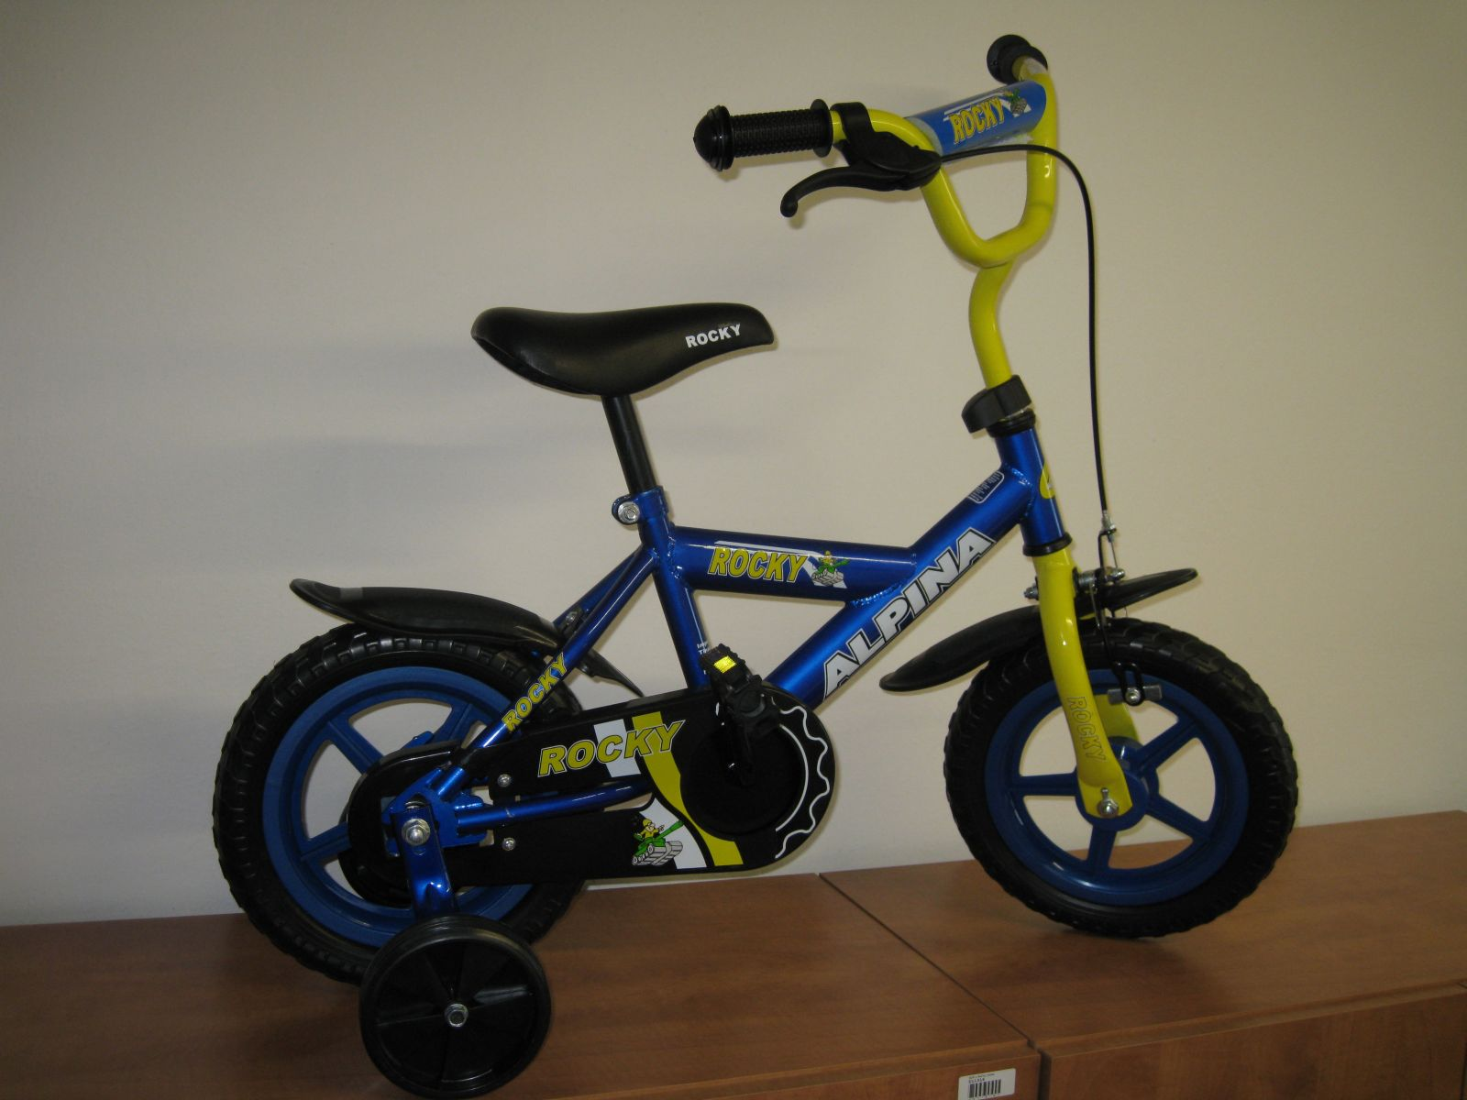

Dangers
The bike doesn’t have two independent braking systems – as a result of the insufficient braking system, a collision with a barrier is likely to happen.
When the power of 64 N was used, the left handle was pulled off the handlebar (according to the appropriate standard, it should resist the power of 70 N).
Insufficient distance from the pedal to the mudguard was measured, i.e. there is smaller space for the tiptoe than required (89 mm are required by the standard, but only 80 mm were measured). When pedalling, the child might hit the mudguard with the toe-cap his shoe.
In the consequence of these defects, a small cyclist may hit a barrier or lose balance, fall and potentially get injured.
With regard to the above mentioned deficiencies, it is more than probable that a small user may get injured when using the product in a common and predictable way.
The CTIA banned selling of this children’s bike and subsequently the distributor took action and withdrew the product from the market. After appropriate documentation is elaborated, the bicycle Alpina Rocky 12’’ will be filed in the RAPEX system.

