 | PRESS RELEASE

Scooter Spiderman is not safe!
(Prague, September 13, 2012) Another of the six scooters which had been taken to laboratory assessment of safety within the control action of the CTIA failed to meet the requirements of the appropriate standard and legal regulations. When the strength of the handlebar of the Scooter Spiderman was tested, the folding mechanism broke there where the riding system is connected to the platform. Such serious deficiency and other deviations from the standard may cause serious injuries to children who may fall over the handlebar when riding the scooter. The CTIA banned selling of the scooter and the distributor subsequently withdrew the dangerous product from the market.
The Czech Trade Inspection Authority found that a product which is dangerous to it users and especially children is sold in the inner market.

Scooter Spiderman
Manufacturer, importer: unknown

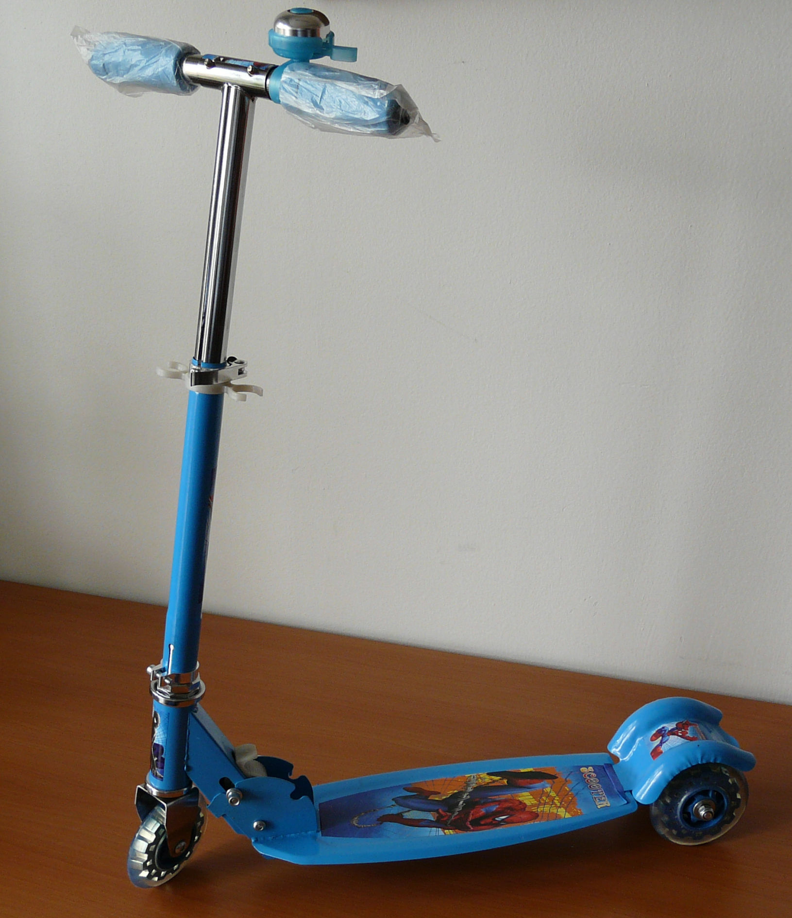

Dangers
When the strength of the handlebar of the Scooter Spiderman was tested, the folding mechanism broke where the riding system is connected to the platform and sharp edges and tips appeared (see the below picture).

Also within this test, the moving spigot slipped off the hole and the handles were separated from the rest of the scooter.
In the hinged part, there are holes in which a stick of 5 mm in average can fit, but it is not possible to put in a stick of the average of 12 mm (the requirement is that if the stick of 5 mm in average fits in, it must also be possible to put in the stick of 12 mm in average).
The average of the endings of the handles is 31.6 mm (the requirement is minimally 40 mm).
The average of the front wheel is 98.1 mm (the requirement is minimally 120 mm).
With regard to the detected deficiencies it is more than probable that when using the product in a common and predictable way, children can get very seriously injured. The CTIA banned selling of the Scooter Spiderman and the distributor subsequently took action and withdrew the product from the market.

Further information can be found on the website of the CTIA www.coi.cz or at the communication department of the CTIA.

