 | PRESS RELEASE

Dangerously small whistle
(Prague, October 18, 2013) Whistle Profi Sport Collection is among products whose sale was banned by the Czech Trade Inspection Authority. It was made in China and its distributor warned on its packaging that “toy is not suitable for children below 3 years of age; there is a danger of swallowing of small parts”. “Such warning would be all right if the whistle was not so very small. Technical standard stipulates that toys put into operation by mouth and intended to be put into mouth must not fit in testing tube for small parts. The requirement – which is applicable regardless the age of children for which the toy is intended – was not met in the case of the particular whistle,” said Vladimír Velčovský, the Director General of the Czech Trade Inspection Authority.

The Czech Trade Inspection Authority detected the following product which is offered in the Czech market and poses serious risk especially to children:
Whistle Profi Sport Collection
Art. 35301
EAN:5902384353015
Made in China
Distributor: VIZOPOL s.r.o., Vizovice

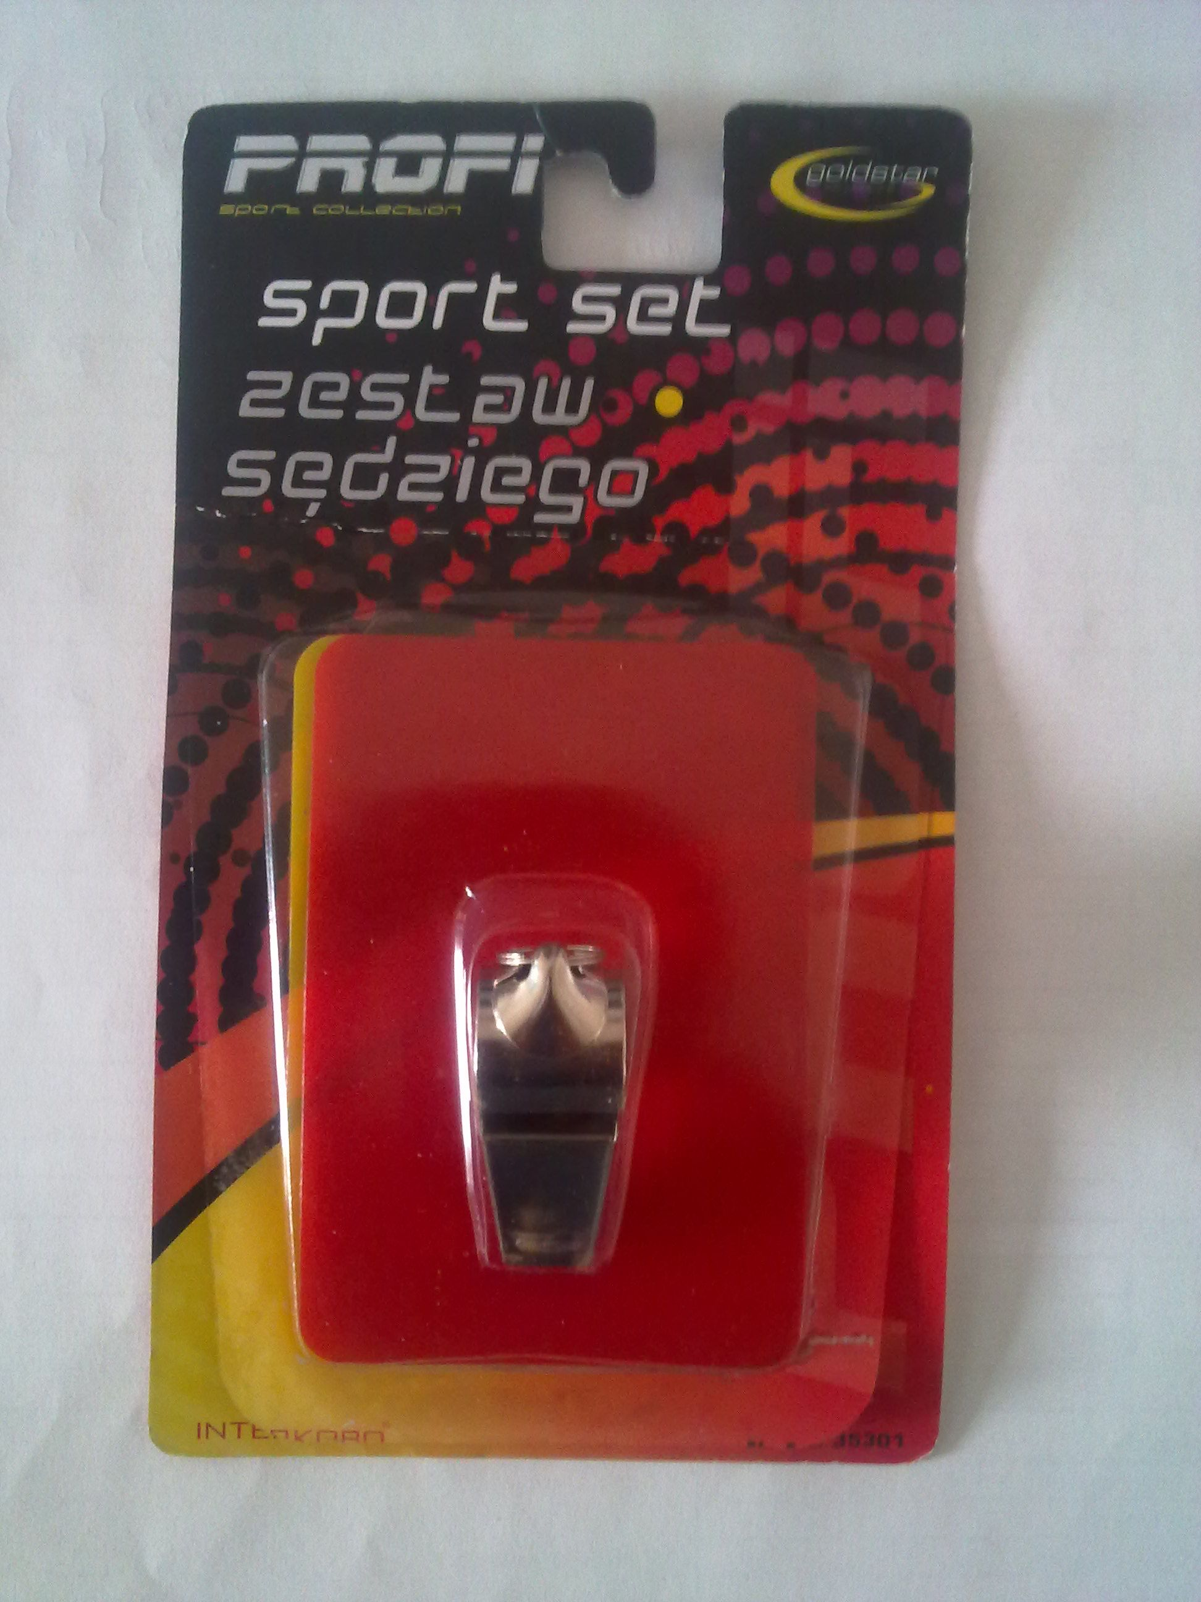 | 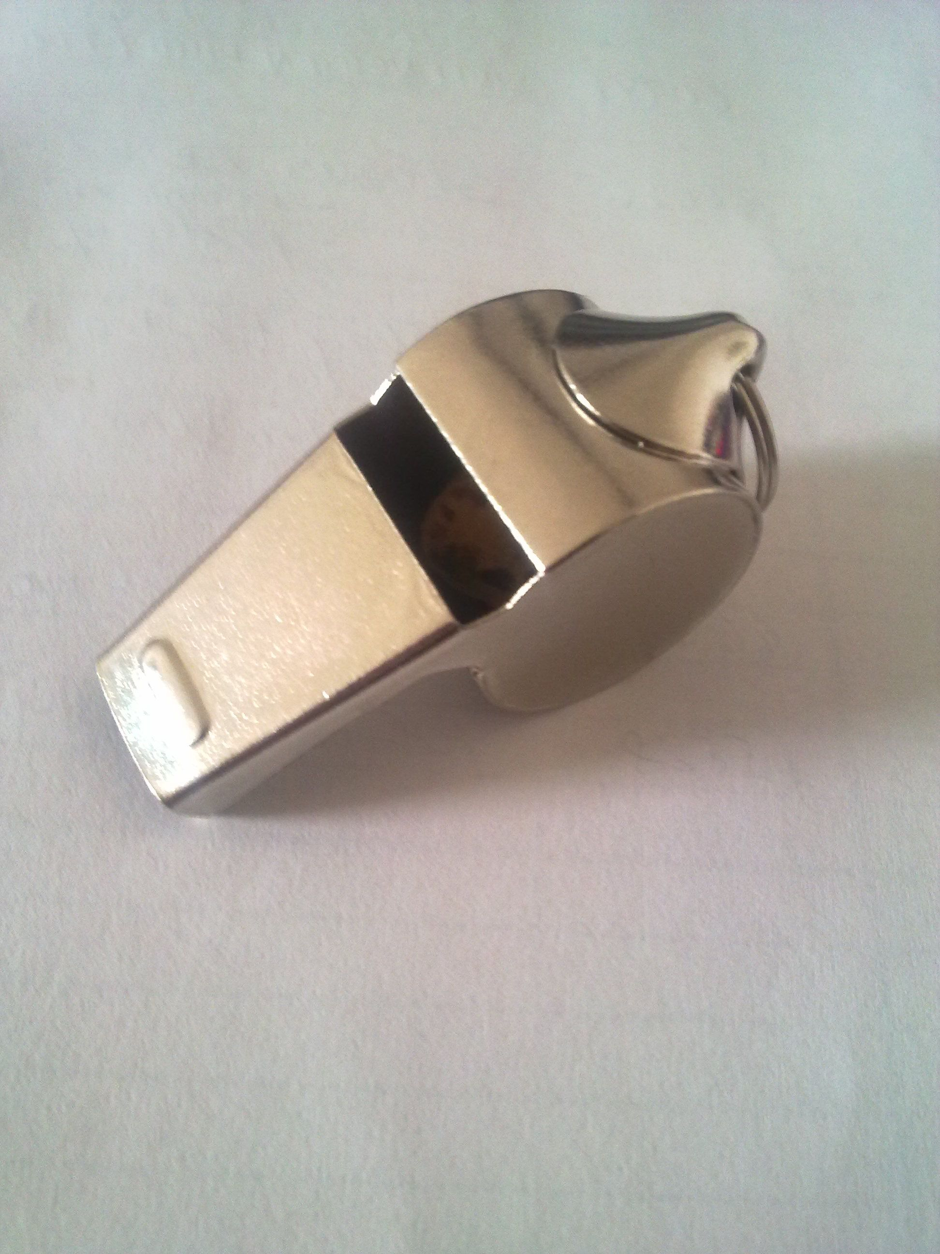

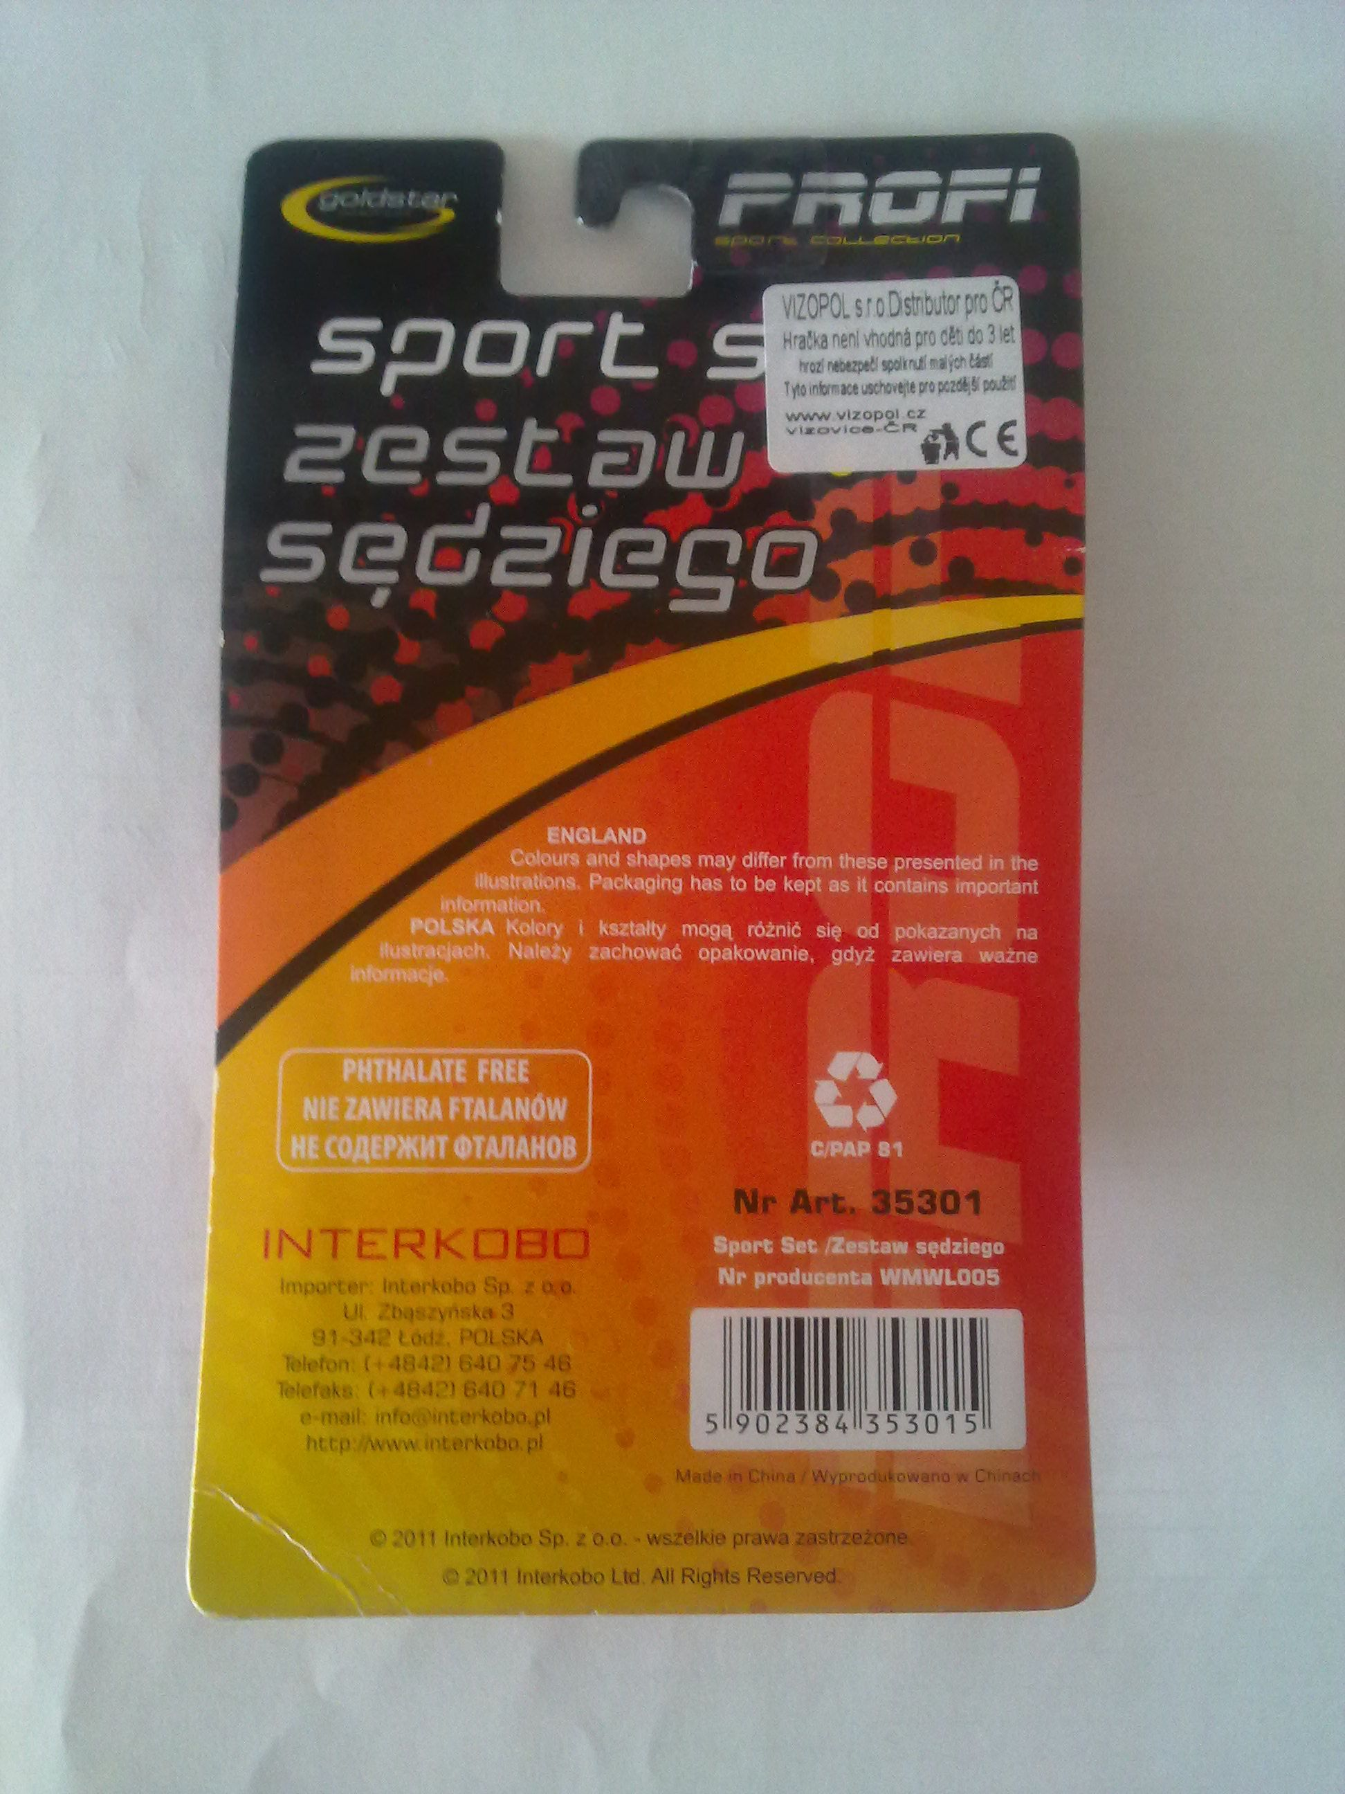 | 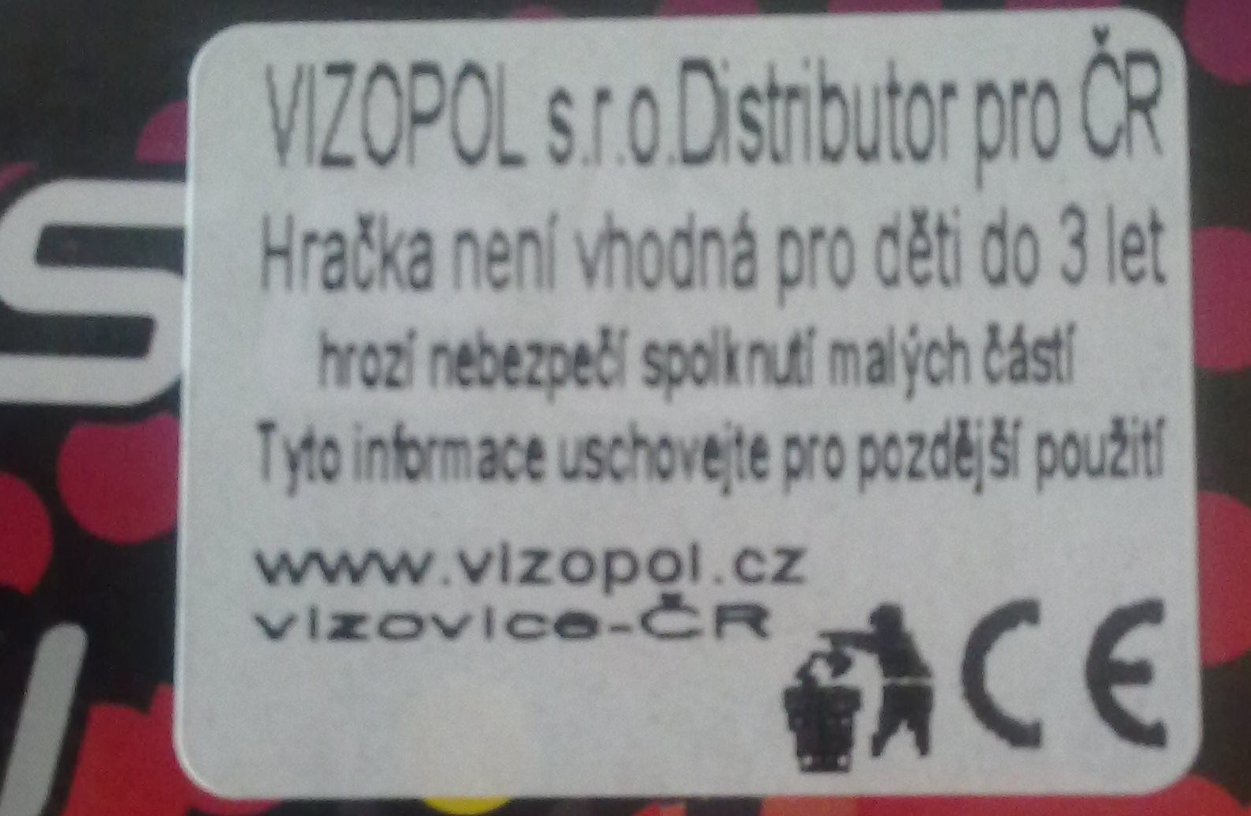

Danger
The whistle fails the requirement of the technical standard ČSN EN 71.1, namely Article 4.11 because the whole product fits into the texting tube for small parts. The above mentioned standard stipulates that toys that are put into operation by mouth and other toys intended for being put into mouth must not - as a whole - fit into testing tube for small parts. The requirement is applicable regardless the age of children for who the toy is intended.

When using the above mentioned product in a common and predictable way, a situation can occur when a child gets injured. There is a risk of choking as a result of inhalation of the whistle.
CTIA banned sale of the whistle Profi Sport Collection and distributor subsequently took measure to withdraw the product from the market.

