 | PRESS RELEASE

Still too many fakes in the Czech market
(Interim report of third quarter of 2013)
(Prague, November 28, 2013) In the third quarter, CTIA inspections that are focused on products infringing certain intellectual property rights continued. Inspectors checked whether sellers offered, sold or stored counterfeits, illegal imitations of products or copies of audio or video media. The Czech Trade Inspection Authority focuses not only on stall sale in border regions or market places that are known for sale of fakes, but also inspects points of sale and boutiques in shopping malls or city centres widely visited by tourists as well as e-shops. Within inspections focused on unfair commercial practices, inspectors also detected other breaches which resulted in shortcomings being detected in 72% of inspections in the third quarter. A total of 3,859 pieces of counterfeits were collected; their price calculated in prices of originals amounted to almost 7 million CZK. A total 223 fines amounting to 1.9 million CZK were lawfully imposed for breaches of obligations within the evaluated period.

Within the inspection action held in the period of July 1 to September 30, 2013, a total of 335 inspections were carried out to check whether sellers comply with the prohibition to use unfair commercial practices as stipulated in section 5 of the Act No. 634/1992 Coll. on Consumer Protection, namely whether they comply with the prohibition to offer, sell as well as store products infringing certain intellectual property rights. Besides CTIA, other bodies of state administration participated in selected inspections focused on unfair commercial practices. Collaboration with the Police of the Czech Republic was used within 12 actions, employees of customs administration and Alien Police also participated in 12 actions, and bodies of hygienic surveillance were present at 3 inspection actions.

Inspection results – sale of counterfeits (3rd quarter of 2013)
Inspectorate | Number of inspections | Inspections with findings |  | Detected breaches in %
Inspectorate | Number of inspections | Total | Counterfeits | Total | Counterfeits
Středočeský and Prague | 61 | 20 | 11 | 32.8% | 18.0%
Jihočeský and Vysočina | 58 | 54 | 3 | 93.1% | 5.2%
Plzeňský and Karlovarský | 104 | 95 | 49 | 91.6% | 47.1%
Ústecký and Liberecký | 43 | 24 | 15 | 55.8% | 34.9%
Královéhradecký and Pardubický | 10 | 6 | 0 | 60.0% | 0.0%
Jihomoravský and Zlínský | 14 | 14 | 12 | 100.0% | 85.7%
Moravskoslezský and Olomoucký | 45 | 30 | 24 | 66.7% | 53.3%
Total | 335 | 243 | 114 | 72.5% | 34.0%

Detected breaches
CTIA inspectors proved breaches of generally binding legal regulations in 243 of the total of 335 inspections, i.e. in 72.5% of cases, including 114 cases (34.0%) in which prohibition to use unfair commercial practices was breached which was in contradiction with section 5 par. 2 of the Act No. 634/1992 Coll. on Consumer Protection. Number of inspections, findings and share of individual CTIA inspectorates is shown in the above chart. Differences regarding number of inspections were determined by specifics of individual regions as well as the frequency of inspections carried out by other authorities, especially customs bodies.

Taken measures and imposed sanctions
A total of 3,859 pieces of counterfeits were collected and stored out of reach of inspected persons within the monitored period. If these products were sold, owners of intellectual property rights would lose approximately 6,755,806 CZK if prices of originals were calculated. It has been or will be lawfully decided on confiscation of the collected products that failed to comply with special legal regulations. These products will subsequently be destroyed or used for humanitarian purposes if appropriate.
In the 3rd quarter of 2013, 223 fines amounting to the total of 1,938,500 CZK were imposed for breaches of generally binding legal regulations. Other administrative proceedings have not ended, yet.

Structure of collected products
Proportion of individual assortment groups of all collected counterfeits is shown in the following graph:
*Note: ”Other” include product assortment which is not so common – e.g. various cards, glasses, toys and so forth.

The following graph shows the share of the most frequently counterfeited brands. Illegally used trade-marks not included within the chart were collected in lower number than 100 pieces.

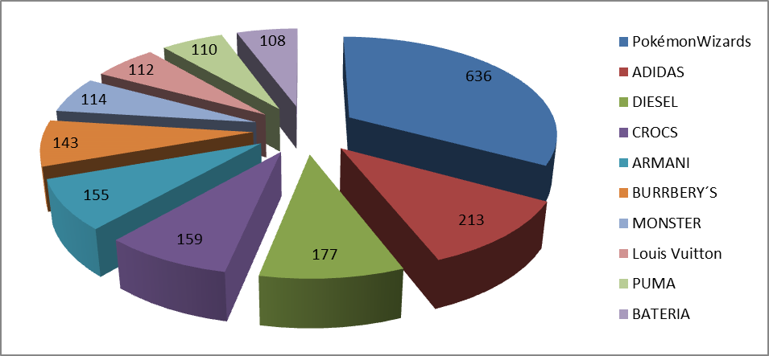

Conclusion
Compliance with the prohibition to use unfair commercial practices, namely breaches of certain intellectual property rights, has permanently belonged among monitored fields as well as inspection activities of the Czech Trade Inspection Authority. Fakes of branded products can also be more frequently purchased somewhere else than at stalls and marketplaces. Within the past years, sale of counterfeits is increasingly more detected in classic shops as well as in larger shopping malls and boutiques in touristic locations and e-shops. This is why inspectors focus their attention on these premises as well. Besides the offer of forgeries, other negative features are detected and the overall rate of cases of sellers’ illegal conduct is high – almost three quarters of all inspections carried out. Intellectual property rights of the owners of the trade-mark Pokémon Wizards were breached most frequently. In terms of assortment, intellectual property rights were most frequently violated by offer, sale or storage of textile products.

