 | PRESS RELEASE

Turtle with magnet is a dangerous toy!

(Prague, March 10, 2015) Risk of health damage is posed by a plastic turtle with magnet. CTIA inspectors detected the product in a retail shop in Western Bohemia. Minimal power was used to separate a leg and head from the toy’s body. A child could inhale or swallow the released small parts that could obstruct airways or injure internal organs. After CTIA had prohibited sale of the product, its distributor withdrew the dangerous toy from the market. After necessary documentation is elaborated, the toy will be notified into the system RAPEX.

Turtle with magnet
No. 74815
Manufacturer: unknown
Importer: COLTEX Plus, s.r.o., Praha
EAN: 0042000048156

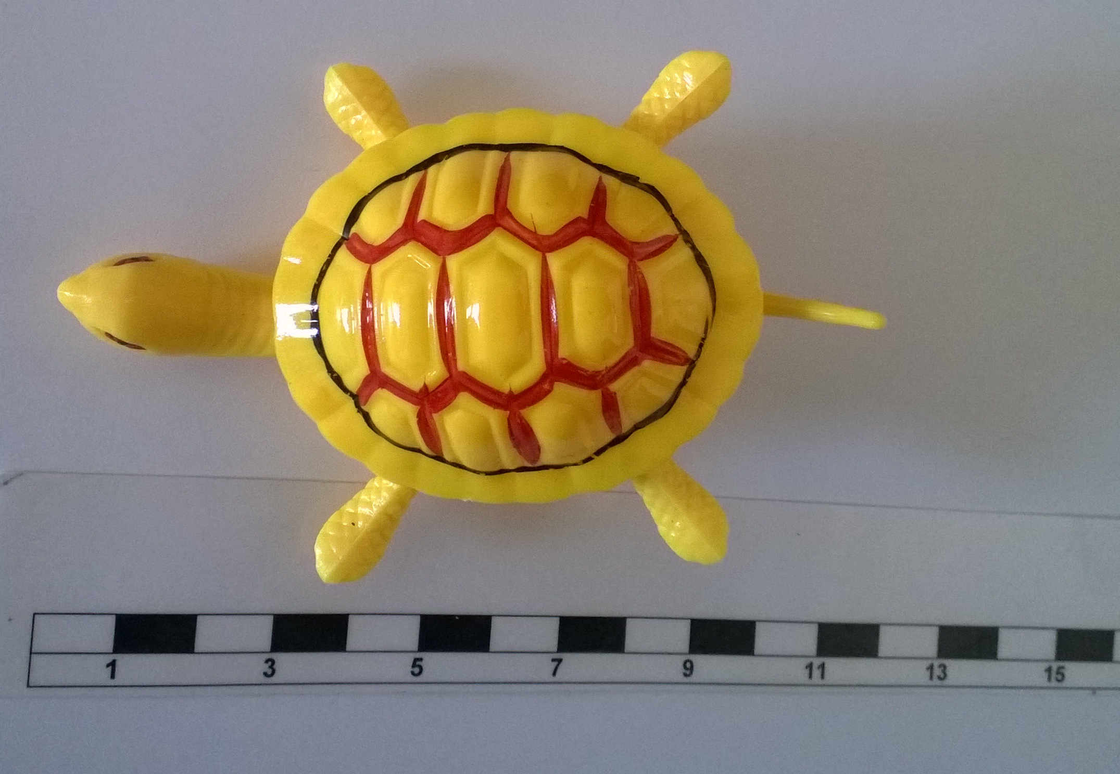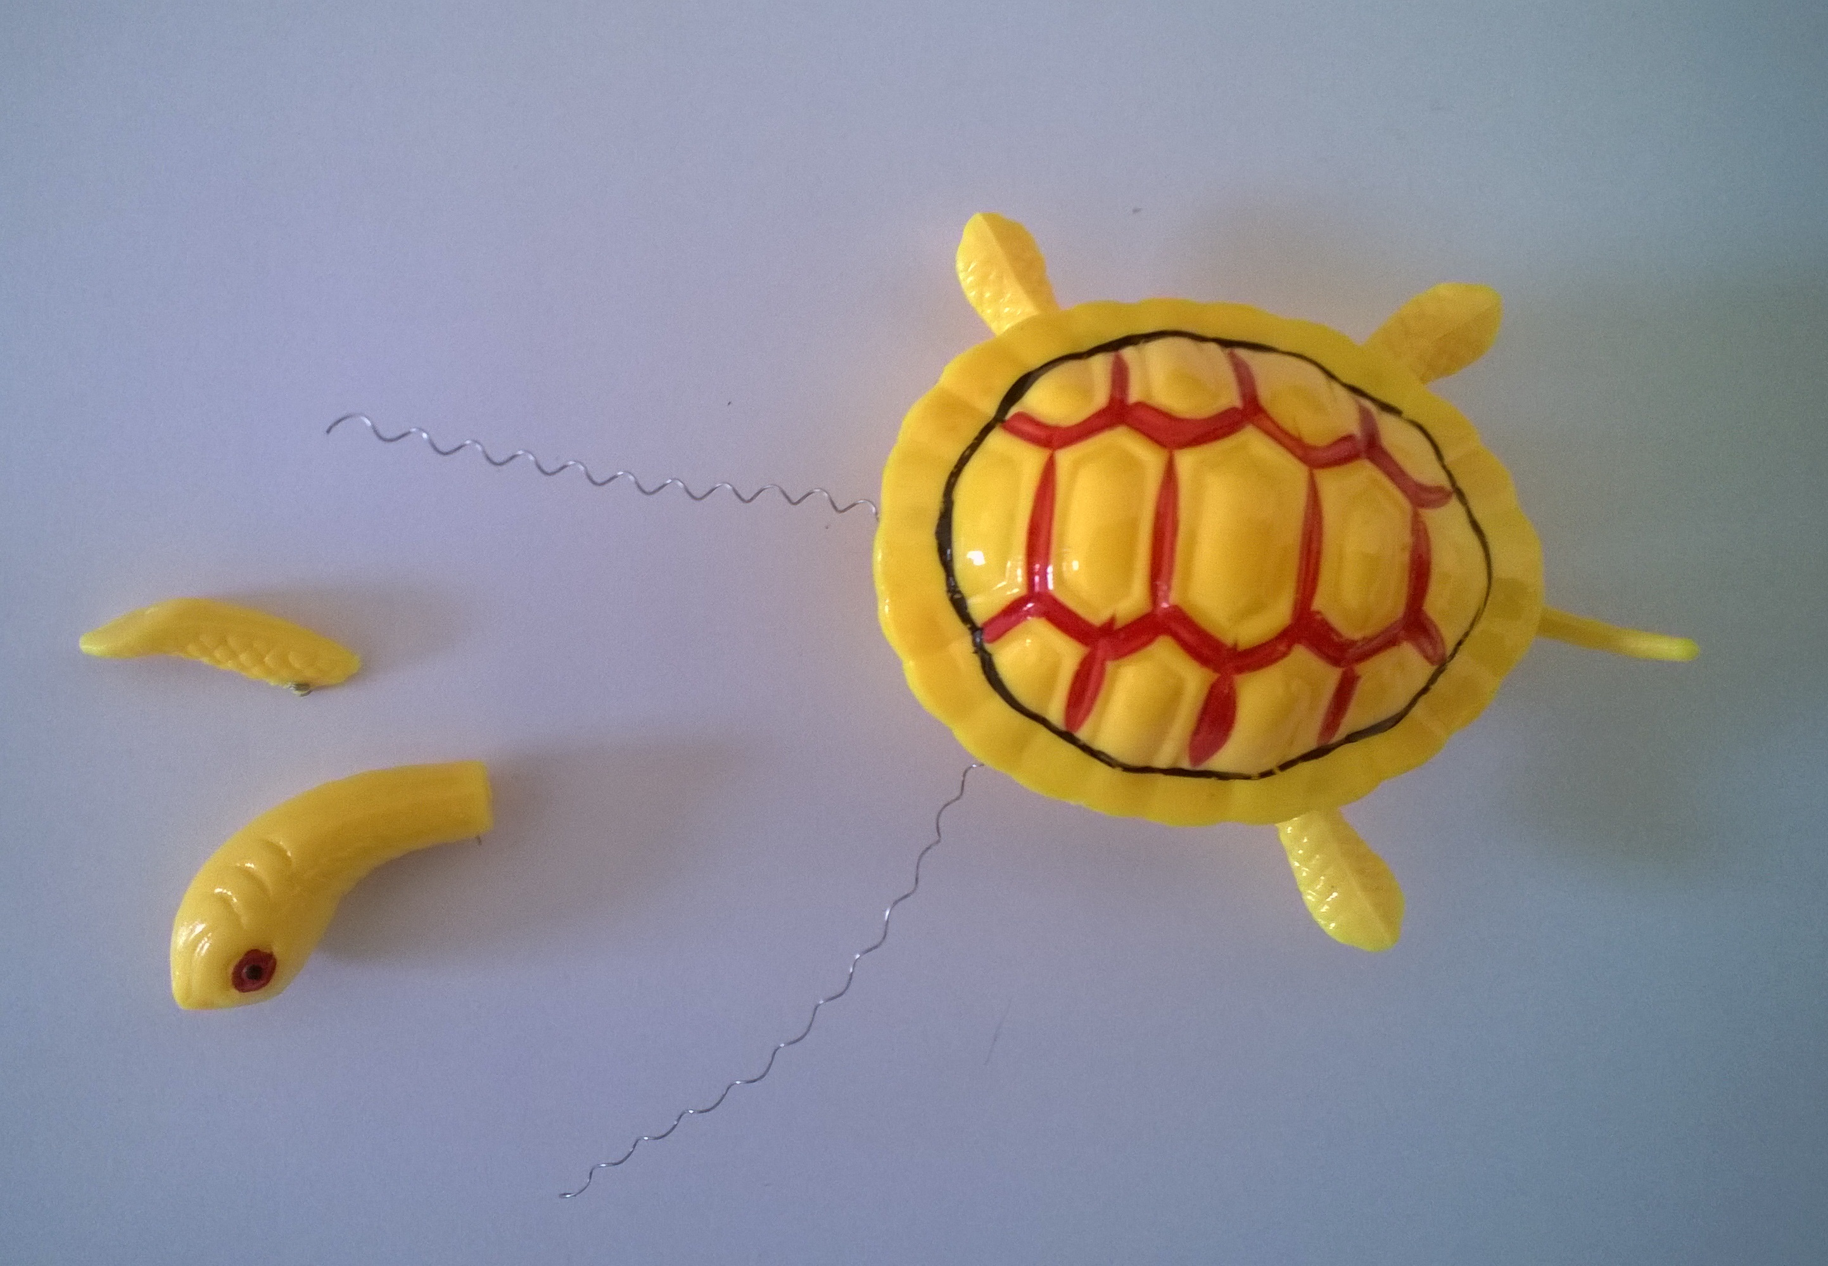

Risks

A leg and head easily separated when the power of 20 and 21 N was used within a pull test – which is less than the standard’s requirement (90±2 N).

This means that a child can be injured when playing with the product in a usual and predictable way. Swallowing or inhalation of separated small parts can obstruct airways or cause injury to internal organs.

Imposed measures

The Czech Trade Inspection Authority prohibited sale of the turtle with a magnet and distributor took action and withdrew the product from the market. All documents necessary for notification of this dangerous toy into the RAPEX system will be transferred for further elaboration to the contact point at the Ministry of Industry and Trade.

