 | PRESS RELEASE

Lighting pendant with owl can damage child’s sight!

(Prague, June 15, 2015) When monitoring the market with toys, the Czech Trade Inspection Authority detected a product that posed health risk to consumers, especially children. It is an owl-shaped keys pendant which lights and hoots. Expert assessment on safety showed that even a short exposure of children’s eye to the light can damage sight within usual manipulation with the toy even if glasses are used. Those parents who purchased this product are advised to consider risk rate of using such product by their children.

Product description:
Barnyard Brites BOW WOW
Owl-shaped keys pendant which lights and sounds
EAN: 6980110760374
Importer: Q. I. M. S.R.O.
Manufacturer: Made in China

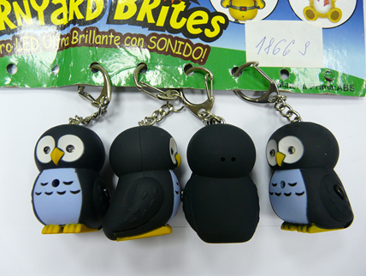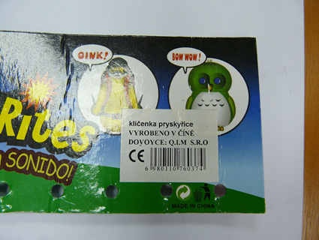

Danger

Intensity of the ray of light exceed the limit determined by Class 1 for photochemical danger (the determined limit is 39µW). In one case 40.0µW was measured, in another case it was 40.1µW and in the third case it was 40.3µW.
Risk of injury to sight during short exposure of the eye to the light is posed only within 0.25 seconds even if glasses are used (the time limit of 0.25 seconds is a presumed instinctive reaction of a person to avoid eye contact with light).

Taken action
The Czech Trade Inspection Authority prohibited sale of the pendant with luminous owl and distributor subsequently took action based on which he withdrew the dangerous product from the market. The product was notified to the RAPEX contact point by the Ministry of Industry and Trade.

