 | PRESS RELEASE

Revolver – a toy which endangers child’s health

(Prague, October 6, 2015) Parents who don’t buy imitations of guns to their kids do the right thing as not all such toys are safe. This was also proven by a recent CTIA officers’ finding. They detected a revolver offered in the Czech market which poses a serious risk of health damage. It can happen that within a usual and predictable way of use of the product, a child can get injured as a result of inhalation or swallowing of released small parts or a whole missile. Danger is also there when a child shoots a different object from the gun, for example a pencil – this is possible without the consumer being informed about it. Based on prohibition of sale, the distributor withdrew the product from the market and complete documentation was transferred to the contact point at the Ministry of Industry and Trade which would notify the product into the system RAPEX.

Revolver Toys No. A-34
Country of origin: China

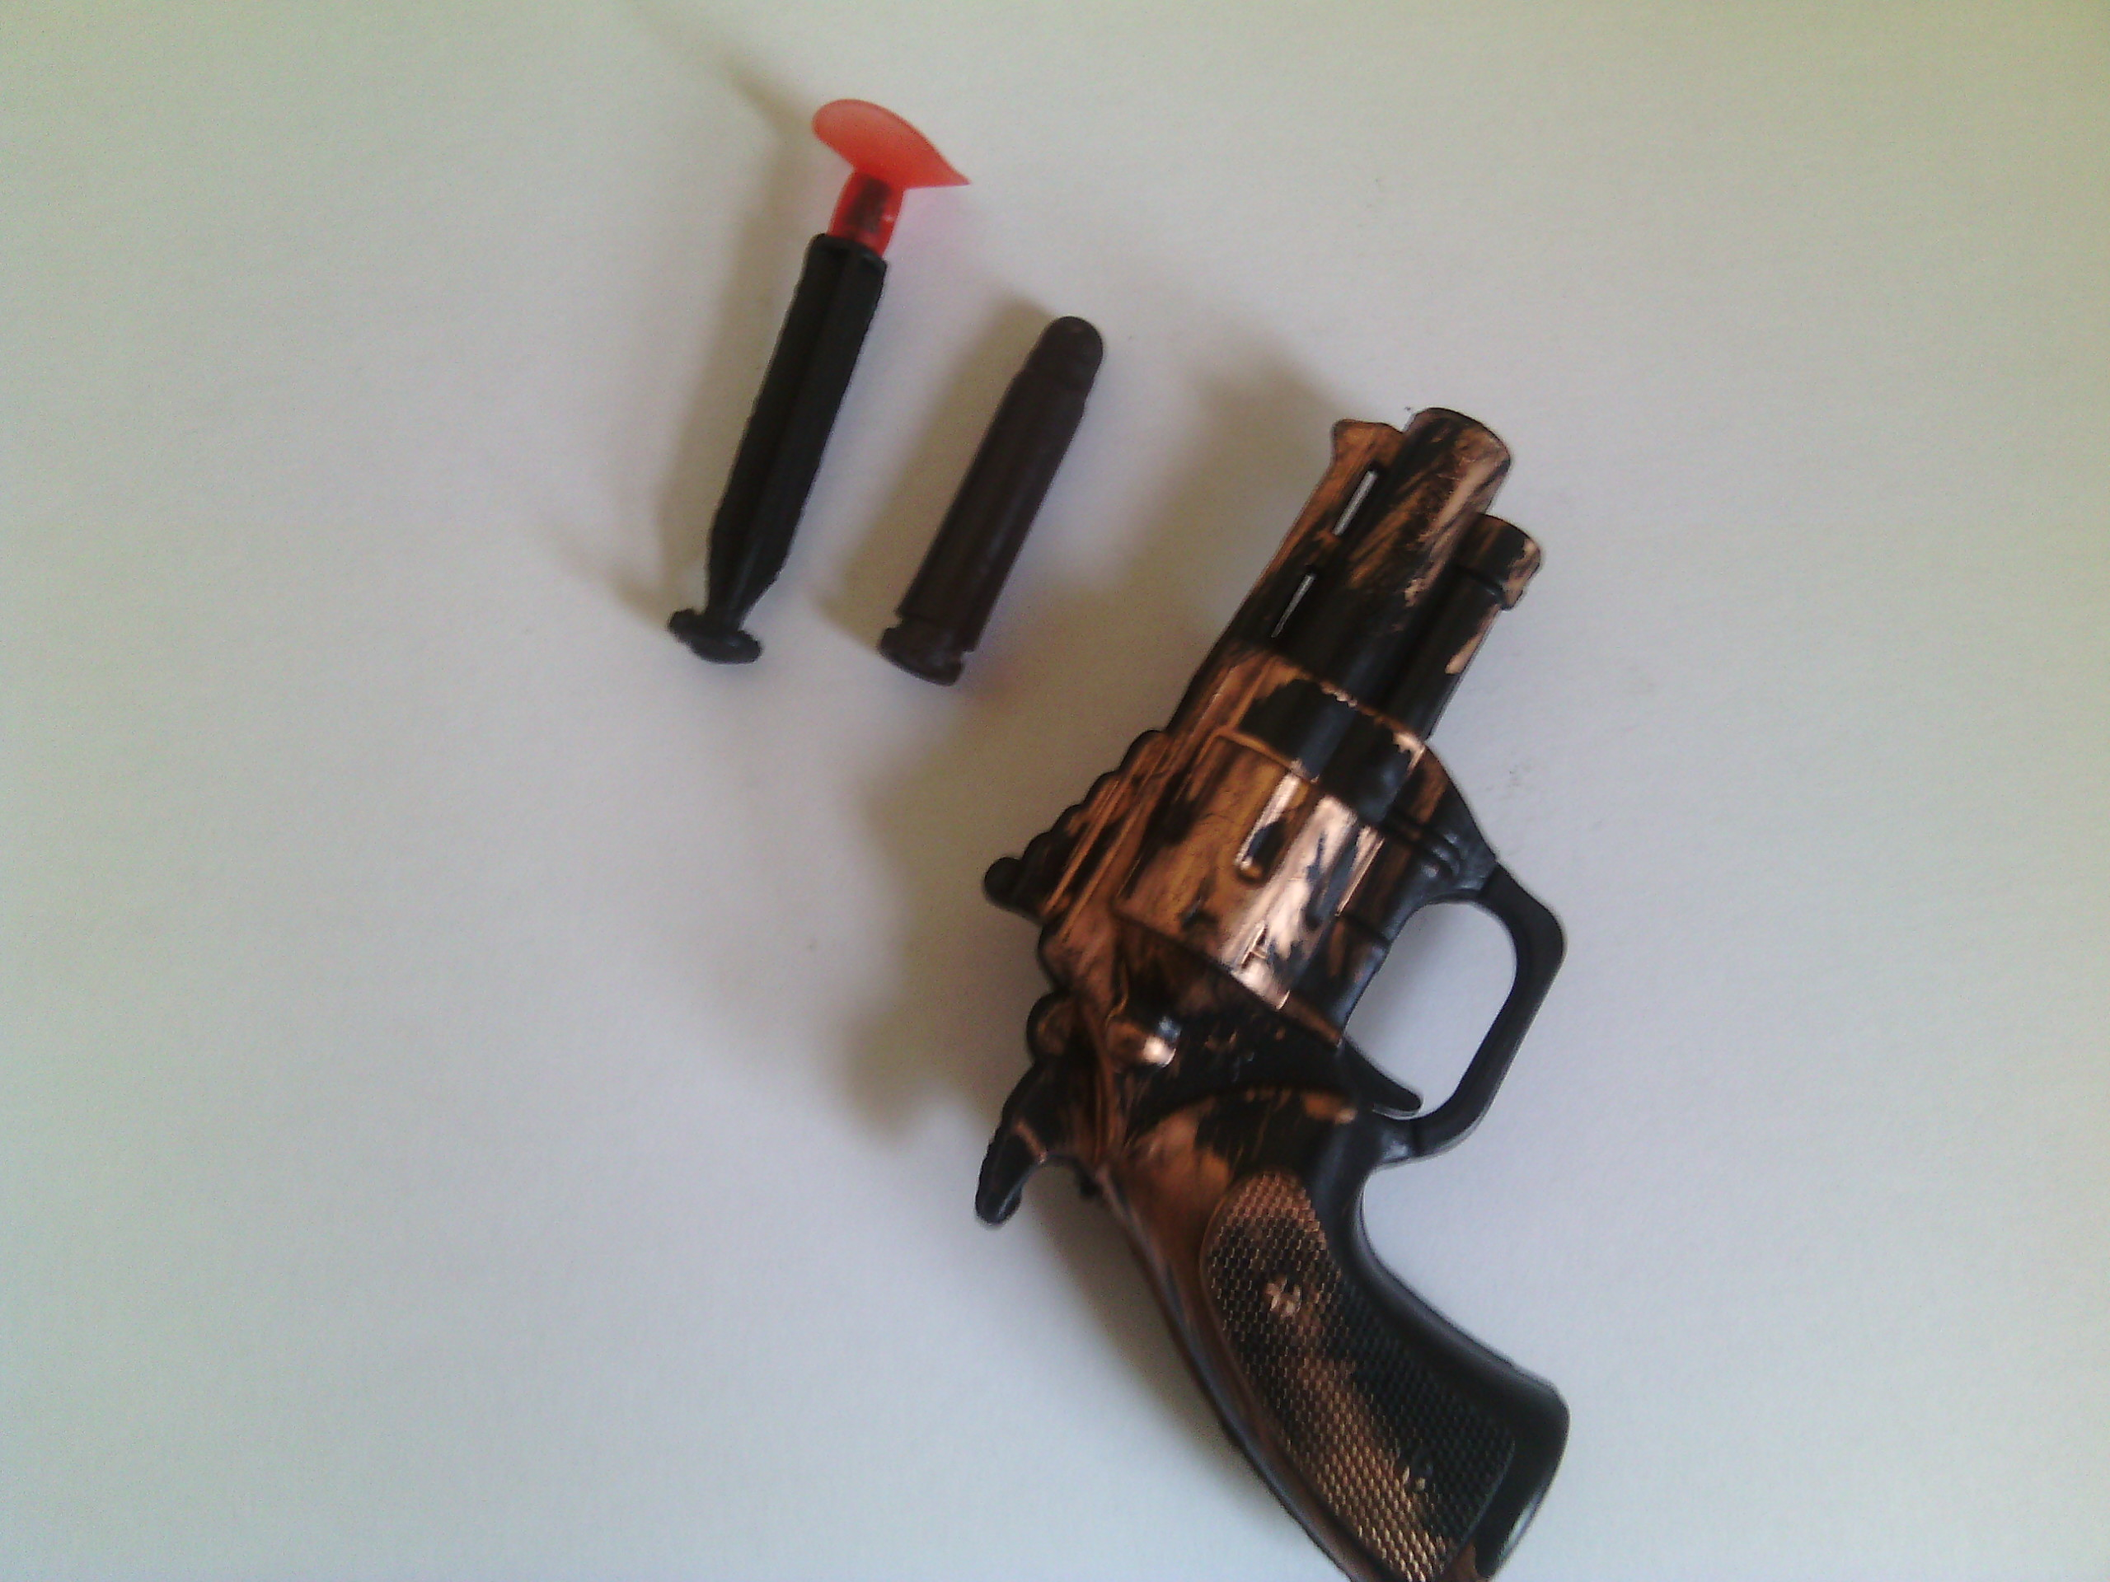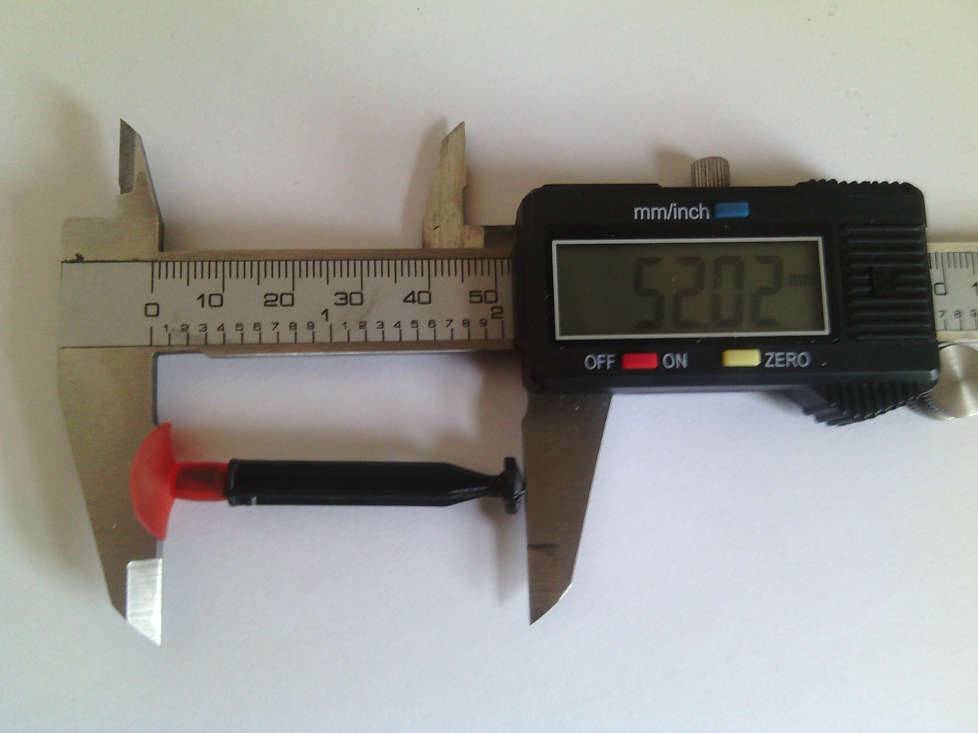
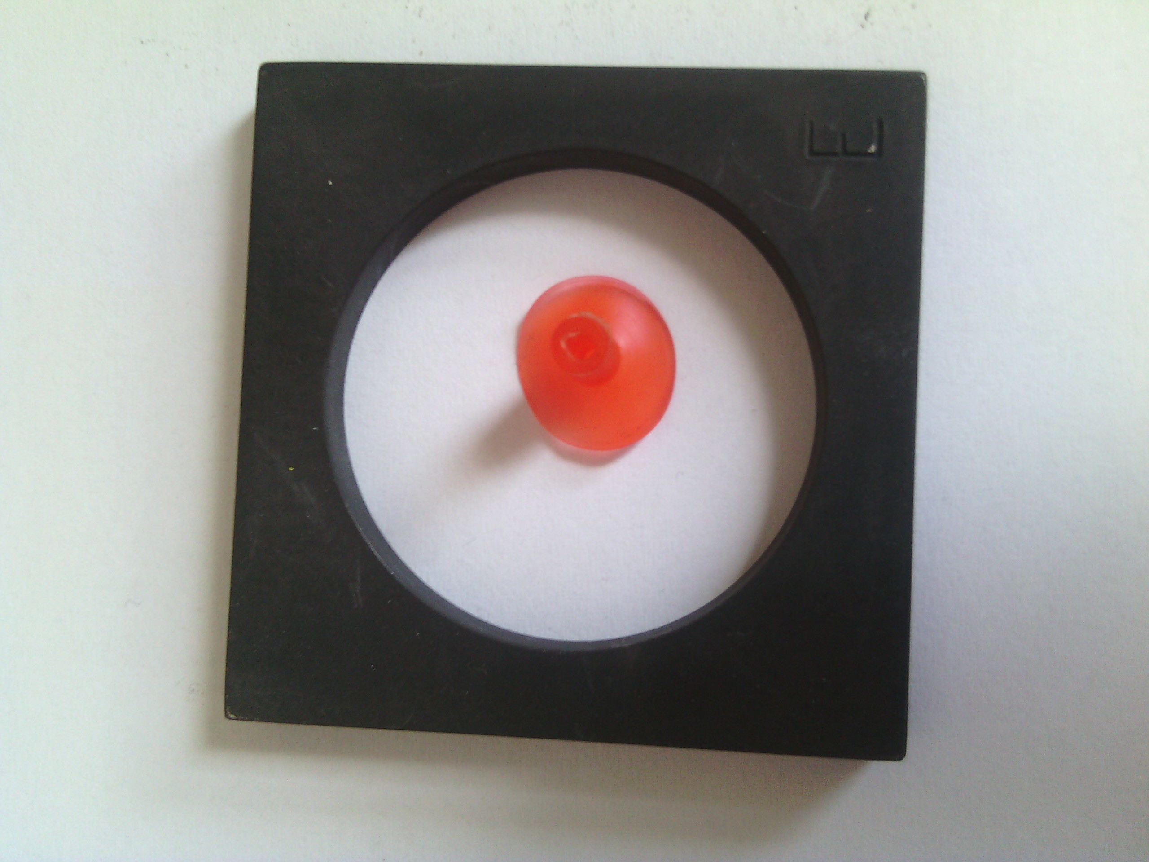

Danger
A suction cup which fits to the test tube for small parts released from the missile when the power of 11 N was used, i.e. less than stipulated in the standard (i.e. 90±2N). The missile with a suction cup is 52 mm long, but the minimal length as required by the applicable technical standard is 57 mm.
It is also possible to shoot other objects from the revolver, e.g. it is possible to shoot pencils as proven within the laboratory test. Despite it is possible to shoot other objects, there is no sign attached to the products warning against use of other subjects.
With regard to the above mentioned defects, it is possible that within a usual and predictable way of use a situation can occur when a child gets injured in the consequence of inhaling or swallowing released small parts or the whole missile. In such case air ways can get blocked and inner organs can be injured. Another risk Is the risk of injury by a different object shot out of the toy.

Imposed measures
The Czech Trade Inspection Authority prohibited sale of the toy and distributor subsequently withdrew the particular product from the market. Documentation was transferred to the contact point at the Ministry of Industry and Trade which would notify the toys to the database of dangerous products RAPEX.

