 | PRESS RELEASE

Small parts of cuddly snowman can cause suffocation

(Prague, November 11, 2015) Cuddly toys belong among the most favourite toys no matter how they look like. Anyhow, they need to be safe when children should play with them. A cuddly snowman failed this elementary requirement because it posed serious risk of blocking air ways in the consequence of inhalation of released small parts. The Czech Trade Inspection Authority prohibited sale of the dangerous toy and distributor subsequently withdrew the product from the market. After all necessary documents were elaborated, the product was notified into the system RAPEX.

Cuddly snowman

Country of origin: Made in P. R. C.
Manufacturer/Importer: unknown
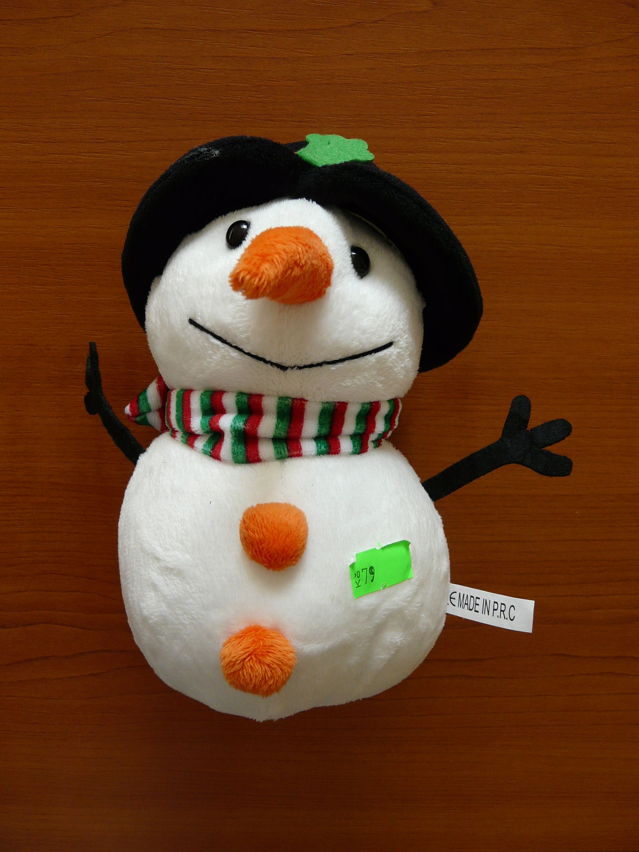

Product description
A softly stuffed snowman is about 200 mm high and made of white plush. Its carrot-shaped nose is also made of plush, eyes are plastic, “arms” are made of black felt and mouth is sewn. Buttons are made of tight plush. The snowman has a hat decorated with a taffeta ribbon and a scarf around its neck. A cord with a suction cup is sewn to the head.

Danger
During the pull test, several small parts released from the toy and fitted to the test tube. The button released when the power of 20.1 N was used, one eye released after the power of 61.3 N was used and the other eye when the power of 62.8 N was used. The requirement determined by the applicable technical standard is 90±2 N. The cord with a suction cup released after the power of 88.3 N was used and fitted to the test tube for small parts as well. After the cord released, a hole appeared into which the front part of the stick of the diameter 12 mm could be inserted and filling of the toy was easily accessible.

It is very probable that within game, i.e. within usual and predictable way of use of the product, a situation can occur within which small parts can be inhaled. This concerns plastic eyes, button, the toy’s filling and subsequent blocking of child’s air ways.
Imposed measures
The Czech Trade Inspection Authority prohibited the sale of the particular product and subsequently distributor withdrew the dangerous product from the market. After all required documents were elaborated, the cuddly snowman was notified into the system RAPEX.

