 | PRESS RELEASE

Whistling duck with light effects is dangerous to children

(Prague, January 13, 2016) The Czech Trade Inspection Authority warns consumers against a dangerous toy, a whistling duck with light effects which was detected in the Czech market. It poses health hazard especially to small children. Easily separable small parts, i.e. a whistle and a cord loop on the duck’s head, can be swallowed or inhaled and cause choking or suffocation. The elastic cord can be pulled to the length of 70 cm and hence poses risk of strangulation. The Czech Trade Inspection Authority prohibited distribution of this toy and the inspected person subsequently withdrew the product from the market. The product was notified into the system RAPEX as a dangerous toy, file No. INFO 0244/15.

Jo – Jo Duck whistling with light effects
Manufacturer/importer: unknown
Country of origin: China
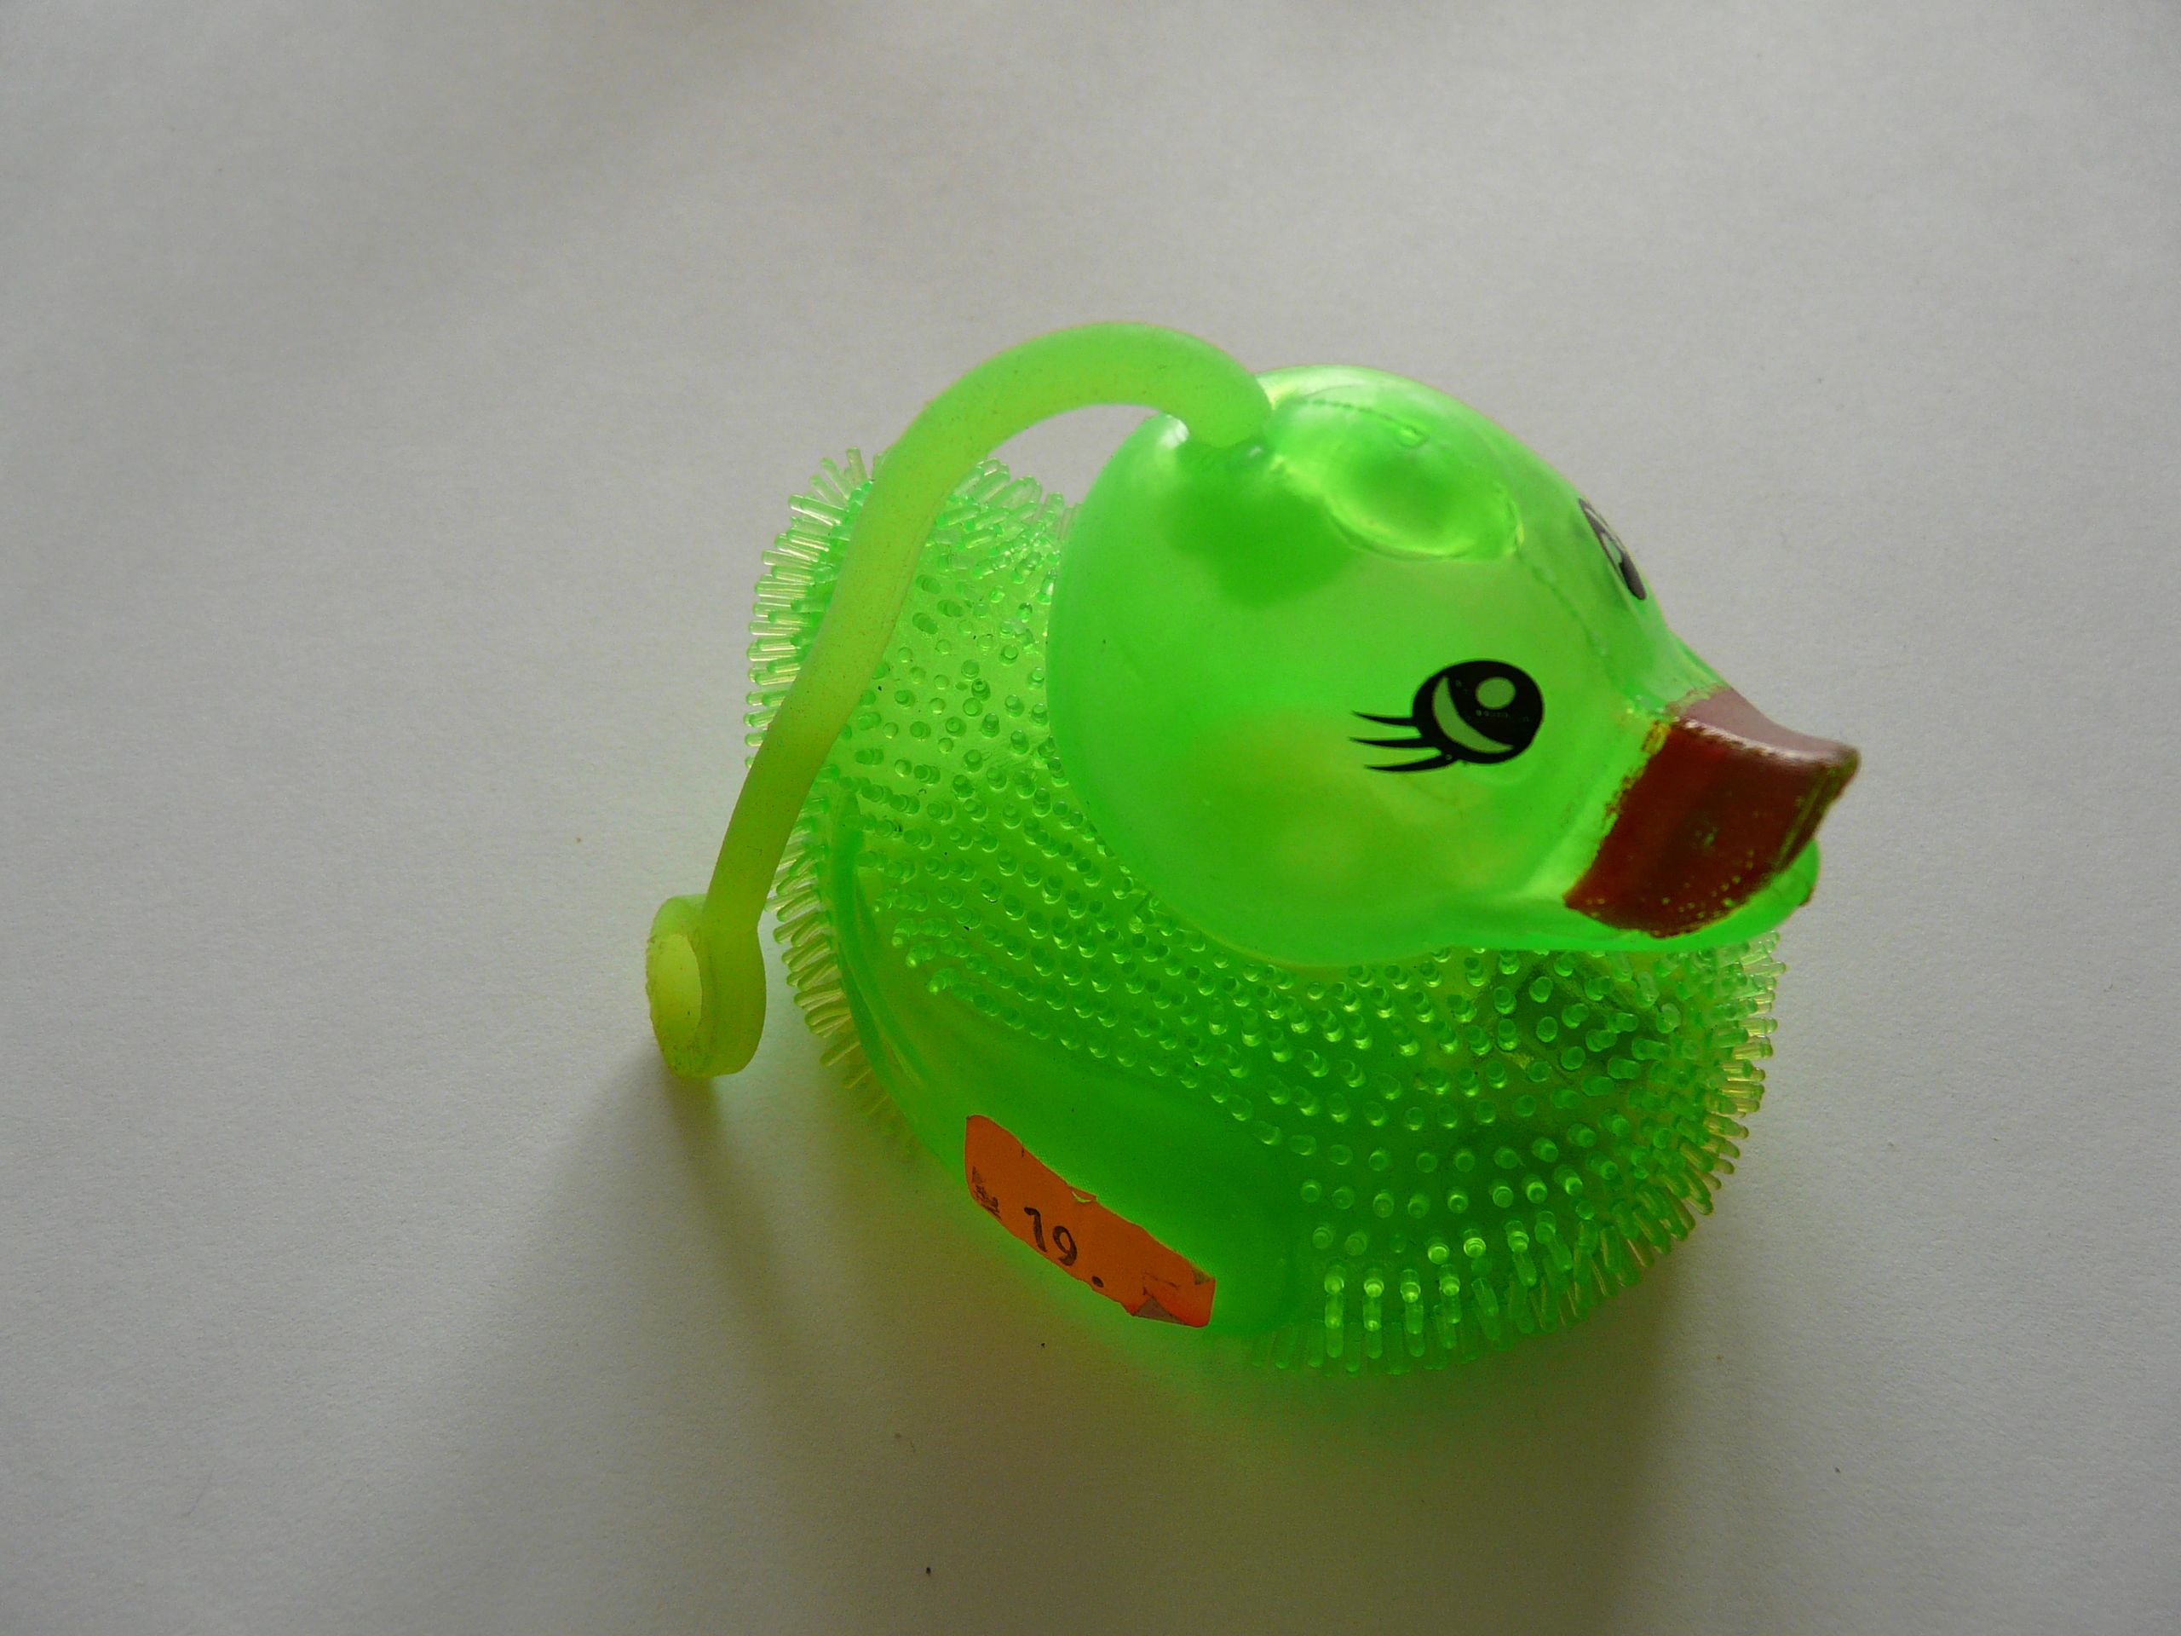

Product description
The light green duck is made from soft plastic. Its body is covered with short soft “thorn” imitating a feather. A 95mm long elastic cord with a loop from the same material on its end is affixed to the upper part of the head. There is a hole with a whistle at the bottom of the toy – when it is pressed, the toy whistles. A plastic ball that flickers is inserted inside the hollow toy which is 85mm long, 65mm wide and 61mm high. The text “Made in China” as well as the number 201320571413.6 can be read on the bottom of the toy.

Danger
During a product safety test it was discovered that the whistle which fits into the test tube for small parts can be easily separated when the power of only 5.1N is used. During a pull test the elastic cord was torn from the duck’s head when the power of 12.2N was used and the cord’s loop separated when the power of 19.2N was used – this is another small part which all fitted into the test tube for small parts.
Within usual and predictable way of use of the product, i.e. during game, a situation can occur when a child can be injured after unwitting inhalation or swallowing of the released parts which can result in chocking or suffocation. The danger of strangulation is caused by the very long elastic cord that can be stretched up to the length of 70 cm.

Taken action
The Czech Trade Inspection Authority prohibited further sale of the whistling toy and its distributor subsequently took action and withdrew the dangerous product from the market. The product was notified as a dangerous product to the RAPEX contact point at the Ministry of Industry and Trade and published in the system RAPEX, file No. INFO 0244/15.

