 | PRESS RELEASE

Plastic rattle can endanger the health of smallest users

(Prague, August 17, 2016) The Czech Trade Inspection Authority discovered that a toy, a rattle, is offered in the retail market and can pose serious health risk to children under 3 years. The hazard is that within a common and usual way of use the toy can break and small parts can be released – a child could swallow or inhale them. CTIA inspectors imposed ban on this toy type as well as its withdrawal from distribution. The product will be published in the European database of dangerous products RAPEX.

Some toys can become a high health hazard. This was the case of a plastic toy which failed the technical requirements for toys.

The plastic toy is composed of three cage-shaped plastic balls with the proportions of 140 x 93 x 30 millimetres with flat plastic bars. There is a jingle in each of the three green, blue and red balls.

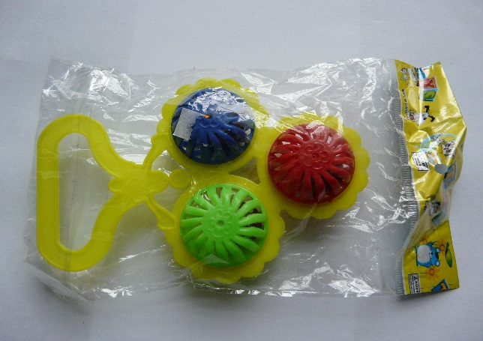

Original product within sale

The product – in contradiction with its assumed use – is assessed as unsuitable for children under three years due to the posed hazard of swallowing of small parts.

Hazards

The toy failed safety requirements for toys. A laboratory test proved that the toy failed the requirements for these products within pull test, strength crash test and pressure test. During all these tests, individual parts of the product were damaged, balls broke and jingles released. It is probable that within common and usual way of use, the toy can be broken and small parts released – a child can swallow or inhale these parts. A vendor cannot avoid the responsibility for such danger only by stating that there is a danger and marking the product with a pictogram “unsuitable for children under 3 years”.

Measures taken

The Czech Trade Inspection Authority banned distribution of this product and imposed its withdrawal from distribution. The toy was notified and published in the European database of dangerous products RAPEX, No. INFO 0100-16.

