 | PRESS RELEASE

Dangerous doll

(Prague, December 14, 2017) Within its activities, the Czech Trade Inspection Authority focuses on dangerous products that could endanger the health of consumers. It found out that a toy is offered in the Czech market although it can pose health risk to children.

Inspectors found out about the following toy – a doll – which is offered and sold in the market. It is a plastic toy with a soft plastic head and brown hair. Its body is made from a non-transparent plastic. The doll wears a violet dress and a crown on its head. On the packaging is a CE marking, pictogram “Unsuitable to children under three years”, warning in English (unsuitable to children under three years due to the presence of small parts), and information that the set contains other accessories just like glasses and so forth, unsuitable for girls under three years, danger of swallowing or inhalation of small detachable parts.

Laboratory tests showed that the toys failed the requirements of the applicable EU Regulation. It contained harmful substances that exceeded limits permitted by the above mentioned legislation.

The Czech Trade Inspection Authority imposed prohibition of distribution of the product and withdrawal from distribution. The toy was also notified to the contact point at the Ministry of Industry and Trade and the information was published in the RAPEX database, notification number A12/1634/17.

Doll „FASHION GIRL“

Name of the product on the packaging: FASHION GIRL
Type / model No.: NO: 338
EAN: 6923400115300 on a sticker
6953216603388 directly on the box
Country of toy’s origin: Made in China
Identification number: Not displayed
Importer: B&B Market, 319 Libušská, Praha 4
Trader: UNIONA, s.r.o., Žábova 377, 149 00 Praha

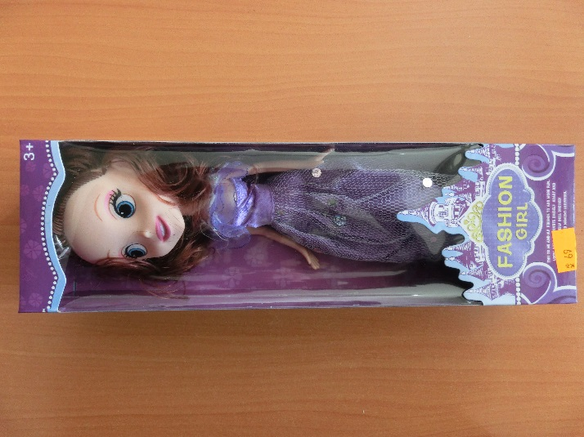
Picture of the product

