 | PRESS RELEASE

Plastic headdress poses a safety risk to children

(Prague, March 1, 2018) The Czech Trade Inspection Authority found a dangerous toy named “Svítící rohy” (Illuminating horns). It is a plastic headdress with an insufficiently secured battery cover.

The Czech Trade Inspection Authority found out that a toy which could pose a risk to children is offered in the Czech market. It is a black plastic headdress on which two red horns are affixed. In the middle of the headdress is a heart-shaped plastic box containing two button cells. The box has a cover which is not secured against opening. Thin wires ending with LED lights come out of the box. The product is packed in a transparent bag with a paper sticker displaying identification data and the following warning: “Warning! Unsuitable for children below 3 years. Danger of swallowing or inhalation of small parts. Danger of suffocation. Remove all tags, packaging or plastic hangers before using the toy. Keep the packaging – it contains important information.”

CTIA found out that the button batteries can be taken out of the toy without the necessity to use any instrument. The box’s cover can easily be opened with a simple move. A child can put the batteries into mouth and inhale or swallow them after they are taken out of the box. The product is not in compliance with the safety requirements pursuant to the government order, specified in a technical standard which among others governs that the button cells and batteries of the R1 type must not be accessible without the use of any tool and shall be accessible only after two independent moves are made.

The Czech Trade Inspection Authority imposed measures in the form of an immediate withdrawal of the product from distribution. The toy was notified to the contact point by the Czech Trade Inspection Authority and published in the RAPEX system, notification number A12/0156/18.

Identification data - headdress „Svítící rohy“

Product name displayed on packaging: Svítící rohy
Type / model No.: ITEM NO: 4793-440012
EAN: 8599900047939
Importer: Alfa Perfex s.r.o., Sokolovská 428/130, 186 00 Praha 8
Identification data of manufacturer: YIHENG TOYS FACTORY, Store 2287 D Area, YIWU International Trade City Zhejiang Province, China

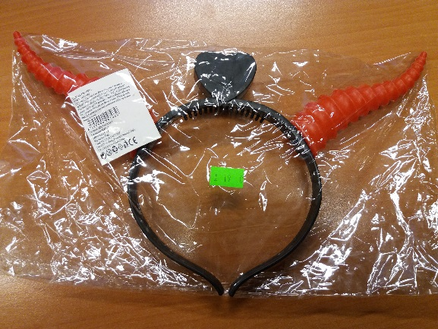
Picture of the product

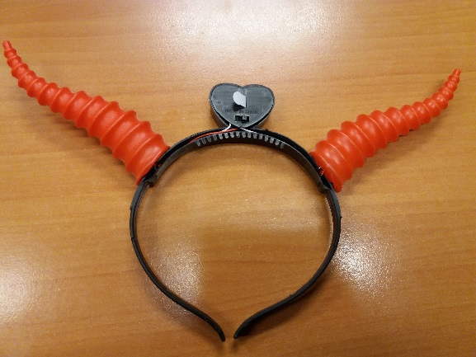
Hračka bez obalu

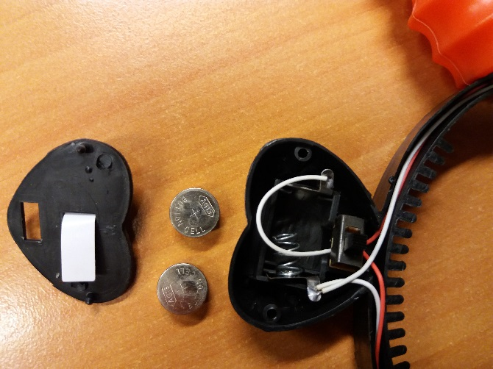

Open box with button batteries

