 | PRESS RELEASE

Flaws within each inspection of outdoors heaters

(January 25, 2019) Last year, the Czech Trade Inspection Authority focused on the inspection of outdoor heaters used by restaurants on their open air premises during winter time. CTIA found deficiencies within all 9 inspections, specifically regarding the accompanying documentation and product marking. Foremost, safety warning were missing although they must be visibly placed on the product or its packaging. The most serious shortcoming concerned a table heater which was insufficiently protected against possible touch of its burner by a consumer – a wrong grid could endanger the consumer.

In the second semester of 2018, the Czech Trade Inspection Authority carried out inspections aiming at gaseous appliances, outdoor heaters and radiant heaters without any flue connection for outdoor use or intended for sufficiently ventilated spaces.

9 inspections were carried out within the inspection. In 7 cases distributors and in 2 cases importers were inspected. 7 types of gaseous heaters for outdoor use or for sufficiently ventilated spaces were inspected. All of them were heaters usually used for heating outdoor spaces in restaurants during winter time.

The goal of the inspection was to check if, when marketed, the inspected appliances are supplied with required documentation and if their packaging is equipped with the required instructions and safety information. Further, CTIA inspected if the competent commercial entities meet the requirements when marketing the products and within suppliers chain it verified the previous supplier in order to find out the importer to the EU or the manufacturer. Specifically we speak about the fulfilment of and compliance with the applicable Czech and European standards, such as instructions for use and maintenance, applicable safety warnings and information on the product or its packaging in the country where it shall be distributed, CE marking and other information.

Detected flaws and imposed measures

During the inspection, the Czech Trade inspection Authority found misconducts in the area of accompanying documentation and product marking, foremost display of information and safety warnings that must be on the product or its packaging. No serious findings were detected in the area of CE marking. In one case, a product was detected which obviously didn’t meet the safety requirements for the protection against accidental touch of a burner.

Most serious finding was detected in a case of a table heater – there was insufficient protection of its burner against accidental touch by a consumer. A wrong grid could really endanger them when the heater was on. Therefore prohibition of distribution was issued until the importer ensures removal of the defect. Consumers should be watchful and avoid purchases of such a product.

Other flaws and taken action:

- In 2 cases, distribution of appliances was prohibited (breach of provision of section 13 par. 9 of the Act No. 22/1997 Coll. pursuant to section 7 par. 1 letter a) of the Act No. 64/1986 Coll.) and suggestions for the launch of administrative proceedings were submitted;

- In 1 case, the seller used unfair commercial practices, failing to inform about the possibility to make a claim and about the out-of-court dispute resolution (breach of provision of section 4 par. 1 and 4, section 13 and 14 par. 1 of the Act No. 634/1992 Coll. on Consumer Protection), and the suggestion for the launch of administrative proceedings was submitted;

- In 1 case, the product failed the technical requirements and other obligatory marking (breach of provision of section 13 of the Act No. 22/1997 Coll.); an on-the-spot fine amounting to CZK 5,000 was imposed;

- In 2 cases, the prohibition to place products on the market was imposed until necessary measures are taken to remove the detected defects (breach of provision of section 13, par. 9 of the Act No. 22/1997 Coll.);

- In 2 cases, prohibition to distribute the product was imposed until defects are removed (breach of provision of section 13, par 9. Of the Act No. 22/1997 Coll.).

Example of a correct grid of an outdoor heater:

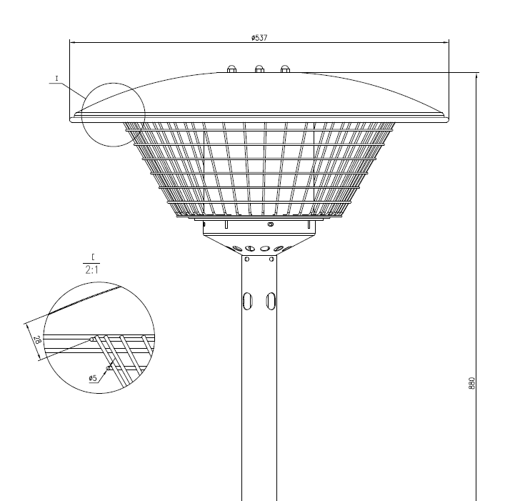

Example of a wrong grid of an outdoor heater:

