 | PRESS RELEASE

Classic presentation sales events still on decline
(Final report of 2018)
(Prague, February 8, 2019) The Czech Trade Inspection Authority has monitored the organization of sales presentation events for a long time. In recent years, they have seen their numbers declining. In 2016, the law was violated in 76 percent of inspections, and in 2018 it was only 27 percent. The organizers of the events most often and repeatedly violated the obligation to notify the CTIA about the organization of such events. "The results of the inspections confirmed that the organization of the classic presentation sales events is on the decline. However, the unpleasant and aggressive practices of junks move to the e-commerce, social networks as well as offers of energy supplies. Although the CTIA recorded a significant decline in the number of sales presentation events, it will continue these inspections," said the CTIA Director General Mojmír Bezecný.
The Czech Trade Inspection Authority carried out a total of 73 inspections in 2018. In addition to uncovering unfair and aggressive commercial practices, CTIA also inspected compliance with the notification obligation, compliance with the ban on accepting payment for a product or service before the expiry of the 7-day period from the conclusion of the contract. Breaches of legal regulations were discovered within 20 inspections, i.e. 27.4% Out of the total number of inspections.
The number of traditional presentation sales events decreases. This is also evident from the number of consumer submissions. The Czech Trade Inspection Authority received 281 submissions in 2016 and only 28 in 2818.

Inspections – presentation sales events 2018
Inspectorate | Number of inspections | Inspections with findings | Ratio of findings
Středočeský and Prague | 21 | 10 | 47.6%
Jihočeský and Vysočina | 5 | 1 | 20.0%
Plzeňský and Karlovarský | 3 | 0 | 0.0%
Ústecký and Liberecký | 17 | 4 | 23.5%
Královéhradecký and Pardubický | 14 | 2 | 14.3%
Jihomoravský and Zlínský | 2 | 1 | 50.0%
Olomoucký and Moravskoslezský | 11 | 2 | 18.2%
Total | 73 | 20 | 27.4%

Detected breaches
The Act No. 634/1992 Coll. on Consumer Protection, was breached in 37 cases:

- In 11 cases, the notification obligations relating to the organization of events were breached (section 20 par. 1);
- In 9 cases, vendors breached the organizers’ obligation to notify the CTIA 10 days before the event is held (section 20 par. 3);
- In 6 cases, the invitation to the demonstration didn’t include some of the obligatory data, such as the timetable, the identification of the offered or advertised products and their price, i.e. the price without taking into account any discounts individually negotiated with the consumer at the organized event. Cases were also found that no name, address, and identification number of the person who organized the event were in the invitation (section 20a).

Vendors infringed the Act No. 255/2012 Coll. on Inspection, by having failed the required measures.

Inspections of presentation sales events
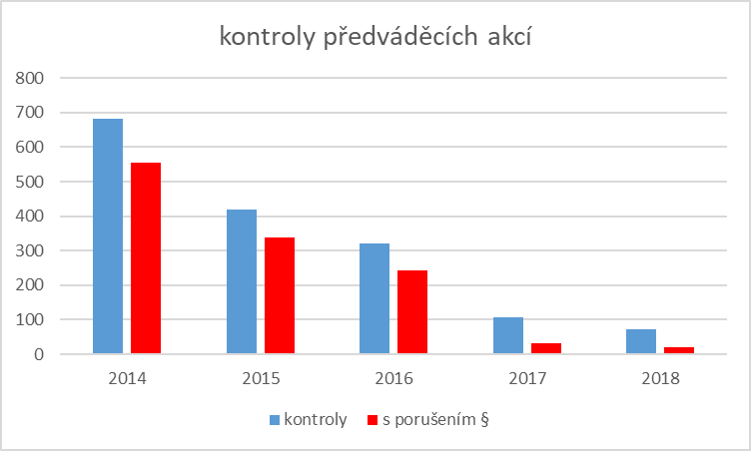
Legend: Inspection With findings

Imposed measures and sanctions

CTIA imposed 20 fines totalling CZK 4,740,000 in 2018, which was CZK 17,424,000 less than in 2017 (CZK 22,164,000).

The highest fines for presentation sales events, which came into force in 2018, amounted to the total of CZK 2,000,000 in case of Exen trade s.r.o., that among others used unfair commercial practices and provided false information about when the presentation sales event would be held. The company WORM s.r.o. was also subject to fines totalling to CZK 1,500,000. The third highest fine amounting to CZK 500,000 was imposed to BNM-MEDICAL CZECH SE, s.r.o.

