 | PRESS RELASE

CTIA found dangerous plush dogs with ribbons and glasses
(Prague, April 18, 2019) Two toys appeared in the market, which can be dangerous for the youngest children. These were small barking dogs, one with red ribbons and one with glasses and a hat. CTIA inspectors found that in case of the both toys it is possible to open the battery case without the necessity to use any instrument and to remove the batteries from the case – small children can put the batteries in the mouth and suck them. Furthermore, the toys contain small parts, such as a jingle bell, which can also be dangerous to children. The products also don’t contain any information about the age of the child for which they are intended, nor do they contain the required warning about the danger posed by small parts that they contain.

The Czech Trade Inspection Authority found out that two products appeared in the Czech market that could pose a risk to small children. These electric toys with various accessories are made of hard plastic and covered with plush material. One male model has two red ribbons glue affixed to the head and a golden spring with a jingle bell around the neck. The second dog type is different. It has a hat on its head, glasses on its eyes, and also a jingle bell. There is a plastic case with two AA batteries on the tummy of the both models. The closing of this battery case is formed by a latch and a screw – but the screw was missing on the products offered for sale. Some children under the age of three could, without the use of any instrument, manage to open the latch and remove the batteries from the case. There are no restrictions displayed as regards the age of the child for which the toy is intended, or any other information indicating a potential hazard. The dog with the red ribbons is also without any identifying information about the toy manufacturer or importer to the Czech Republic.

Barking dog with red ribbons
Product name: not displayed
Type number: not displayed
EAN: not displayed
Identification of the importer: not displayed
Identification of the manufacturer: not displayed
Country of origin: Made in China

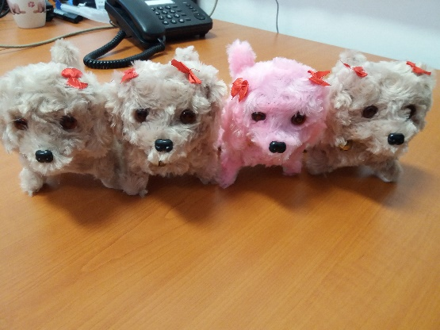

Barking dog with glasses and a hat
Product name: Pes
Type number: 4-4N140LNN4355
EAN: 8594355123450
Identification of the importer: AMADEO GOLD s.r.o.
Identification of the manufacturer: not displayed
Country of origin: Made in China

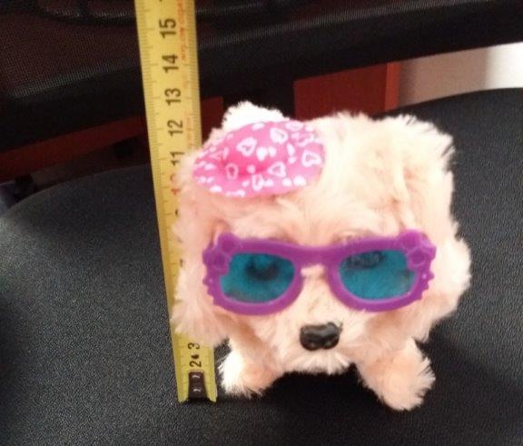
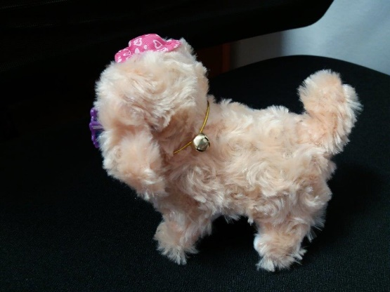

Picture of the battery case without the screw to ensure that the batteries are inaccessible.

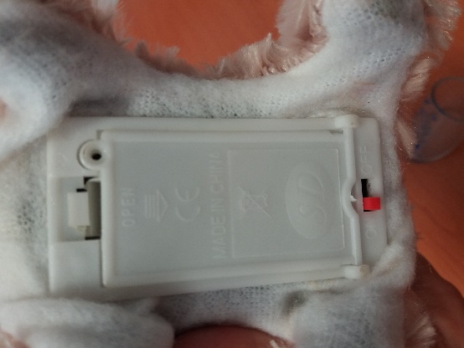

Cause of Hazard

Both toy models don’t comply with the requirements of the Government Order No. 86/2011 Coll., on Technical Requirements for Toys, which are specified in the technical standard EN 62115 - Electrical Toys - Safety. The requirement of the Article 14.7 of the cited standard is not fulfilled although it states that batteries of toys intended for children under three years of age shall not be removable without the use of an instrument unless the battery compartment cover is sufficiently secure. The toys also contain small parts, such as the jingle bells, that fit into the small parts cylinder.

Finding:

The case in which the batteries are stored can be opened without the use of any instrument by simply sliding the cover out within one move. For these reasons, small children may be able to remove the batteries from the case, put them in their mouth and bite or suck them. This is the case also for the accessible jingle bell which can be swallowed by the baby.
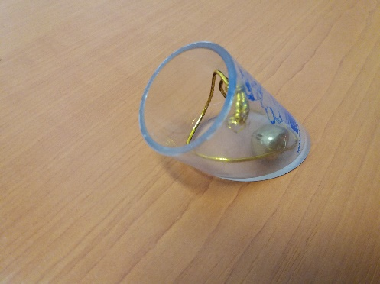
Small parts released as put in the tube for small parts

Measure taken

The Jihomoravský and Zlínský Inspectorate of the Czech Trade Inspection Authority imposed the vendor a protective measure consisting of the prohibition to distribute and the order to withdraw the products from the market. Information about the both dangerous toys were reported to the contact point at the Ministry of Industry and Trade and published in the system RAPEX.

