 | PRESS RELEASE

Masha doll is dangerous
(Prague, August 2, 2019) The Czech Trade Inspection Authority found out that in the Czech market there is a toy (a doll) “Masha and the bear” which is offered to consumers and which is dangerous to small children because the battery case isn’t secured enough. The child can swallow or inhale the batteries easily taken out from the case. Moreover, the doll Masha contains excessive amount of lead.
The Czech Trade Inspection Authority detected a toy in the domestic market – it is a plastic doll with blond hair with a pink scarf. It is dressed in a pink dress and white blouse. The doll was offered in a paper box with a window. The toy is powered by button batteries, it makes sounds and speaks. A plastics case with button batteries is placed in the centre of the doll’s back. The case isn’t secured, it is only closed when two plastic parts are pulled together. The case in which the batteries are placed can be opened without the necessity to use any instrument. After the batteries are pulled out from the case, a child can swallow or inhale them.
The laboratory tests also proved a major noncompliance with the requirements of the EU Directive 2011/65/EU – RoHS). Up to 66.9% of lead was proven in four solder joints inside of the toy. It was a multiple exceedance of the permitted amount. Failure to comply with the requirements poses a serious environmental risk.
The product is not in compliance with the requirements of legal regulations (Government Order No. 86/2011 Coll. on The Safety of Toys, that are specified in the standard EN 62115 – Electric Toys - Safety). The standard’s requirement is that button cells and the R1 batteries must not be accessible without using any tolls if the cover of their space can’t be opened only after performing at least two simultaneous independent actions. This requirement applies on all toys. The battery cover doesn’t have the required strength.
The Czech Trade Inspection Authority imposed a protective measure prohibiting the distribution and ordering the withdrawal of the products from the market. The toy was notified to the contact point at the Ministry of Industry and Trade and published in the RAPEX system.
Product information:
Masha and the Bear - Doll
Product name: Masha and the Bear (written in Cyrillic)
Model type / number: NO: 9918
EAN: 8590042080761
Importer identification data: CONIX COMPANY s.r.o., Hybernská 1012/30, Praha 1 (as displayed on the product packaging)
Identification data of the importer: Not displayed
Country of origin: Made in China

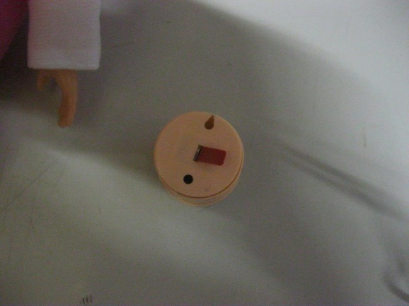
Unsecured case with button batteries
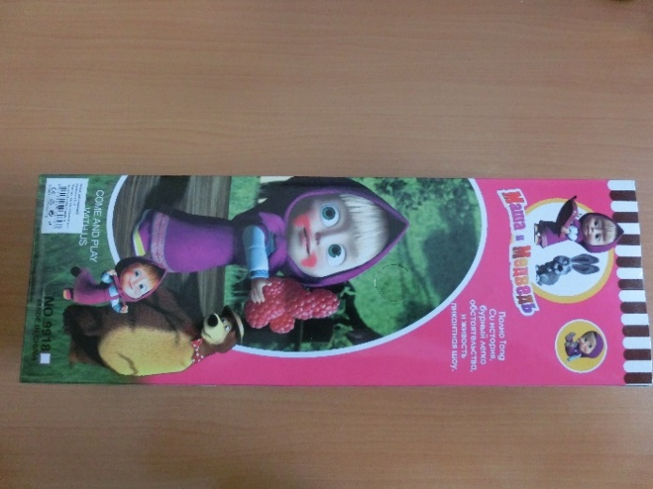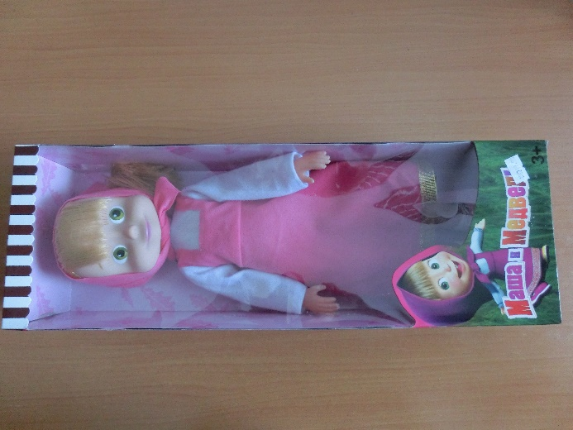
Picture of the product

