 | PRESS RELEASE

There is another toy posing a risk to the environment
(Prague, January 16, 2020) The Czech Trade Inspection Authority found that there is a toy in the market that poses a risk to the environment. It's a toy that's offered under the following title: Tree with a "Singing Bird".

This is a battery operated plastic toy - a tree on which a bird sits and makes noises. There's an illuminating animal in the tree. Another bird is inserted into a box. The toy is powered by 3 x AA batteries. It isn‘t suitable for children under 3 years of age. The toy is sold in a cardboard box.

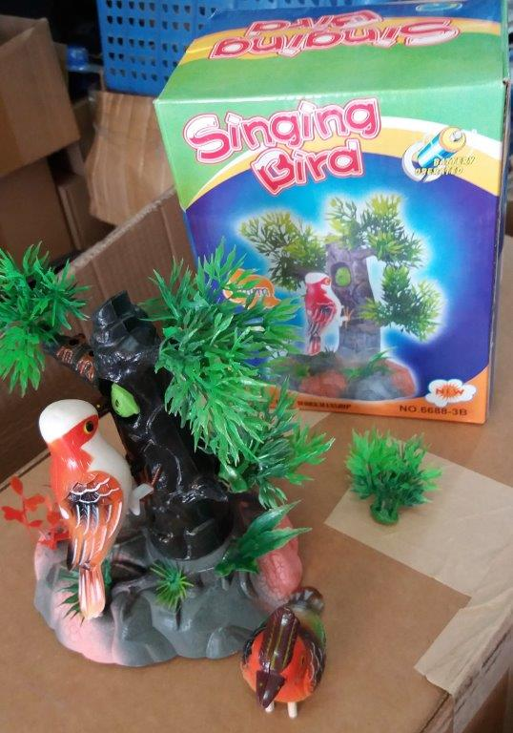

Original product

Tests carried out by an expert laboratory confirmed a significant noncompliance with the requirements of the Directive (2011/65/EU - RoHS) – multiple lead overruns were detected on the soldered joint within the toy (it contained up to 77.2% of lead when compared to the permitted limit value of 0.1%). Non-compliance with the requirements of the legislation in force poses a serious environmental risk due to possible environmental pollution.

The Czech Trade Inspection Authority also detected other defects. Instructions for use, containing safety information and instructions for battery operated toys, weren’t attached to the toy in Czech or another language as required by the standard (EN 62115:2005 harmonised to NV No. 86/2011 Coll., on Technical Requirements for Toys). The manufacturer's identification (according to NV No. 86/2011 Coll.) was not indicated on the toy or packaging.

In order to prevent the further occurrence of identical products in the market, the Czech Trade Inspection Authority imposed a protective measure on the distributor, which was to prohibit the distribution and withdrawal of the abovementioned products from the market or from circulation. All information on the dangerous toy were passed on to the RAPEX contact point at the Ministry of Industry and Trade.

Product identification data:

Product name: „Singing Bird“
Trademark: not indicated
Model No.: 6688-3/ Item No. 29436
EAN: 5845233294360
Manufacturer: not indicated
Distributor: ZARTHA CRIPS s.r.o., Makovského 1177/1, 163 00 Praha 6, IČ: 05193141
Product origin: China

