 | PRESS RELEASE

An illuminating teddy bear can be dangerous for the youngest children
(Prague, January 27, 2020) The Czech Trade Inspection Authority prohibits the toy „Medvídek svítící ve tmě“ („Teddy Bear illuminating in the dark") in the market. The toy is dangerous for small children, who can lightly release small parts of this toy and then inhale or swallow them.

The Czech Trade Inspection Authority found that there was a toy - Teddy Bear illuminating in the dark – in the offer in the market in the Czech Republic. A toy can pose a risk to the smallest children. It is a textile toy 21 cm tall, a softly stuffed teddy bear in a combination of pink and green colour. The eyelet and nose are made of hard plastic. The toy is designed for the smallest children and is sold in a blue paper box. After exposure to daylight or artificial light, the toy can illuminate in the dark.

The Czech Trade Inspection Authority found that the product does not comply with the requirements of the applicable legislation (GO No. 86/2011 Coll., on the Safety of Toys, as specified in the technical standard EN 71-1+A1 Safety of toys – Mechanical and physical properties). During the stroke test, small parts (eyes) loosened from the toy and, during the seam strength test, holes with a diameter of 12 mm were formed at the seams. Both of these parts of the toy could be swallowed or inhaled.

The Czech Trade Inspection Authority imposed a protective measure on the seller in order to prohibit the distribution and carry out the withdrawal of the product from the market or from circulation. The toy was reported to the contact point at the Ministry of Industry and Trade and published in the RAPEX system.

Product information:

Product name: Medvídek svítící ve tmě
Brand: Teddies
Model type: 00515002
EAN: 8592190515027
Importer identification data: Teddies s.r.o., Česká 151/16, 602 00 Brno
Manufacturer identification data: Top Trend Co. Ltd., 10 floor, Fu Chang Sheng industrial park, Shenzen City
Country of origin: Made in China

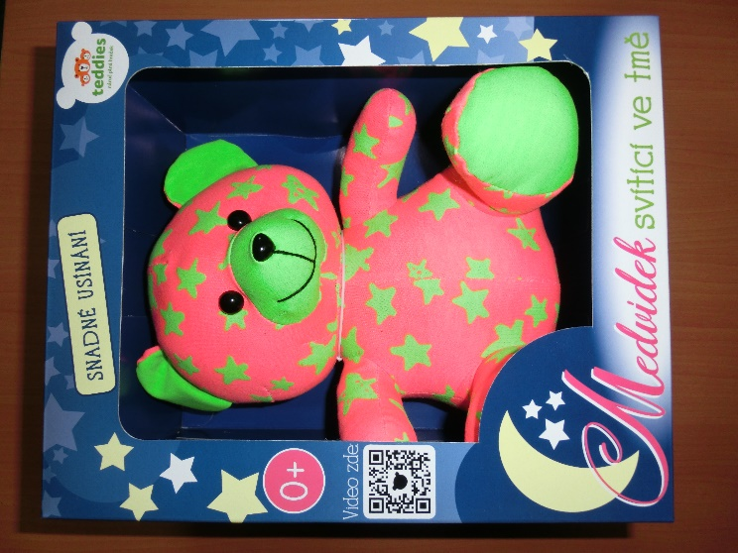
Product picture

The toy after laboratory tests

