 | PRESS RELEASE

CTIA prohibited the children’s tracksuit „Mertoglu Baby“
(Prague, March 2, 2020) The Czech Trade Inspection Authority found that a textile product that didn‘t comply with the safety requirements of children's clothing was offered for sale in the domestic market. It was the children's tracksuit "MERTOGLU Baby".

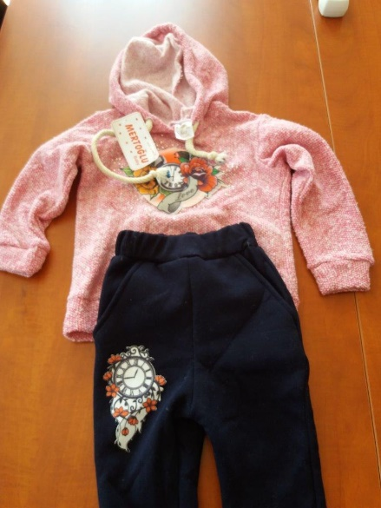
Picture of the offered product

The children's tracksuit is designed for 3 to 4 year old children. The set consists of a sweatshirt of pink colour with long sleeves and sweatpants of a dark blue colour. On the front of the hoodie is sewed a picture of flowers with a clock and the inscription "Love". Also on the right leg of the pants is a similar picture with clock and coloured flowers. A shoelace, topped with knots against fraying, is stretched through a „tunnel“ in the hood of the hoodie. In the neck of the product there a textile label is sewed with the following information: "Mertoglu Baby", 3 – 4 y- roky, Made in Turkey.

The Czech Trade Inspection Authority identified the cause of the hazard and found that the product didn‘t comply with the requirements of the Act (Act No. 102/2001 Coll., on the General Safety of Products, which are specified in Safety of Children’s Clothing – Cords & Drawstrings on Children’s Clothing). Clothing intended for small children shall not be designed, manufactured or supplied with withdrawal cords or functional cords in the area of the head, neck or upper chest. Clothes with a cord around the neck must be made without loose ends in the neck area. For this model of the hoodie, which forms one of the kit parts intended for children aged about 3 to 4 years, the safety requirements aren‘t met. During games and within normal behavior, children are at risk of being caught by functional cords, e.g. parts of the various game elements common at playgrounds or other fun elements.
The Czech Trade Inspection Authority imposed a protective measure on the seller (pursuant to Section 7 par. 2 leter g) and (h) of Act No. 102/2001 Coll.), consisting of the immediate withdrawal of the above mentioned products which are dangerous and which have already been placed on the market and the recall of the above-mentioned dangerous product from the consumer who demonstrably purchased the product at the inspected workplace. Information about the product was transferred to the contact point at the Ministry of Industry and Trade of the Czech Republic and also published in the RAPEX system.

Product identification
Product Name: Mertoglu Baby
Manufacturer: not specified
Sale: Dětský textil Beruška, Nábřeží Jana Palacha 925/8, 360 01 Karlovy Vary
Supplier identification data: S&K trade s.r.o., Nádražná 34, 900 28 Ivanka při Dunaji
Country of origin: Made in Turkey

