 | PRESS RELEASE

Dangerous Toy – singing dragon
(Prague, May 21, 2020) The Czech Trade Inspection Authority long-term monitors and inspects the offer and sale of toys. In the retail market, a dangerous toy was detected which can pose a risk to smallest children. It is the product „Drak Čmoudík zpívající“ (Singing dragon Čmoudík). CTIA ordered withdrawal of the product from the market.
The Czech Trade Inspection Authority found a dangerous textile toy in the domestic market – a 30 cm tall, softly stuffed two-headed dragon made of a combination of various plush materials of green colour. This is an electric toy, powered by two AA-type batteries placed in a plastic case, which is inserted into a pocket inside of the toy. The cap of this housing is secured against screw opening. The toy sings children's songs after being switched on.
The toy is noncompliant with the relevant standard (standard EN 71-1+A1, which is harmonised to the Government Order No. 86/2011 Coll., marked as unsuitable for children under three years of age). Furthermore, the product doesn’t comply with the requirements of GO No. 86/2011 Coll., on Technical Requirements for Toys, which are specified in the above-mentioned standard EN 71-1+A1 Safety of toys – Mechanical and physical properties. During the tension test, parts of the glue and cables were released from the toy. At the same time, it was also found that there is a hole in the inner pocket of the toy to store the case with batteries, into which it is possible to insert the front part of the 12 mm stick and therefore the toy filling is available to children. During the use of the toy, a small child can rip from the toy the above mentioned small parts or remove from the toy the filling with insufficiently secured seams in the inner pocket. These toy components could be swallowed or inhaled.
The Czech Trade Inspection Authority imposed a security measure on the distributor and the toy manufacturer. The measure consists of the prohibition of the distribution and withdrawal of the product from the market or from circulation. The toy was reported to the contact point at the Ministry of Industry and Trade of the Czech Republic and published in the RAPEX system.

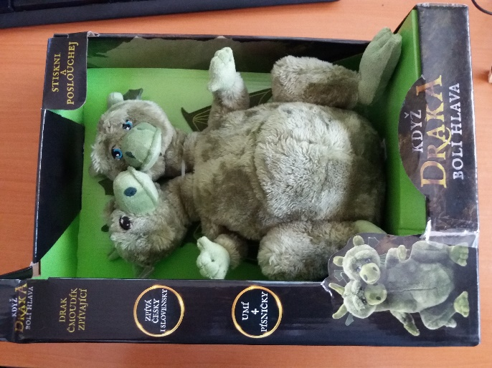
Picture of the product

Detected defects of the toy after laboratory tests
Product information:
Product name: Drak Čmoudík se zvukem
Brand: Teddies
Type / model number: 26010000
EAN: 8592190099916
Identification of the manufacturer: Teddies s.r.o., Česká 151/16, 602 00 Brno
Country of origin: China

