 | PRESS RELEASE

"Squirrel with sound" poses a risk to small children
(Prague, 29 June 2020) The Czech Trade Inspection Authority found that there was a toy on the market in the Czech Republic that could pose a risk to smallest children. It is the product „Veverka se zvukem“ ("Squirrel with sound").
The Czech Trade Inspection Authority found the offer and sale of an electric battery toy – "Squirrel with sound". This is a softly stuffed toy made of brown and white plush, with a bushy tail. After pressing the tummy of the toy, you would hear a sound. The toy is marked with consumer information in the contrary to the expected use as unsuitable for children under three years of age, while according to the legislature, it is expected that softly stuffed toys are intended for the age category of children under three years of age.
Laboratory tests showed that during the use of the toy, a small child might be able to pluck small parts from the toy that can be swallowed or inhaled. The tests also showed that the toy did not meet the restrictive requirements for the presence of DEHP phthalate, which may be present in the material used for the manufacture of toys in the maximum quantity of 0,1 %, but the value found was about 6 %.
In terms of their mechanical and chemical properties, the product doesn‘t comply with the requirements of the Government Order No. 86/2011 Coll., on the Safety of Toys.
The Czech Trade Inspection Authority imposed a protective measure on the toy distributor, consisting of immediate withdrawal of the toy from distribution. The toy was reported to the contact point at the Ministry of Industry and Trade and published in the RAPEX system.

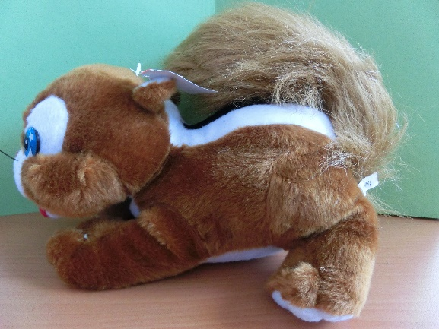
Picture of the product

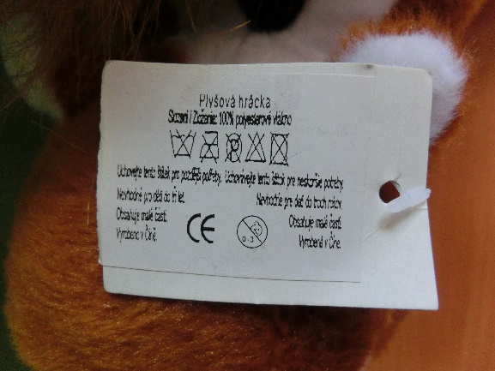
Picture of the paper stamp affixed to the toy with a splint

Detected defects in the toy after pull-off tests of strength

Product infomartion:

Product name: Plush squirrel with sound – „Plush toy“ (Plyšová veverka se
zvukem - „Plyšová hráčka“)
Trademark: Not displayed
Type / model number: Not displayed
EAN: Not displayed
Identification data of manufacturer: Not displayed
Identification data of distributor: Moonlight H-B s.r.o., Československé armády 1506,
738 01 Frýdek-Místek
Country of origin: Made in China

