 | PRESS RELEASE

Dangerous doll for children under three
(Prague, July 21, 2020) The Czech Trade Inspection Authority found that a ROSE toy doll is offered for sale in the domestic market, which does not meet the safety requirements for toys for the smallest children.

The ROSE doll is a textile toy, 30 cm tall, recommended by the manufacturer for children from 18 months of age. The doll has a shaped plastic head covered with hair braided into braids and plastic hands. Other parts of the body are sewn and soft-filled. She is dressed in dresses made of pink fabric, in the torso part is printed with white dots. Decorative parts in the shape of green leaves are sewn into the waist of the dresses. The doll has a pink cap with a green bow on its head.

During the pull test, one of the Velcro parts that fit in the small part test cylinder was released from the toy. During the use of the toy, a small child can rip off a part of the Velcro from the toy and insert the small part in the mouth. This part of the toy could be inhaled. The product does not comply with the requirements of the Government Order No. 86/2011 Coll., on the safety of toys, which are specified in EN 71-1+A1 Safety of toys – Mechanical and physical properties.

The Czech Trade Inspection Authority imposed a protective measure on the toy distributor, which is to prohibit the distribution and ensure the withdrawal of the product from the market or from circulation. The toy was reported to the contact point at the Ministry of Industry and Trade and published in the system RAPEX.

Product information:

Product name: AT panenka ROSE
Brand: JOHNTOY
Type / model number: 27500
EAN: 8711866275007
Manufacturer: JOHNTOY P.O.BOX 451, 2740 AL, WADDINXVEEN - NL

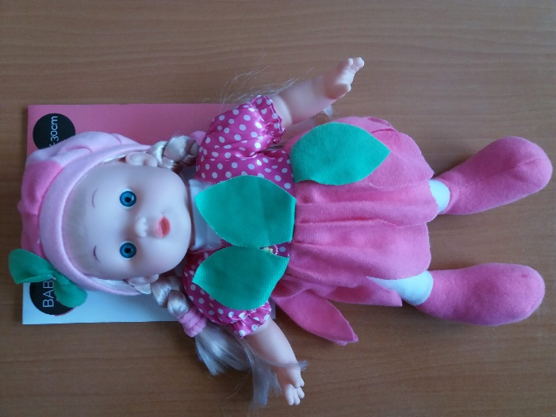

A part released from the toy during the laboratory test

