 | PRESS RELEASE

Emos SMART4 charger can cause electric shock
(Prague, 5 August 2020) In the market of the Czech Republic, the Czech Trade Inspection Authority identified electrical equipment that may pose a serious safety risk to consumers. When the product is plugged into a socket and the user touches it, electric shock can occur. We speak about the EMOS SMART4/N8168S battery charger.
The Czech Trade Inspection Authority found out about the supply and sale of a dangerous product in the domestic market. It is the EMOS SMART4/N8168S battery charger in paper packaging. The product poses a serious risk of electric shock that could cause injury or even death of its user touching the head of the fixing screw of the product body, on which a dangerous 230V mains voltage appears due to the penetration of insufficient insulation between the primary and secondary parts of the product. If the user touches the head of this screw when the charger is inserted in the socket, the situation can result in a serious injury or even death of the user due to the electric shock. The average value of the measured output current differs by more than 10 % from the nominal value of the DC output current displayed on the product. This information also did not comply with the requirement for the compliant product labelling.
The Czech Trade Inspection Authority imposed a protective measure on the seller (provision of Section 50 par. 3 of Act No. 90/2016 Coll. on conformity assessment of selected products when made available in the market), which is a prohibition on the supply to the market and withdrawal of a given product that has already been placed on the market. The product was reported to the contact point at the Ministry of Industry and Trade, and information about it was published in RAPEX.
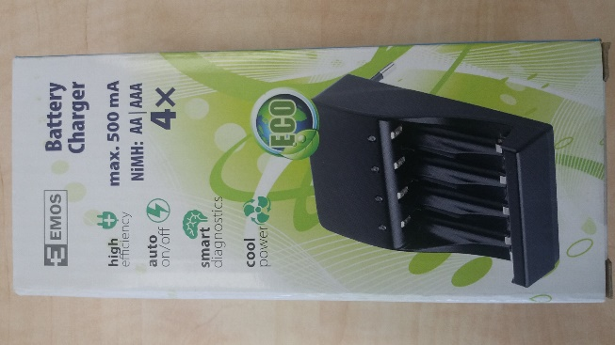
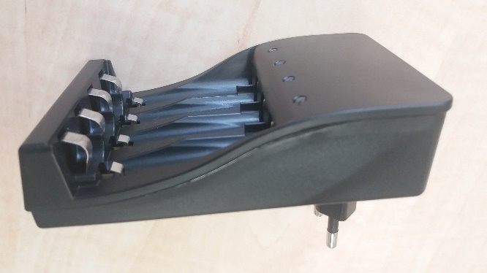

Picture of the packaging and the product
Product information:
EMOS SMART4/N8168S battery charger

Product name: Nabíječka baterií
Model type / number: EMOS SMART4/N8168S
Production number/EAN: 8592920033937
Identification data of the manufacturer: EMOS spol. s r.o., Šířava 295/17, 750 02 Přerov
Identification data of the importer: -
Distributor: NWT a.s., nám. Míru 1217, 76824 Hulín
Country of origin: Czech Republic

What it displayed on the product: EMOS, CE, typ SMART4, power input AC 100 – 240 V AC, 50/60 Hz, 200 mA, output 1,4 V DC = 500 mA +- 10%, protection class II marking, marking of indoor use, Manufacturer: EMOS spol. s r.o., Šířava 295/17, Přerov, Czech Republic.
What is displayxed on the packaging: EAN 8592920033937, Nabíječka baterií SMART4/N8168S (i.e. product name), www.emos.eu, Manufacturer: EMOS spol. s r.o., Šířava 295/17, Přerov, Česká republika, NiMH: 4 x AA/AAA, power input AC 100 – 240 V AC, 50/60 Hz, 200 mA, output 1,4 V DC = 500 mA +- 10%.

