 | PRESS RELEASE

CTIA prohibited a dangerous hoverboard
(Prague, 8 March 2021) The Czech Trade Inspection Authority found that in the market in the Czech Republic there is machinery, which can pose a serious risk to consumers. This is the product Hoverboard/Kolonožka STANDARD E1.
The Czech Trade Inspection Authority detected a dangerous hoverboard/Kolonožka STANDARD E1 product in the domestic market. The product is packed in a paper box, in which another paper box with an image of the product and a packaging to carry the product are inserted. In the box depicting the product there is a filler made of foam polystyrene, a power supply, the hoverboard in an LPDE packaging and a user manual.
Picture of the packaging and product
On the packaging with the picture of the product the following information is displayed: Smart Balance Wheel, CE Marking, RoHS, FCC, Weight: 12 kg, Voltage: 36 V, max. speed: 12 km/h, product model: smart, Specification: 650x245x230.
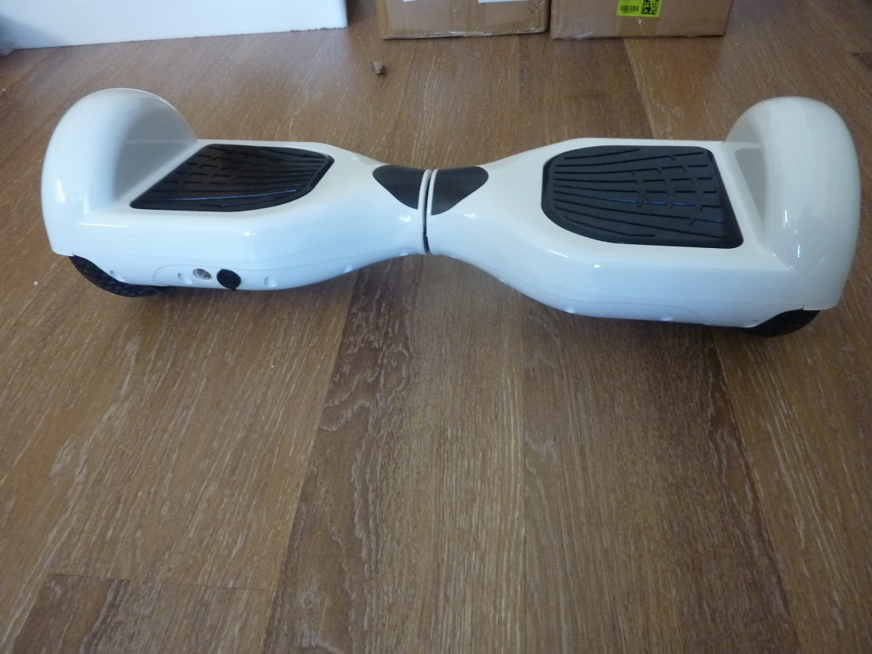
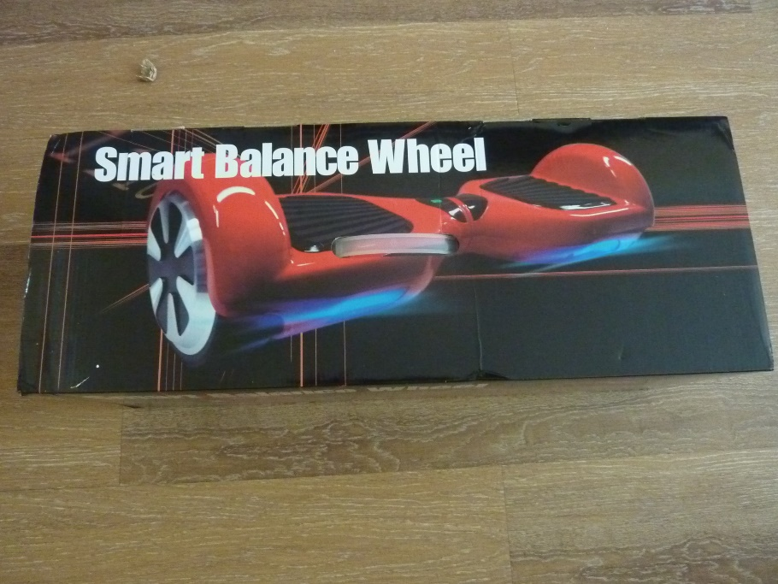

Information displayed on the paper box in which the product was inserted:

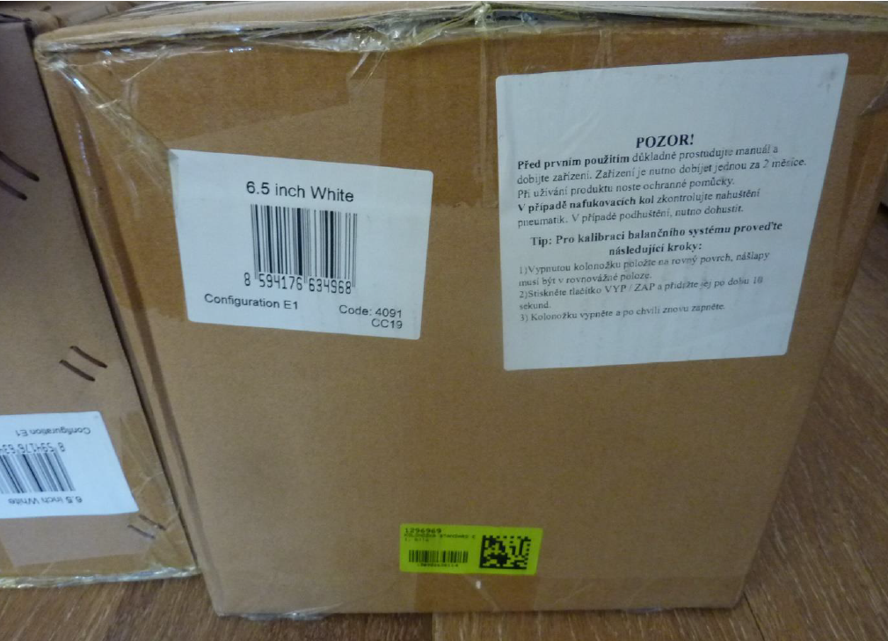
Label with pictograms on the product
On the product there is the inscription Kolonožka and the label with pictograms: use protective equipment, do not drink alcoholic beverages, charging 230 V indoors only, CE marking, RoHS compliant, FCC, brand for ecological disposal. Further CC19, Mode: further unreadable, Kolonožka Eljet s.r.o., Pod Baštami 299/7 Praha 160 00.
Power Charger, model: GX-22, INPUT 100 – 240 V, 50/60 Hz, 1.5 A, OUTPUT 42 V = 2000 mA, CE marking, FCC, LPS, pole marking, "indoor only, Caution! with another text in English.

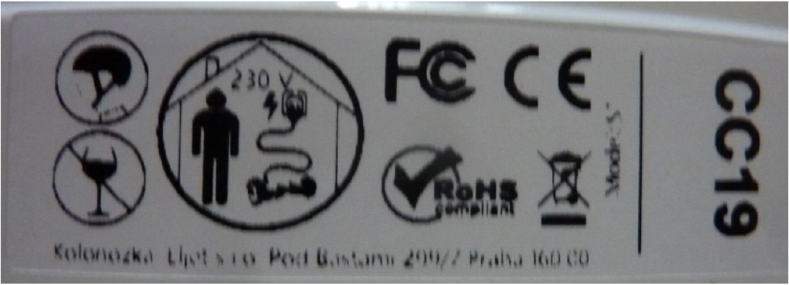

The product has been identified with a serious risk caused by a possible fall from the hoverboard in wet weather, where due to insufficient protection of the hoverboard from the effects of water, splashing water enters the control electronics and the charging connector, which are not designed to work under such conditions. Water is in such a quantity that it interferes with the proper functioning of the device and impairs its safety. As a result of a malfunction of the control electronics, the user falls off the hoverboard and serious injury may occur. After testing the product, toxic as well as incendiary gases began to be released and plastic parts were ignited. Furthermore, the product did not indicate the type or series, year of production. Neither the user manual nor the packaging of the product included an EC declaration of conformity or a document 31/414/EC declaration of conformity with details of the machinery, which does not necessarily contain a serial number and a signature.
The Czech Trade Inspection Authority imposed a protective measure on the distributor (pursuant to Section 18a par. 3 and 4 of Act No. 22/1997 Coll., on Technical Requirements for Products), which is a ban on the distribution and withdrawal of a product that is dangerous and has already been placed on the market. The product was reported to the MIT contact point and information about were been published in RAPEX.

Hoverboard/Kolonožka STANDARD E1

Product name: Hoverboard/Kolonožka
Model type/ number: STANDARD E1
Production number/EAN: 8594176634968
Identification data of manufacturer: Eljet s.r.o., Kladenská 278/61, 160 00 Praha 6
Identification data of importer: -
Distributor: Internet Mall, a.s., U garáží 1611/1, 17000 Praha 7
Country of origin: China

