 | PRESS RELEASE

Vendor is not obliged to serve a customer with no respirator on
(Prague, August 19, 2021) The Czech Trade Inspection Authority has recently been receiving increasingly frequent inquiries about alleged discrimination against consumers who are not allowed to enter the premises without a respirator on. The obligation to wear a respirator (or similar equipment) indoors is currently provided for by an emergency measure of the Ministry of Health and a retailer is certainly not committing discrimination if they don't allow a customer to enter the premises without a respirator (or similar equipment).
If a seller, for the purpose of protecting against the spread of COVID-19, refuses to serve a customer who violates the measure by not wearing a required respiratory protective equipment, such conduct cannot be considered prohibited discrimination in the meaning of Section 6 of the Consumer Protection Act. Such conduct pursues the legitimate objective of protecting other customers and employees of the establishment from being infected with COVID-19, and it is - in order to achieve that objective - reasonable to require a legally prescribed respiratory protective device as a prerequisite to the sale of a product or the provision of a service. Such a condition is not obviously arbitrary or irrational and does not undermine the dignity of the customer in any way. The information that the CTIA is sanctioning such conduct is a fake news story that is often disseminated on social media.
Below is also a sample of a similar post that is being spread on social media and is not true:

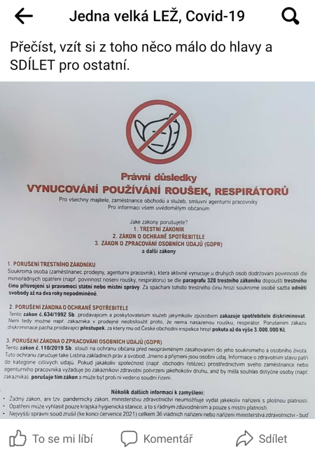
↑ One of unture posts on social media

