 | PRESS RELEASE

In Q3 2021, the CTIA took counterfeits for more than CZK 30 million
(Interim report for Q3 2021)
(Prague, 8 November 2021) In the third quarter of this year, the Czech Trade Inspection Authority continued its inspections to ban the offer and sale of counterfeit goods. It carried out a total of 232 inspections, during which it took 10,204 items of counterfeited goods worth CZK 30,266,372 when calculated in the prices of original products. Compared to the second quarter, there was a huge increase in seized counterfeited goods, as 2,507 pieces of counterfeit goods worth CZK 7,667,227 were taken from traders in this period.
In the period from 1 July to 30 September 2021, the Czech Trade Inspection Authority carried out an inspection action aimed at compliance with the ban on the offer, sale and storage of products infringing certain intellectual property rights or unauthorised use of a trademark protected under a special legal regulation. The inspections were carried out not only based on own knowledge but also basd on submissions from IPR owners and consumers.
During this period, the Czech Trade Inspection Authority carried out 232 inspections and in 115 inspections it saw violations of the prohibition on offering, selling and storing products infringing certain intellectual property rights. During this action, CTIA took 10,204 pieces of counterfeit products at the price of the originals amounting to CZK 30,266,372. Compared to the second quarter of 2021, there was a large increase in seized counterfeits, with 2,507 items of counterfeited goods taken from traders in the last quarter, with the value of the originals amounting to CZK 7,667,227. The high increase in the detected counterfeited goods can be attributed to the relaxation of the measures against the spread of the COVID-19 epidemic in Q3. Marketplaces and market stands that were closed in the previous quarter reopened. It was confirmed that vendors in the marketplaces are still offering large quantities of counterfeit products. The regions bordering Germany and Austria are the most affected.
In terms of product range, the most frequent IPR infringements related to clothing and textile products, and the number of taken audio products also increased. For products taken, the highest share was for trademarks of Tommy Hilfiger, Nike, Louis Vuitton and Adidas.
The event also included inspections of compliance with other legal regulations. These were violated in 181 cases. Apart from Section 8 of Act No. 634/1992 Coll., on Consumer Protection, the most frequently violated, in 46 cases, was Section 12 of the same Act, which imposes on the seller the obligation to inform the consumer, in accordance with price regulations and directly applicable European Community legislation, of the price of the products sold or services provided by clearly marking the product with the price or making information on the price of the products or services appropriately available otherwise.
Within this control action, the Czech Trade Inspection Authority used the cooperation with the Police of the Czech Republic (in 28 cases), the Alien Police (in 4 cases) and trade licensing authorities (in 3 cases).

Inspectorate | Number of inspections | Inspections with findings |  | Findings in %
Inspectorate | Number of inspections | Total | § 8 | Total | § 8
Středočeský and Prague | 9 | 8 | 7 | 88.9% | 77.8%
Jihočeský and Vysočina | 29 | 16 | 0 | 55.2% | 0.0%
Plzeňský and Karlovarský | 59 | 42 | 25 | 71.2% | 42.4%
Ústecký and Liberecký | 48 | 40 | 28 | 83.3% | 58.3%
Královéhradecký and Pardubický | 24 | 16 | 5 | 66.7% | 20.8%
Jihomoravský and Zlínský | 36 | 36 | 36 | 10.,0% | 100.0%
Olomoucký and Moravskoslezský | 27 | 23 | 14 | 85.2% | 51.9%
Total | 232 | 181 | 115 | 78.0% | 49.6%

Measures taken
In Q3 2021, the Czech Trade Inspection Authority imposed a total of 137 fines amounting to CZK 1,265,000.
Taken products failing specific legal regulations will be subject to lawful decisions on their forfeiture or seizure and will subsequently be destroyed or used for humanitarian purposes.
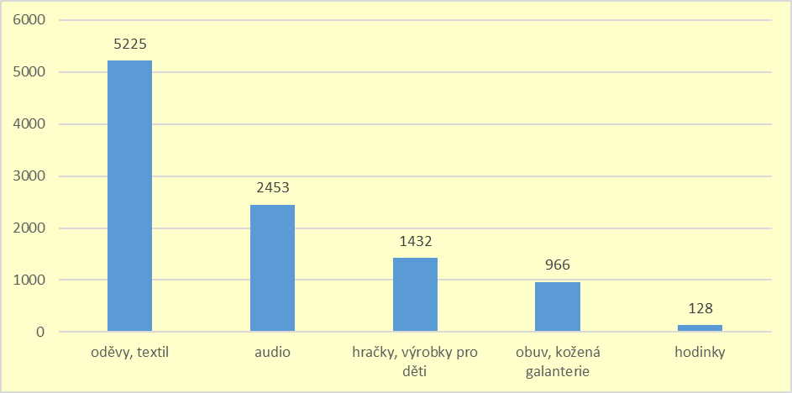
Table No 1: Numbers of individual range groups of products and the number of detected products in items

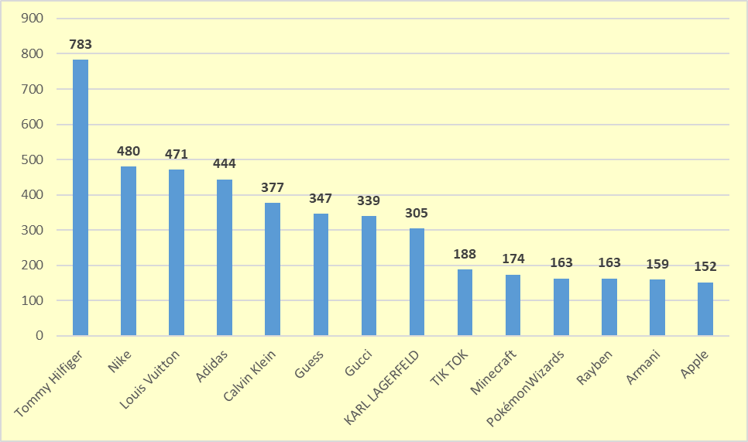
Table No 2: Share of selected trademarks in the total number of taken products in items. Trademarks not listed were present in fewer than 150 taken products.

