 | PRESS RELEASE

CTIA banned a dangerous inflatable child seat
(Prague, November 1, 2022) The Czech Trade Inspection Authority (CTI) found that the e-shop www.miniinthebox.com offers a floating child seat that may pose a health risk to smallest children. The product in question is sold as SEA 700.
The Czech Trade Inspection Authority found a product, a children's floating inflatable seat for use in water, on the website www.miniinthebox.com, which also offers goods for delivery to the Czech Republic. The seat is designed in the shape of a toy car with play elements, which are a yellow plastic steering wheel and a sound device - a horn. The seat with play features is packaged in a clear plastic bag with an inserted paper leaflet with a warning in English that the product is not a life-saving device and children should not be left in or near water unsupervised. This warning is accompanied by the pictogram 'not suitable for children under three years of age', although the product is clearly suitable for children as young as 12 months. Directly on the product is the warning in English "Warning! Only to be used in water in which the child is within it's depth and under adult supervision" and the country of origin label "Made in China". There is no available consumer information or the necessary warnings in the Czech language.
The Czech Trade Inspection Authority has found that the product does not comply with the safety requirements. According to REACH Regulation 1907/2006 (EU legislation), phthalates must not be used as substances or in mixtures in concentrations higher than "0.1% by weight". Laboratory tests showed that the white plastic material from which the toy is made does not comply with safety requirements due to the increased presence of phthalate, which according to the Ministry of Health can interfere with fertility and increase the risk of allergies. The amount of this phthalate was more than 200 times higher than the limit. This is a product that may pose a serious risk of long-term health damage to young children playing. Phthalates can enter a child's body through the skin or when they lick the plastic with their mouths and, according to scientific findings, can damage the reproductive system and increase the risk of asthma and cancer.
The safety requirements of the current regulations are not met by the packaging material either. In this case, the plastic film is not of the thickness or size that would prevent it from adhering tightly to the mouth and nose of a small child. The film could stick tightly to the nose and mouth of a small child and prevent the child from breathing. Packaging in which toys are packaged for retail sale shall not pose a risk of suffocation by blocking air from entering the mouth and nose.
The Czech Trade Inspection Authority has imposed a protective measure on the operator of the sales website, which is a ban on placing the product on the market. The design of the product does not comply with the legal requirements and the product may be dangerous to children. The toy was reported to the contact point at the Ministry of Industry and Trade and published in the Safety Gate system.

Product of information:
Product name: SEA.700
Series /Type: S853335600002
EAN: 2000606843870
Website identification data www.miniinthebox.com
Website operator identification data: Light In the Box Ltd., Room 705-706, 7/F, China Insurance Group Building, No. 141, Des Voeux Road Central, Hong Kong, SAR.
Country of origin: Made in China

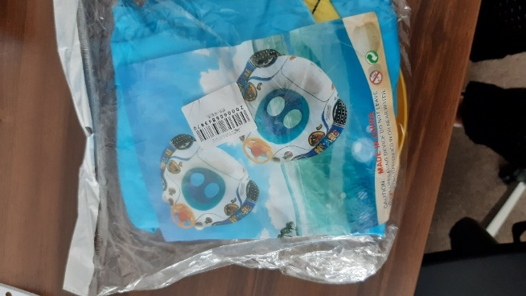
Product packaging on delivery

Seat after inflation

