 | PRESS RELEASE

The CTIA banned a dangerous children's cash box
(Prague, November 10, 2022) The Czech Trade Inspection Authority found that the e-shop www.miniinthebox.com offers a toy that may pose a serious safety risk to smallest children. It is a coin box sold as the "Coin box".

The Czech Trade Inspection Authority found that the website www.miniinthebox.com, which also offers goods for delivery to the Czech Republic, was offering a dangerous toy to consumers. It was a plastic coin box in the shape of a sphere made up of six different coloured pieces. The toy was delivered disassembled with an inserted illustrative paper instruction for the assembly of the individual parts. The product is packed in a transparent plastic bag with a blue cuff, on which, in addition to the wording "TOYS", there is a pictogram "unsuitable for children under three years of age", the CE Marking of Conformity, a warning in English about the small parts contained in the product "!Warning CHOKING HAZARD - Small parts ..." and the indication of the country of origin "Made in China". There is no available consumer information or warnings in the Czech language for the product. There is no indication of the manufacturer of the toy.

The product failed the strength tests. The plastic parts broke and created sharp parts that fit into the cylinder for small parts (the product does not comply with the requirements of Government Regulation No 86/2011 Coll., on technical requirements for toys, which are specified in EN 71-1).

The safety requirements are also not met for the packaging material. In this case, the plastic film does not reach the thickness or dimensions that would prevent it from adhering tightly to the mouth and nose of a small child. The packaging in which toys are packaged for retail sale shall not pose a risk of suffocation by blocking the access of air due to external blockage of the mouth and nose.

The Czech Trade Inspection Authority imposed a protective measure on the operator of the sales website, which was to withdraw the product from the market. The toy was reported to the contact point at the Ministry of Industry and Trade and published in the Safety Gate system.

Product information:

Product name: Coin box (prasátko na mince – pokladnička)
Series /Type: S670636200002
EAN: 2000590864660
Website identifiction data: www.miniinthebox.com
Website operator identification: Light In the Box Ltd., Room 705-706, 7/F, China Insurance Group Building, No. 141, Des Voeux Road Central, Hong Kong, SAR.
Country of origin: Made in China

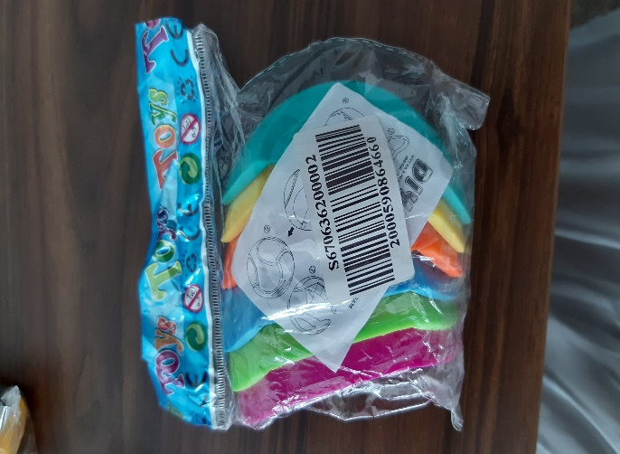
Packaging of the unpacked proct

Picture of the folded product

Plastic parts released from the toy during strength tests

