 | PRESS RELEASE

CTIA banned a dangerous swim ring
(Prague, January 3, 2023) The Czech Trade Inspection Authority found that a floating seat that may pose a serious health risk to the smallest children was offered on www.miniinthebox.com. The product is offered as the Inflatable Awning Baby Yacht.
The Czech Trade Inspection Authority found that an offer of a floating seat was published for consumers on the sales website www.miniinthebox.com, which also offers goods for delivery to the Czech Republic. This is a plastic inflatable product - a seat with leg openings for small children, used for activities in the water. The seat is designed in the shape of a fish with fins and an open mouth. The sun visor, which represents the upper jaw and head of the fish, can be removed from the product. The seat is packed in a transparent plastic bag with an inserted paper leaflet. On it is a warning in English that the product is not a life-saving device and children should not be left in or near water unsupervised. This warning is accompanied by the pictogram 'unsuitable for children under three years of age', although the product is clearly suitable for children as young as 12 months. Directly on the product is the warning in English "Warning! This is not a lifesaving device. Do not leave child unattended while product is in use. Adult supervision recommended. Always stay in the pool within arm´s reach of child." The product also bears the country of origin marking "Made in China", the CE Marking of Conformity, the EN-71 marking and an additional warning in English: "Warning: Aquatic toy use only under supervision". There is no available consumer information or warnings in the Czech language on the product or its packaging.
During the tests (according to the technical standard EN 71-1:2014 + A1:2018 harmonised to Government Regulation No 86/2011 Coll., on Technical Requirements for Toys), small pieces of plastic material were torn from the side and tail fins of the product, fitting all into the test cylinder for small parts.
These small impermeable pieces of plastic material can be torn off the product by a child and placed in the mouth. If inhaled into the larynx or directly into the lungs, the child may suffocate and suffer health damage.
The Czech Trade Inspection Authority has imposed a protective measure on the operator of the sales website, which is to withdraw the product from the market. The toy was reported to the contact point at the Ministry of Industry and Trade and was published in the Safety Gate system.
Product information:
Product name: Inflatable Awning Baby Yacht
Series No. /Type No.: S853884200002
EAN: 2000606450030
Identification data of the website: www.miniinthebox.com
Identification data of the website operator: Light In the Box Ltd., Room 705-706, 7/F, China Insurance Group Building, No. 141, Des Voeux Road Central, Hong Kong, SAR.
Country of origin: Made in China

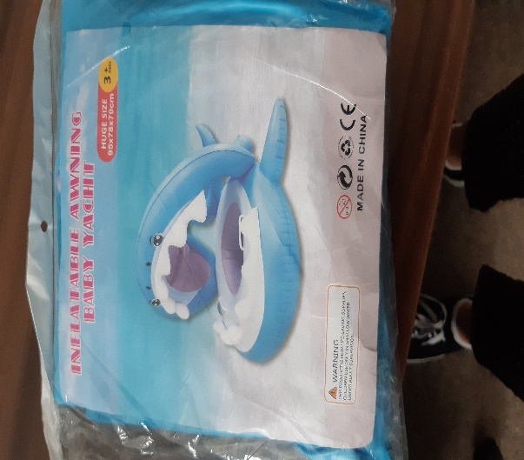

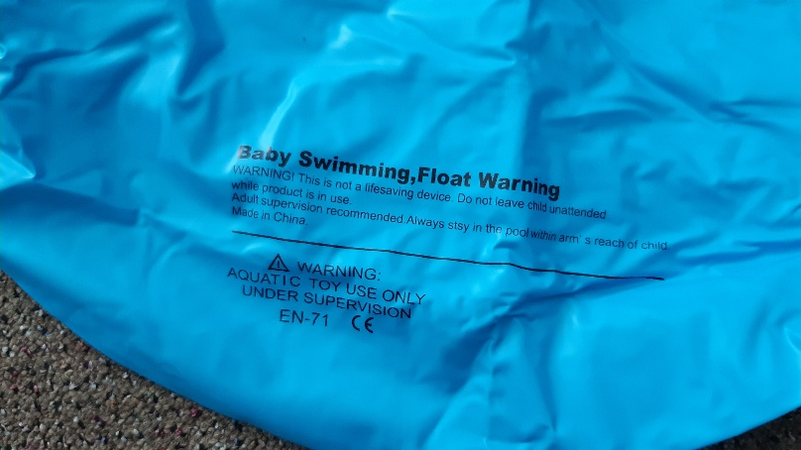
Balení výrobku při doručení

