 | PRESS RELEASE

CTIA seized almost 4,000 items of counterfeit goods worth more than CZK 4 million
(Report for Q3 2022)

(Prague, 12 December 2022) In Q3 2022, the Czech Trade Inspection Authority carried out inspections focused on breaches of the Consumer Protection Act, which, among other things, prohibits traders from offering, selling and storing products that infringe certain intellectual property rights. In this period, the CTIA carried out 159 inspections and detected non-compliance with this provision of the Act in 54 cases (34.0%). In total, the CTIA seized 3,790 pieces of counterfeit goods at the prices of originals amounting to CZK 4,100,011.

The Czech Trade Inspection Authority carried out 159 inspections in the period from 1 July to 30 September 2022, which focused on compliance with the ban on the offer, sale and storage of products infringing certain intellectual property rights or unauthorised use of a trademark protected under a special legal regulation. In 54 inspections, it detected the offer, sale and storage of counterfeit goods (34.0%).

The places of inspection were ordinary shops and e-shops, as well as marketplaces and marketplaces close to the Czech border (e.g. in the villages of Strážný, Folmava, Svatá Kateřina, Železná Ruda), where the incidence of counterfeit goods is still evident. Consumer suggestions were also used during the inspections. Most of the seized counterfeits were imitations of the PokémonWizards brand, textile products and shoes of the Nike and Adidas brands.

In total, out of 159 inspections, breaches of all legal provisions were found in 126 cases (79.3%).

 | Number of inspections | Inspections with findings |  | Ratio f findings
 | Number of inspections | Total | § 8 | Total | § 8
Středočeský and Prague | 2 | 2 | 2 | 100.0% | 100.0%
Jihočeský and Vysočina | 30 | 23 | 4 | 76.7% | 13.3%
Plzeňský and Karlovarský | 56 | 46 | 22 | 82.1% | 39.3%
Ústecký and Liberecký | 23 | 15 | 12 | 65.2% | 52.2%
Královéhradecký and Pardubický | 16 | 15 | 3 | 93.8% | 18.8%
Jihomoravský and Zlínský | 4 | 4 | 11 | 100.0% | 275.0%
Olomoucký and Moravskoslezský | 28 | 21 | 0 | 75.0% | 0.0%
Total | 159 | 126 | 54 | 79.3% | 34.0%

Detected findings
In 54 inspections, the Czech Trade Inspection Authority detected the offer, sale and storage of counterfeit products. In addition to sanction measures, it seized a total of 3,790 counterfeit products amounted to CZK 4,100,011 calculated in the prices of originals. The seized products were, in accordance with Section 7b of Act No. 64/1986 Coll., on the Czech Trade Inspection Authority, stored out of reach of the inspected persons. Products that do not comply with the special legal provisions, for which a lawful decision to forfeit or seize them will be taken, will subsequently be destroyed or used for humanitarian purposes.

In this period, the Czech Trade Inspection Authority imposed a total of 128 fines amounting to CZK 3,156,500.

Chart 1: Share of product groups in the total volume of seized products infringing certain intellectual property rights

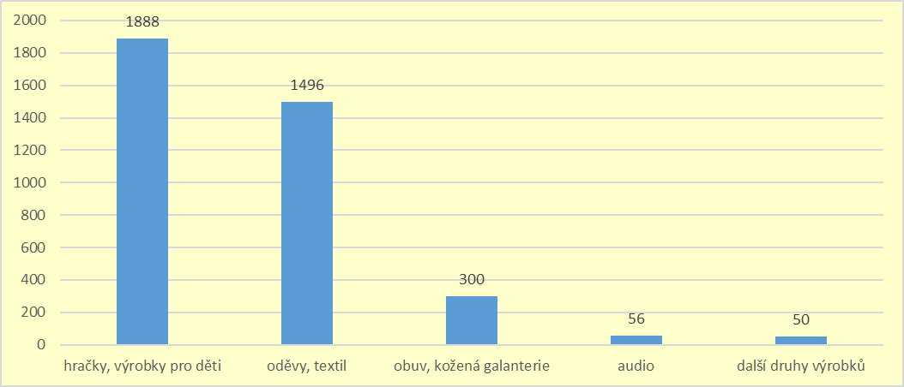

Chart 2: Seized products by brand in quantities over 50 units

