 | PRESS RELEASE

CTIA banned 28 dangerous toys in 2022
(Final report for 2022)
(Prague, 6 April 2023) The Czech Trade Inspection Authority continuously monitors the safety of children's toys offered and sold in the domestic market. During 2022, it inspected a total of 1,943 toy models and found deficiencies in 753 models. It then reported 28 unsafe toys into the European Commission's information system for the rapid exchange of information on dangerous non-food products "Safety Gate", about which the CTIA informs the public and publishes data on www.coi.cz. For breaches of Act No. 22/1997 Coll., on Technical Requirements for Products, it imposed a total of 279 fines amounting to CZK 4,245,500 in 2022.
During the last year, the Czech Trade Inspection Authority carried out inspections focused on compliance with the requirements of Act No. 22/1997 Coll., on Technical Requirements for Products (specified in Government Decree No. 86/2011 Coll., on Technical Requirements for Toys, which transposes the Directive 2009/48/EC of the European Parliament and of the Council into Czech legislation). The aim of the year-long inspection action was to verify whether the basic requirements for the safety of this product range are met and whether the toys that are marketed, labelled and supplied to the market meet the technical and administrative requirements imposed on this product range.
Inspectors inspected a total of 1,943 toy models at 7 manufacturers, 25 importers and 757 distributors and found mainly administrative deficiencies in 753 models. During inspections of labelling, accompanying documentation and consumer information, they verified whether the origin of the toys was traceable (information on the manufacturer or importer was available) and whether the products were equipped with other mandatory information. Where this information contained any restrictions (e.g. a pictogram not suitable for children under three), CTIA officers inspected whether the reasons for the restriction were communicated to the consumer.

For some toys, several administrative flaws listed below were cumulated:
- 470 deficiencies in the identification of the toy manufacturer;
- 341 deficiencies in the identification of the importer;
- 265 deficiencies in the accompanying documentation (e.g. completely missing warnings, instructions or warnings for consumers);
- 257 deficiencies in the mandatory CE conformity marking;
- 187 deficiencies in the accompanying documentation (missing warnings, instructions or warnings for consumers in the Czech language);
- 128 deficiencies in the mandatory marking of the toy with type, serial number or model.

Identified deficiencies
During 2022, the Czech Trade Inspection Authority assessed 28 toy models as non-compliant with safety requirements. These toys were recalled on the Czech market or were offered on foreign internet platforms that have an offer available in the Czech language on their websites. The identified non-conformities were mostly related to electrical toys. These products contained excessive amounts of lead in the solder joints. Such toys can cause contamination of water or soil if disposed of incorrectly and can therefore be a source of environmental risk to animals and plants.
Inspection staff have also removed toys from the market intended for young children up to the age of three that contained small parts or failed mechanical tests where small parts separated from the toys tested. Small parts in toys are dangerous for smallest children, who may swallow or inhale them. The available button batteries or small magnets also posed safety problems. These parts of toys, if swallowed by children, can cause serious health problems in the digestive tract.
All 28 dangerous toys were reported to the European Commission's information system for the rapid exchange of information on dangerous non-food products "Safety Gate".
The Czech Trade Inspection Authority will continuously carry out inspection activities based on the findings of repeated shortcomings and actively search the market network for toys that could pose a risk of injury or damage to children's health. In view of the increasing sales of toys offered via the internet, more attention needs to be focused on sellers who distribute toys in e-shops and wholesale marketplaces.
The CTIA warns consumers about the dangers of the widespread use of magnetic NEOCUBE balls, which are popular especially among teenage children. Based on many repeated laboratory assessments of different models of these toys, the magnetic flux of individual balls with a diameter of about 3 to 5 mm is found to be too strong. If several of these balls are swallowed, they may join together through the walls of the digestive tract and subsequently block the intestines. Consumers are also warned that there are still many electrical toys on the market which do not comply with the requirements of the current legislation. If disposed of incorrectly, they pose an environmental risk of contamination of water and soil, e.g. by lead, which is often present in solder joints of electrical toys in contradiction to the requirements of applicabel legal regulations. Incorrect liquidation may bring an enviromnetal risk of contamination of water and soil, e.g. with lead that is often contained excessively in solder joints of electric toys.
Measures and sanctions imposed
During 2022, the Czech Trade Inspection Authority imposed a total of 279 fines amounting to CZK 4,245,500 for breaches of Act No. 22/1997 Coll., on Technical Requirements for Products, within the toy inspections.

Attachment: List of 28 dangerous toys
Attachment
LIST OF DANGEROUS TOYS NOTIFIED IN „SAFETY GATE“ in 2022
Sample number | Name | Notification No. | Published on
3223_S | Fidgetová důlková klíčenka | A12-00785-22 | 24. 5. 2022 | 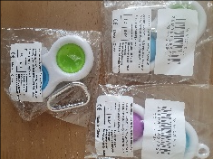
3229_S | Hračka na baterie „Magic track  Autodráha“ | A12-00802-22 | 31. 5. 2022 | 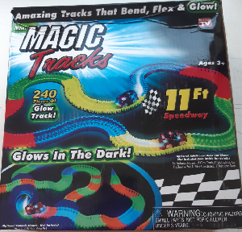
3182_S | Hračka na baterie „Lokomotiva“ | A12-00805-22 | 31. 5. 2022 | 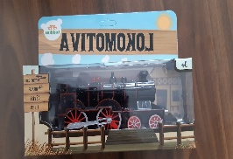
3195_S | Hračka na baterie „Žehlička“ | A12-00838-22 | 7. 6. 2022 | 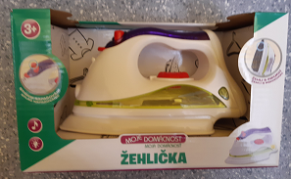
3218_S | Hračka na baterie „Auto POLICE“ | A12-00885-22 | 16. 6. 2022 | 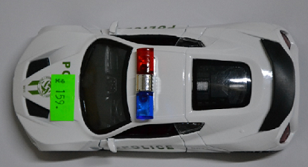
3187_S | Hračka na baterie „Svítící medvídek“ | A12-00889-22 | 17. 6. 2022 | 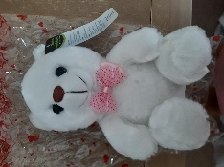
3188_S | Hračka na baterie „Přímočará pila“ | A12-00895-22 | 21. 6. 2022 | 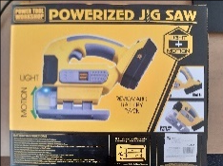
3184_S | Hračka na baterie loď „Marine Rescue“ | A12-00905-22 | 23. 6. 2022 | 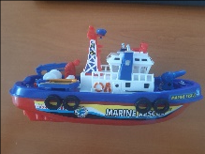
3198_S | Hračka na baterie „Fire Car“ | A12-00903-22 | 23. 6. 2022 | 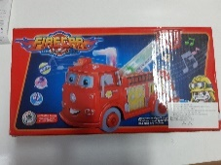
3233_S | Hračka na baterie „Autíčko ze železa“ | A12-00921-22 | 27. 6. 2022 | 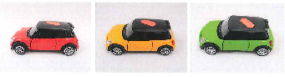
3232_S | Hračka na baterie „Vesmírná pistole“ | A12-00961-22 | 5. 7. 2022 | 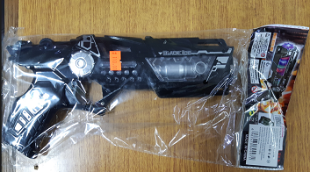
3239_S | „Neocube 5 mm“  Magnetické kuličky | A12- 01006-22 | 11. 7. 2022 | 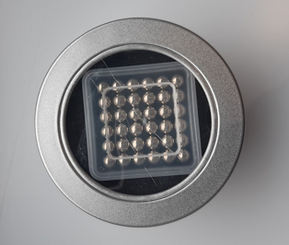
3235_S | Hračka na baterie „Vláček CRH“ | A12/01127/22 | 13. 7. 2022 | 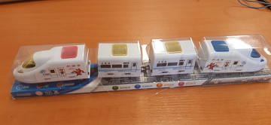
3234_S | Hračka na baterie „Brick game 9999“ | A12/01063/22 | 19. 7. 2022 | 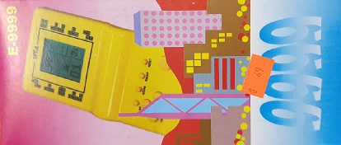
3241_S | „Neocube 3 mm“ Magnetické kuličky | A12-01079-22 | 19. 7. 2022 | 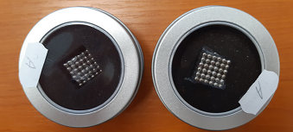
3244_S | „Rohy Čert“  Plastová čelenka | A12/01105/22 | 27. 7. 2022 | 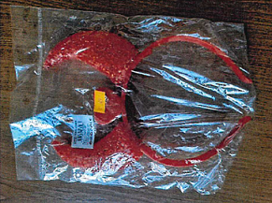
3254_S | Magnetické kuličky černé 5 mm, 216 ks | A12-01080-22 | 19. 7. 2022 | 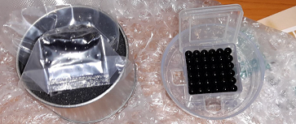
3255_S | Magnetické kuličky zelené 5 mm, 216 ks | A12/01098/22 | 26. 7. 2022 | 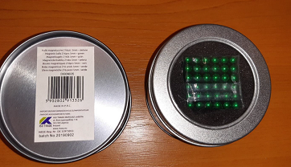
3219_S | Hračka na baterie „Auto taxi“ | A12/01107/22 | 28. 7. 2022 | 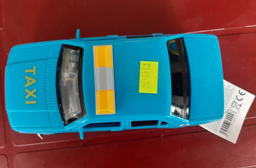
3174_S | Hračka na baterie Stunt Sea Lion | A12/01106/22 | 28. 7. 2022 | 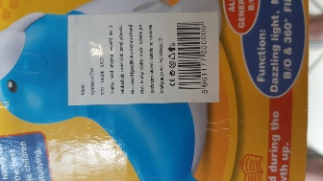
3238_S | Hračka na baterie „Lokomotiva Classic Train“ | A12/01126/22 | 2. 8. 2022 | 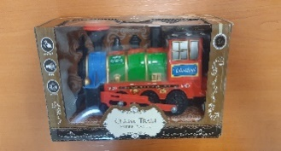
3193_S | Hračka na baterie „Super Stunt Racing“ | A12/01128/22 | 2. 8. 2022 | 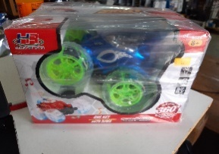
3173_S | Hračka na baterie RC Auto UTV Cross Country | A12-01143/22 | 4. 8. 2022 | 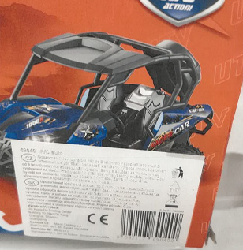
3237_S | Hračka na baterie „AUTO SPEEDS 3D LIGHT RACING“ | A12/01138/22 | 4. 8. 2022 | 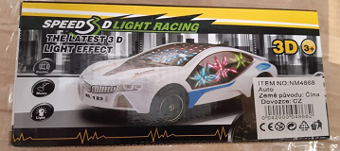
3214_S | „Baby Yacht“ Plavecký kruh | A12/01334/22 | 22. 9. 2022 | 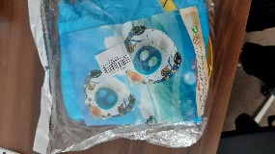
3210_S | „Coin Box“ Pokladnička na mince | A12/01375/22 | 4. 10. 2022 | 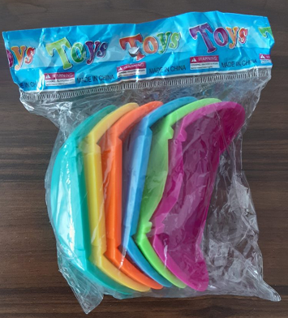
3215_S | „Inflatable Awning Baby yacht“  Plavecký kruh | A12/01561/22 | 7. 11. 2022 | 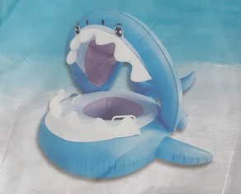
3181_S | Hračka na baterie „Mluvící papoušek“ | A12/01646/22 | 21. 11. 2022 | 