 | PRESS RELEASE

CTIA seized nearly 2,700 pieces of counterfeit goods worth CZK 3.8 million
(Prague, 12 June 2023) The Czech Trade Inspection Authority continued its inspections of the ban on the offer, sale and storage of counterfeit goods in the first quarter of 2023. It carried out a total of 230 inspections and found violations of the ban on the offer, sale and storage of products infringing certain intellectual property rights in 84 inspections. Within this inspection action, it seized 2,683 pieces of counterfeit goods with a value of CZK 3,762,218 for the originals.
In the period from 2 January to 31 March 2023, the Czech Trade Inspection Authority carried out an inspection action focused on compliance with the ban on the offer, sale and storage of products infringing certain intellectual property rights. In total, it carried out 230 inspections and in 84 inspections it detected infringements of the prohibition of offering, selling and storing counterfeit goods, which represented the ratio of 36.5%. In terms of product range, the most frequent infringements of intellectual property rights were in toys and other products intended for children and textile products.
The locations of the inspections were fixed establishments, e-shops, marketplaces and marketplaces in the border areas of the Czech Republic. The Czech Trade Inspection Authority used the assistance of other state administration bodies in some inspections, namely 6 inspections were carried out in cooperation with trade licensing offices.
The inspections focused on compliance with Section 8 of Act No. 634/1992 Coll. on Consumer Protection were carried out in the reporting period based on the initiative and previous findings of the CTIA. Furthermore, they were also based on initiatives by owners of intellectual property rights or their representatives and on consumer submissions.
Within the framework of the inspection action, the CTIA also inspected compliance with other obligations arising from legal regulations within the surveillance scope of the Czech Trade Inspection Authority. In total, 78.7% of the total 230 inspections were with breaches of legal regulations.
Inspectorate | Number of inspections | Inspections with findings |  | Ratio of findings
Inspectorate | Number of inspections | Total | § 8 | Total | § 8
Středočeský and Prague | 12 | 12 | 10 | 100.0% | 83.3%
Jihočeský and Vysočina | 37 | 27 | 12 | 73.0% | 32.4%
Plzeňský and Karlovarský | 51 | 35 | 13 | 68.6% | 25.5%
Ústecký and Liberecký | 39 | 31 | 18 | 79.5% | 46.2%
Královéhradecký and Pardubický | 27 | 25 | 11 | 92.6% | 40.7%
Jihomoravský and Zlínský | 3 | 3 | 3 | 100.0% | 100.0%
Olomoucký and Moravskoslezský | 61 | 48 | 17 | 79.0% | 27.9%
Total | 230 | 181 | 84 | 78.7% | 36.5%

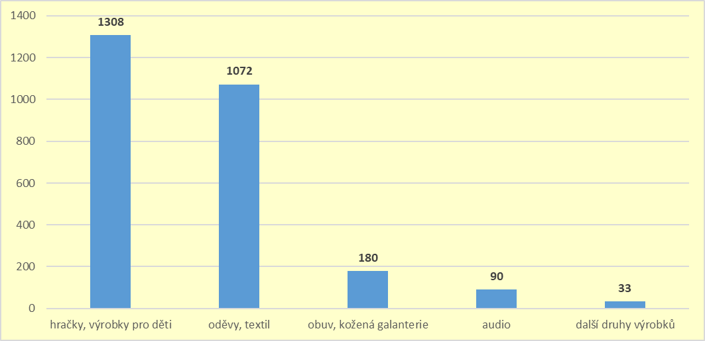
Chart 1: Share of product groups in the total number of taken products infringing certain intellectual property rights. The chart shows the share of selected trademarks in the total volume of seized products. Trademarks not listed were present in fewer than 30 products seized.

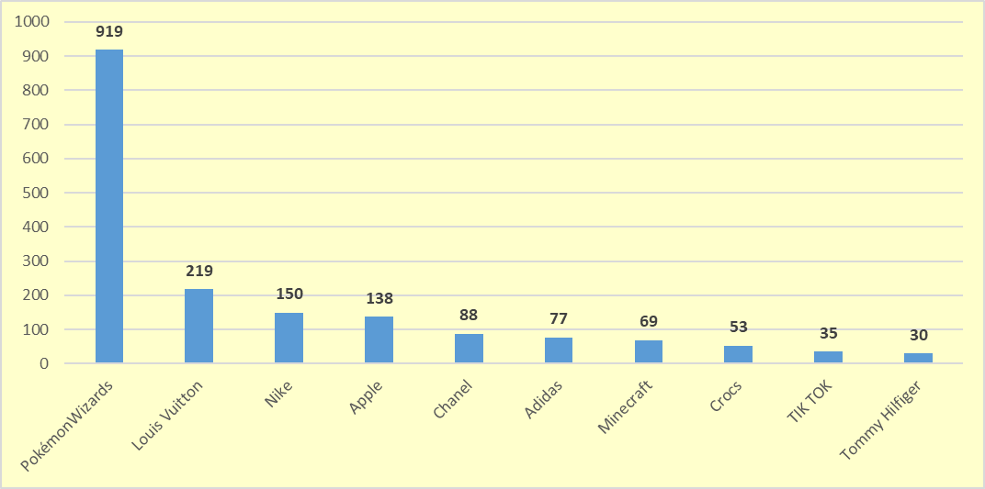
Chart 2: Seized products by trademarks in quantities over 30 units
Imposed measures
In addition to the sanction measures, the Czech Trade Inspection Authority seized a total of 2,683 pieces of counterfeit goods, which, in the value of the original prices, was worth CZK 3,762,218. In accordance with Section 7b of Act No 64/1986 Coll., on the Czech Trade Inspection, the seized products were stored out of reach of the persons inspected. Products that do not comply with the special legal provisions, for which a final decision on their forfeiture or seizure will be taken, will subsequently be destroyed or used for humanitarian purposes.
On the basis of the violations of all legal regulations detected, a total of 174 fines worth CZK 2 513 500 were imposed within the inspection action from 2 January to 31 March 2023.
As the results of inspections in this area have long shown that products infringing certain intellectual property rights are still found in Czech ordinary stores in the interior and in border marketplaces, the CTIA will continue its inspections in the following quarter of 2023.

