 | PRESS RELEASE

CTIA monitored fuels quality: Last year, a total of 12 of 2,542 taken samples failed

(Final report of 2023)

(Prague, 15 March 2024) The Czech Trade Inspection Authority regularly monitors and evaluates the fuel quality in the Czech market. Last year, it took a total of 2,542 samples of fuels at Czech filling stations. 12 samples (0.5%) failed the quality requirements. The CTIA imposed a ban on the sale of 29,360.71 litres of fuels in the value of CZK 1,057,070.89. Compared to 2022, there was an improvement, when in 2022, out of 2,545 samples taken, 18 (0.7%) did not comply with the quality requirements.
The Czech Trade Inspection Authority inspects and monitors the fuel quality (automotive gasoline, diesel fuel, FAME, blended diesel fuel, diesel fuel B10, diesel fuel with high FAME content, paraffinic diesel fuel (HVO), LPG, CNG, bio-CNG, LNG, bio-LNG and ethanol E85) through sampling and laboratory analysis. Compliance with the provisions of Section 3(1) of Act No 311/2006 Coll., on fuels and fuel filling stations, as amended, was inspected. Twelve samples failed the quality requirements, which represented 0,5% of non-compliant samples in the overall assessment.
In the course of 2023, pursuant to the provisions of Section 7(1)(a) of Act No. 64/1986 Coll., on the Czech Trade Inspection Authority, the CTIA imposed 6 measures consisting of a ban on the sale of fuels that did not meet the quality and composition requirements set out in the implementing legislation, special legislation and Czech technical standards. The measure was issued for:

- 17,227.71 l of diesel fuel with a value of CZK 582,437.99,
- 12,133.00 l of motor gasoline with a value of CZK 474,632.90,

all in a total quantity of 29,360.71 litres of fuel and a total value of CZK 1,057 070.89. Within the market surveillance, a ban was also imposed on the sale of CNG, the quantity and value of which could not be quantified due to the technology used (pumping and treatment of CNG from the pipeline).

Collected fuel samples according to types from January to December 2023
Fuel type |  |  | Collected samples |  | In % |  | Non-compliant samples |  | % of fuel type
motor gasoline |  |  | 1,001 |  | 39.4 |  | 4 |  | 0.4
diesel fuels |  |  | 1,200 |  | 47.2 |  | 6 |  | 0.5
FAME |  |  | 0 |  | 0.0 |  | 0 |  | 0.0
mixed diesel fuel |  |  | 0 |  | 0.0 |  | 0 |  | 0.0
diesel fuel B10 |  |  | 0 |  | 0.0 |  | 0 |  | 0.0
high FAME diesel fuel |  |  | 0 |  | 0.0 |  | 0 |  | 0.0
Paraffinic diesel |  |  | 0 |  | 0.0 |  | 0 |  | 0.0
LPG |  |  | 300 |  | 11.8 |  | 0 |  | 0.0
CNG, bio-CNG |  |  | 41 |  | 1.6 |  | 2 |  | 4.9
LNG, bio-LNG |  |  | 0 |  | 0.0 |  | 0 |  | 0.0
ethanol E85 |  |  | 0 |  | 0.0 |  | 0 |  | 0.0
Total |  |  | 2,542 |  | 100.0 |  | 12 |  | 0.5
Development of the quality of fuel collected during the year 2023
Month | Ratio of non-compliant samples
Month | Automotime petrol | Diesel fuel |  | LPG |  | CNG,  bio-CNG |  | Total
January | 0.0 | 0.9 |  | 0.0 |  | 0.0 |  | 0.4
February | 0.0 | 0.0 |  | 0.0 |  | 0.0 |  | 0.0
March | 0.0 | 2.6 |  | 0.0 |  | 0.0 |  | 1.2
April | 0.0 | 0.0 |  | 0.0 |  | 0.0 |  | 0.0
May | 0.0 | 0.9 |  | 0.0 |  | 0.0 |  | 0.4
June | 0.0 | 0.0 |  | 0.0 |  | 0.0 |  | 0.0
July | 1.4 | 0.0 |  | 0.0 |  | 0.0 |  | 0.5
August | 1.0 | 1.3 |  | 0.0 |  | 50.0 |  | 2.0
September | 0.0 | 0.0 |  | 0.0 |  | 0.0 |  | 0.0
October | 2.4 | 0.0 |  | 0.0 |  | 0.0 |  | 0.8
November | 0.0 | 0.0 |  | 0.0 |  | 0.0 |  | 0.0
December | 0.0 | 0.0 |  | 0.0 |  | 0.0 |  | 0.0
SUMA | 0.4 | 0.5 |  | 0.0 |  | 4.9 |  | 0.5

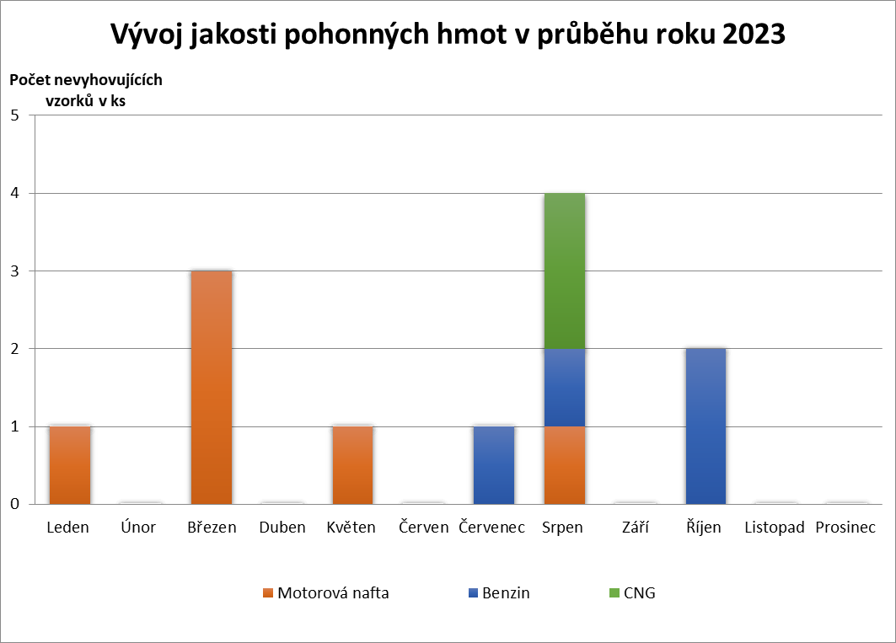

From the above table and graph it is clear that in 2023 the highest number of non-compliant fuel samples, 4, was found in the month of August. In March, 3 non-compliant samples were detected, in October 2 and in January, May and July one non-compliant sample each. No non-compliant fuel samples were identified in the other months of 2023.

Automotive petrol
In 2023, a total of 1,001 samples of motor gasoline were collected and inspected. The Czech Trade Inspection Authority reassessed 3 non-compliant samples of automotive petrol that failed the quality parameter 'vapour pressure'. The samples were reassessed as compliant based on the blending effect, where the measured vapour pressure was below the maximum permitted value with an added deviation. Four samples failed the requirements of the technical standard for the quality of automotive petrol.
The following quality parameters were found to be non-compliant:

Quality indicator | Number of noncompliant quality indicators | % of collected samples of particular fuel type
ethanol | 2 | 0.2
End of distillation | 2 | 0.2

The remaining 997 samples of automotive petrol met the quality parameters set by the technical standard ČSN EN 228+A1/Z1/O2: 2020 - Motor fuels - Unleaded automotive petrol - Technical requirements and test methods.

Diesel fuel
In 2023, a total of 1,200 diesel fuel samples were taken and inspected. Of this number of samples taken, 6 samples did not meet the quality indicators set out in the relevant technical standard, which amounts to 0.5% of the samples taken of the relevant type. The samples of diesel fuel inspected did not comply with the quality parameter 'flash point'. The remaining 1,194 diesel fuel samples met the quality parameters set out in the technical standard EN 590: 2022 and EN 590/O1: 2023 - Motor fuels - Diesel fuels - Technical requirements and test methods.

LPG for propulsion (liquefied petroleum gases)
In 2023, a total of 300 LPG samples were taken and inspected. All samples collected and inspected met the quality parameters set out in the technical standard EN 589+A1: 2022 - Motor fuels - Liquefied petroleum gases (LPG) - Technical requirements and test methods.

CNG (Compressed Natural Gas)
In 2023, a total of 41 samples of this automotive fuel were taken and inspected. Of this number of samples, 2 samples did not meet the quality requirements of the applicable technical standard, representing 4,9 % of the samples taken of the relevant type. The CNG samples inspected did not comply with the quality parameter 'water' (in case of one non-compliant finding, it was a verification analysis after a previous non-compliance finding). The remaining 39 CNG samples met all the quality requirements set out in the technical standard CSN 65 65 6517: 2009 and CSN 65 65 6517/Z1: 2023 - Motor fuels - Compressed natural gas - Technical requirements and test methods.

Biofuels in fuels

During the period under review, the content of fatty acid methyl esters was inspected in 1,200 diesel fuel samples. The ethanol content of motor gasoline was checked in 1,000 samples out of 1,001 samples taken (1 sample was a repeat sample at the same filling station and was not inspected for ethanol content). Laboratory analyses revealed that the permissible upper limit for ethanol content was exceeded in 2 samples of automotive petrol.

Fuel quality development in year-on-year comparison
Non-compliant samples in %
Period | Automotive petrol | Diesel Fuel | Diesel fuel blend* | FAME* | LPG | CNG ** | E85* | B10 | MN s FAME | HVO | Total
2nd half of 2001 | 5.7 | 15.8 | 42.7 | - | - | - | - | - | - | - | 13.5
Year 2002 | 4.0 | 12.2 | 27.7 | - | - | - | - | - | - | - | 9.0
Year 2003 | 10.4 | 13.4 | 20.8 | - | 12.9 | - | - | - | - | - | 12.4
Year 2004 | 6.3 | 12.3 | 14.5 | - | 2.5 | - | - | - | - | - | 8.6
Year 2005 | 4.1 | 7.9 | 10.3 | - | 4.3 | - | - | - | - | - | 6.1
Year 2006 | 2.4 | 6.9 | 17.5 | - | 2.0 | - | - | - | - | - | 4.8
Year 2007 | 3.3 | 5.4 | 46.7 | - | 2.0 | - | - | - | - | - | 4.6
Year 2008 | 1.8 | 8.9 | 66.7 | - | 4.0 | - | - | - | - | - | 5.6
Year 2009 | 2.5 | 7.9 | 40.0 | - | 1.5 | - | - | - | - | - | 5.0
Year 2010 | 5.6 | 9.6 | 23.8 | 25.0 | 0.5 | 0.0 | 65.2 | - | - | - | 7.9
Year 2011 | 2.1 | 6.0 | 17.7 | 17.4 | 0.0 | 0.0 | 21.7 | - | - | - | 4.4
Year 2012 | 1.8 | 4.0 | 18.2 | 4.8 | 1.7 | 0.0 | 5.3 | - | - | - | 3.1
Year 2013 | 2.5 | 3.1 | 7.0 | 4.8 | 2.3 | 0.0 | 0.0 | - | - | - | 2.9
Year 2014 | 0.9 | 2.2 | 5.5 | 13.3 | 12.3 | 0.0 | 0.0 | - | - | - | 3.0
Year 2015 | 0.5 | 1.6 | 3.5 | 9.1 | 0.3 | 0.0 | 11.1 | - | - | - | 1.2
Year 2016 | 0.7 | 1.4 | 7.7 | 14.3 | 0.3 | 0.0 | 14.3 | - | - | - | 1.1
Year 2017 | 1.2 | 0.9 | 0.0 | 0.0 | 0.3 | 0.0 | 9.1 | - | - | - | 1.0
Year 2018 | 1.9 | 0.7 | 0.0 | 0.0 | 0.0 | 0.0 | 0.0 | - | - | - | 1.1
Year 2019 | 0.3 | 1.0 | 0.0 | 0.0 | 0.3 | 0.0 | 10.0 | - | - | - | 0.7
Year 2020 | 0.2 | 0.8 | 0.0 | 0.0 | 0.0 | 0.0 | 12.5 | - | - | - | 0.5
Year 2021 | 0.1 | 0.6 | 0.0 | 0.0 | 2.6 | 0.0 | 50.0 | 0.0 | 0.0 | 0.0 | 0.7
Year 2022 | 0.5 | 1.0 | 0.0 | 0.0 | 0.3 | 0.0 | 0.0 | 0.0 | 0.0 | 0.0 | 0.7
Year 2023 | 0.4 | 0.5 | 0.0 | 0.0 | 0.0 | 4.9 | 0.0 | 0.0 | 0.0 | 0.0 | 0.5
* The higher ratio of non-compliant samples for such labelled fuels is influenced by the cancellation of sales of these fuels at filling stations and thus the low number of samples taken and tested.
** including bio-CNG, LNG, bio-LNG

The above table of year-on-year comparison from the second half of 2001 to 2023 shows that, according to the findings of the Czech Trade Inspection Authority, the quality of fuels has been stable since 2015.
Comparing the results with 2022, in 2023 an improvement in quality has been seen in the samples of automotive petrol (from 0.5% to 0.4%), diesel fuel (from 1.0% to 0.5%) and LPG for propulsion (from 0.3% to 0.0%). A deterioration in quality has been seen in the samples of CNG for propulsion (from 0.0% to 4.9%, the result is influenced by repeated sampling which has been repeatedly assessed as non-compliant with the legislation).

Samples of FAME, blended diesel, B10 diesel, high FAME diesel, paraffinic diesel, bio-CNG, LNG, bio-LNG and E85 ethanol were not sampled in 2023 due to fuel market developments.

Based on the complaints received by the CTIA in 2023, 65 fuel samples were immediately taken and inspected. All these analysed samples met the quality parameters set by the applicable technical standards.

Within its ongoing monitoring of fuel quality, the CTIA cooperates closely with the Customs Administration, the General Financial Directorate and the Police of the Czech Republic. It continuously informs these state authorities about the detected shortcomings in the quality of fuels sold.

