 | PRESS RELEASE

Inspections of toys confirmed deficiencies in mandatory labelling and manufacturer identification. Battery toys contain excessive amounts of lead in solder joints
(Q1 2024 Report)
(Prague, 19 July 2024) The Czech Trade Inspection Authority (CTIA) evaluated inspections aimed at ensuring compliance with the Act on Technical Requirements for Products. It inspected toys intended for children up to 14 years of age. In the first quarter of this year, it carried out 306 inspections and found violations of legal regulations in 151 inspections.
In the first quarter of this year, the Czech Trade Inspection Authority carried out inspections focused on the compliance with Act No. 22/1997 Coll., on Technical Requirements for Products, which are specified in Government Regulation No. 86/2011 Coll., on Technical Requirements for Toys. A total of 306 inspections of toys intended for children up to 14 years of age were carried out. CTIA inspectors found breaches of legal regulations in 151 cases. Infringements of Act No. 22/1997 Coll. were detected in 138 inspections. Seven inspections were carried out at manufacturers, 8 inspections at importers to the EU and 291 inspections at distributors.
In cooperation with other administrative authorities, one inspection was carried out with the staff of the competent Trade Licensing Office and 3 inspections with the staff of the Czech Telecommunication Office.
685 toy models were inspected, including 326 models that were found to be deficient. CTIA officers carried out inspections of toy marking and labelling, accompanying documentation and consumer information and found mainly the following administrative defects:
  - Deficiencies in the mandatory marking and labelling of the toy by its type, serial number or model (137 findings)
  - Deficiencies in the identification of the toy manufacturer (195 findings)
  - Deficiencies in the identification of the importer (80 findings)
  - Deficiencies in accompanying documentation (completely missing warnings, instructions, cautions, 67 findings)
  - Deficiencies in accompanying documentation (missing warnings, instructions or warnings in the Czech language, 88 findings).
  - Lack of labelling of the product with the CE Marking of Conformity (130 findings)
In the case of missing warning notices, the findings may also affect the safety of the toys offered.
A total of three toy models were sampled in domestic shops during the first quarter. Two toys are being assessed to determine whether their design meets the mechanical safety requirements as set by Government Regulation No 86/2011 Coll. and one model of children's pencils is being assessed for suspected exceedances of the permitted limit values for lead content.
During the period under review, electrical toys were assessed as unsafe that contained excessive amount of lead in solder joints. Such toys can cause contamination of water or soil and therefore be a source of environmental risk to animals and plants if disposed of incorrectly. All products have been reported to the Safety Gate alert system.

Name | Notification number
Pistole LN 320/305 | A12/00037/24 | 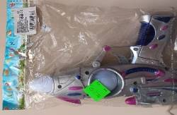
Dívčí kadeřnický salón | A12/00038/24 | 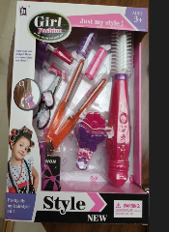
Auto Jeep obracející se | A12/00039/24 | 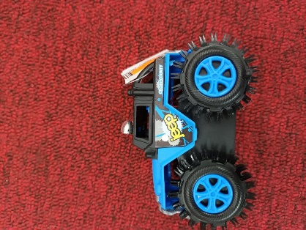
Elektronické klávesy | A12/00040/24 | 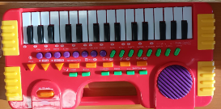
Auto Ford CT Policie | A12/00065/24 | 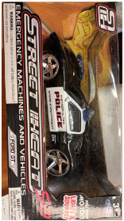
Pistole na baterie | A12/00125/24 | 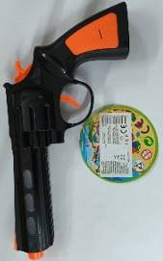
Šroubovák | A12/00244/24 | 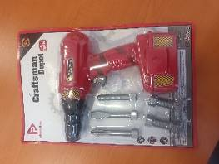
Akuvrtačka | A12/00246/24 | 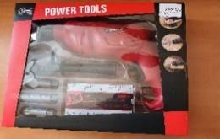
Auto lightining McQueen | A12/00245/24 | 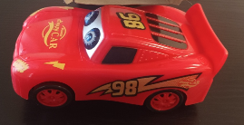
Brick Game E-9999  BAI BIAN | A12/00281/24 | 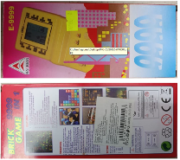
Svítící tank „Special Mission“ | A12/00519/24 | 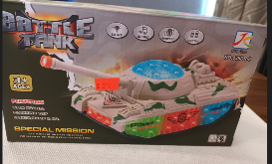
Stojan s mikrofonem | A12/00731/24 | 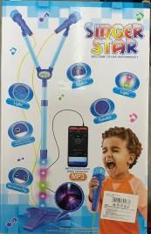
Svítící auto | A12/00730/24 | 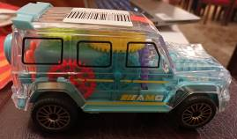
Hračka – bateriová pistole  DESERT EAGLE | A12/00838/24 | 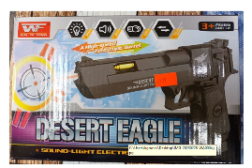
Hračka Aku vrtačka T 1401 | A12/00841/24 | 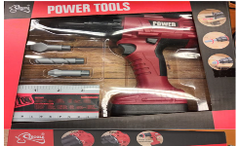

In the first quarter of 2024, a total of 53 on-the-spot fines were imposed in the total amount of CZK 157,000, including 47 fines in the total amount of CZK 135,000 for breaches of Section 13(9) of Act No. 22/1997 Coll., on Technical Requirements for Products. According to its provision, the distributor is obliged to act to prevent the distribution of selected products that do not meet the requirements of the Act, in particular products not bearing the required marking and other markings.
In the administrative proceedings, a total of 87 fines were imposed in the total amount of CZK 2,041,000, of which 67 fines in the total amount of CZK 1,650,000 were imposed for breaches of Section 13(9) of Act No 22/1997 Coll., on Technical Requirements for Products. Seven fines totalling CZK 170,000 were imposed in the administrative proceedings for breaches of Section 13(1) and (2) of Act No 22/1997 Coll., on Technical Requirements for Products, relating to the conditions for placing products on the market of selected products, in particular technical requirements and the specified labelling of products. In accordance with the Act on Technical Requirements for Products, the offer and sale of 139 toy models was prohibited, totalling 8,015 pieces of toys for a total of CZK 97,013.80. In accordance with Act No. 64/1986 SB on the Czech Trade Inspection Authority, the offer and sale of 17 toy models was banned, totalling 1,368 toys for a total of CZK 43,484,02. Pursuant to Act No. 90/2016 Coll., on the assessment of conformity of selected products when they are supplied to the market, the offer and sale of 2 toy models was banned, 5 pieces of which totalled CZK 1,665.
All the findings for the first quarter of 2024 demonstrated recurrent shortcomings in the fulfilment of not only administrative obligations, but also underestimation of the risk on the part of manufacturers resulting from non-compliance with the limit values set for the content of chemical elements in toys by the legislation in force.

