 | PRESS RELEASE

In the second quarter, Czech Trade Inspection Authority took 4,621 items of counterfeit goods for more than CZK 14 million, calculated in prices of originals
(Prague, September 6, 2024) During the second quarter of 2024, the Czech Trade Inspection Authority focused on inspections of compliance with the ban on the offer, sale and storage of products infringing certain intellectual property rights and compliance with obligations arising from other legal regulations within the surveillance scope of the CTIA. It carried out 175 inspections, of which 59 inspections (33.71%) found breaches of the prohibition on the offer, sale and storage of products infringing certain intellectual property rights.
All regional inspectorates of the CTIA were involved in the action aimed at the compliance with Section 8 of Act No. 634/1992 Coll., on Consumer Protection, and 5 inspections were carried out in cooperation with the Trade Licensing Office. In the period from 1 April 2024 to 30 June 2024, a total of 175 inspections were carried out within the inspection action and 119 inspections revealed breaches of legal regulations. This represented 68.00% of the total number of inspections. Of these, 59 inspections showed violations of the prohibition to offer, sell and store products infringing certain intellectual property rights, which irepresented 33.71% of the total number of inspections.
The audited entities were natural or legal persons engaged in business activities in the area of offering and selling products to consumers. According to the method of sale, in the period under review, most infringements were detected in retail outlets, where infringements of legal regulations were detected in 73 inspections, in small shops (63 inspections) in marketplaces (18 inspections) and via e-commerce (4 inspections). In the vast majority of cases, a breach of a provision of the Act on Consumer Protection was found. In the period under review, a total of 4,621 products were taken into custody and stored out of the reach of the persons inspected, which, in the value of the original prices, amounted to CZK 14,091,279. In accordance with Section 7b of Act No. 64/1986 Coll., on the Czech Trade Inspection Authority, the seized products were stored out of the reach of the persons inspected. Products on which a final decision to forfeit or seize them is made will subsequently be destroyed or used for humanitarian purposes.
In the period under review, a major inspection operation was carried out at the Hatě border crossing point, where products worth CZK 4,688,000 in prices of originals were seized, and another at the market in Hřensko, where products worth CZK 2,759,000 in the prices of originals were collected. A total of 106 fines amounting to CZK 1,743,000 became effective in the consequence of infringements of legal regulations detected in connection with the inspection action in the period from 1 April to 30 June 2024. In the period under review, 53 of these fines, totalling CZK 1 436 000, came into force directly in connection with breaches of Section 8 of the Consumer Protection Act.
In terms of product range, most of the seized products belonged to the category of textile products.
Share of product groups in the total volume of seized products infringing certain intellectual property rights)

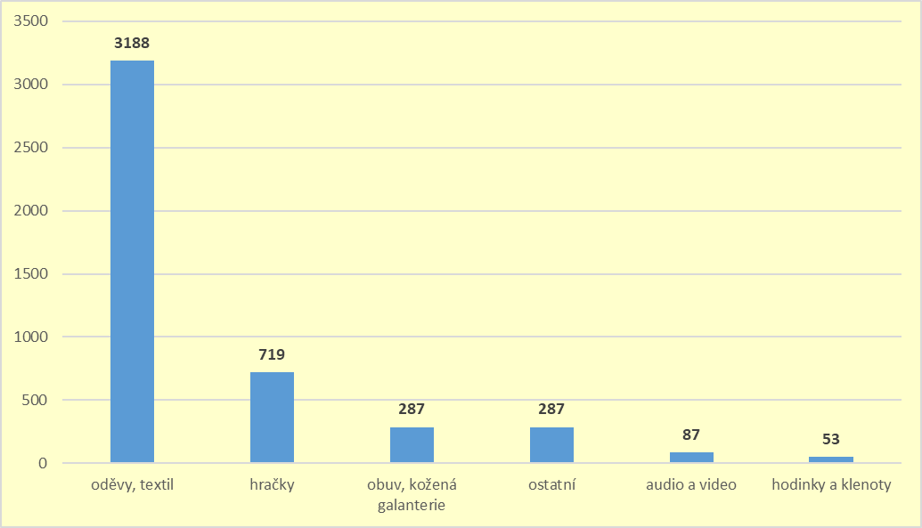
Share of selected trademarks in the total quantity of seized products. Trademarks that are not listed, were present in fewer than 50 products.




