 | PRESS RELEASE

Battery-operated toy "BIO KITCHEN TOYS" contains excessive amounts of lead and cadmium and poses a risk to the environment
(Prague, 4 October 2024) The Czech Trade Inspection Authority has found that a product in the internal market poses a serious environmental risk. It is a battery-operated toy "BIO vařič KITCHEN TOYS". CTIA detected multiple exceedances of lead and cadmium in the soldered joint inside the toy.
The battery-operated toy "BIO vařič KITCHEN TOYS"
Trademark: KITCHEN TOYS
Model number: 335140
EAN: 2200133514063
Manufacturer: PEPCO Poland Sp.z., ul. Strzeszynska 73 A, 60-479 Poznaň, Poland

Importer:
Distributor: PEPCO Czech Republic s.r.o., Hvězdova 1716/2b, 140 78 Praha 4
Product origin: China

It is a cooker-shaped plastic toy with a pot, a sink with a tap and plastic utensils. The toy is powered by two AA 1.5 V batteries and is not suitable for children under 36 months of age. The toy was placed in a paper box and PVC blister. The packaging contained information regarding the product and its use.
Tests carried out by the testing laboratory confirmed significant non-compliance with the requirements of Government Regulation No. 481/2012 Coll., restriction of the use of certain hazardous substances in electrical and electronic equipment (Directive 2011/65/EU - RoHS). The solder joint inside the toy was found to contain multiple exceedances of the lead content of up to 53.9%, 78.8% and 76.9% (depending on the measurement location) compared to the permitted limit value of 0.1% , as well as cadmium content of up to 0.1426% compared to the permitted limit value of 0.01%. Failure to comply with the requirements of the legislation in force poses a serious environmental risk due to possible pollution of the environment.
In order to prevent further occurrence of identical products in the market that do not comply with the requirements of Directive 2011/65/EU - RoHS, as regards the permitted limit for the lead and cadmium content in the components of electrical toys, the CTIA imposed a protective measure on the distributor pursuant to Section 18a(3), (4) of Act No. 22/1997 Coll., on Technical Requirements for Products, as amended, which is a ban on the supply to the market and an obligation to withdraw the product from the market. The product was reported to the contact point at the MIT and information about it was published in the Safety Gate system.
Photo documentation of the product:

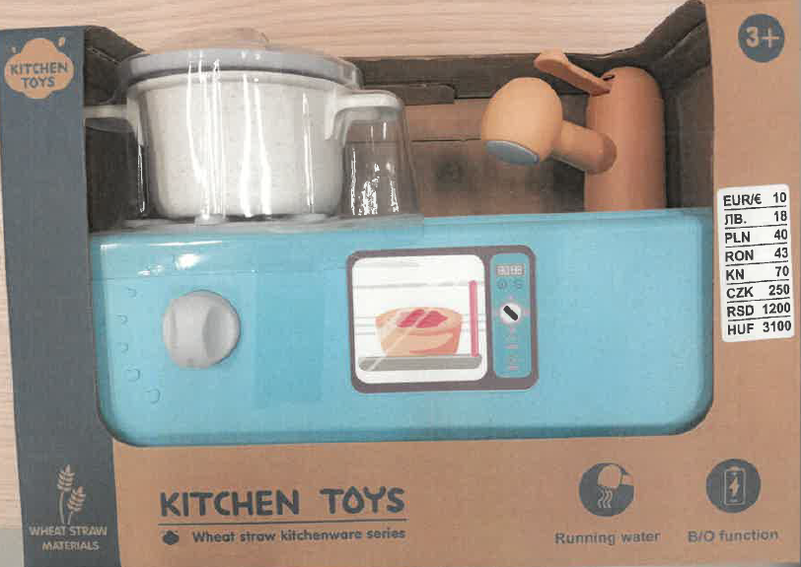t

