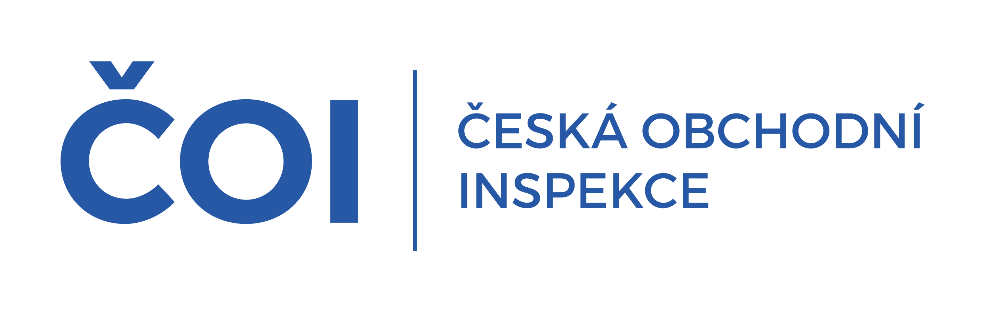 | PRESS RELEASE

Advice for consumers on how to shop safely at Christmas
(Prague, 17 December 2024) Discounts and sales are a standard tool of retailers practically all year round and it is no different at the turn of the year, in the case of Christmas and post-Christmas sales.
The Czech Trade Inspection Authority continually monitors the compliance of sellers with their obligations and, as in the pre-Christmas period, pays increased attention to both traditional and distance forms of sales, including post-Christmas clearance sales.
Consumers themselves can do a lot to ensure safe shopping and reduce risks; information and recommendations can be found at www.coi.cz or www.evropskyspotrebitel.cz. Here are some of them:
- Make a list of priorities, don't buy things you don't need just because they are on sale
- Compare prices from multiple retailers, a discount from one may not mean the best price on the market
- Ask about the terms of the discount, whether it is conditional on e.g. quantity of products purchased, membership of a loyalty programme, signing up to a mobile app etc.
- Ask about the previous price. A seller who declares a discount on the price of a product must inform the consumer of the lowest price at which the product was offered and sold in the 30 days prior to the discount. Exceptions to this obligation are, for example, goods with a short expiry date
- No information other than the current price and the lowest price at which the product was offered and sold in the 30 days before the discount is granted need be included in the information about the discount on the price of the product
- The price listed on the product applies at the time of purchase. We recommend that you request proof of payment from the seller and check the accuracy of the items billed.
- If you are buying from an online retailer, you should also check the reviews of consumer organisations and consumers
- Before you take any binding action, make sure the seller provides contact details (name, address, e-mail, business registration number and telephone number for correspondence), where the e-shop operator is based and familiarise yourself with its terms and conditions. If the e-shop does not have them, or if important identifying information such as the operator's name and address, contact details, email address or phone number is missing from the page, choose another e-shop instead
- Pay by credit card or other online means with a guarantee from the payment intermediary. Money is more likely to be recovered if necessary, but this is usually difficult when paying by bank transfer
- When concluding contracts over the phone, the offer made during the call must be confirmed by the trader to the consumer in text form. The consumer is only bound by the offer once he or she has agreed electronically or by signing a confirmation of the offer in a document
- False pressure may also be created by information, for example, about the limited availability of goods, which may not be true
- It is important to know who you are entering into a contractual relationship with. Whether it is the operator of the e-shop and where it is based, or whether you are using the services of an online marketplace where the provider may be someone other than the seller. You can also use the list of high-risk e-shops, which you can find at www.rizikové.cz. Avoid anonymous e-shops. For information on how to check an unknown seller, visit www.evropskyspotrebitel.cz/podvod.
"Particularly during the Christmas and post-Christmas sales, as well as other discount sales, we recommend caution not only when choosing products, but also where and from whom to buy the product. Particularly for more expensive products, it is important to consider the quality of the product, its durability and availability of service, how I will be able to exercise my consumer rights and issues around secure payment.
When buying online, it is important that consumers know who they enter into a contractual relationship with. With whom will they exercise their rights to claim defective performance or the right to withdraw and return goods without giving a reason within 14 days," adds the Director General of the CTIA, Ing. Jan Štěpánek.
Czech entities can be checked in the Commercial Register /www.justice.cz/ or the Trade Register /www.rzp.cz/, entities based in EU countries at www.e-justice.europa.eu.

