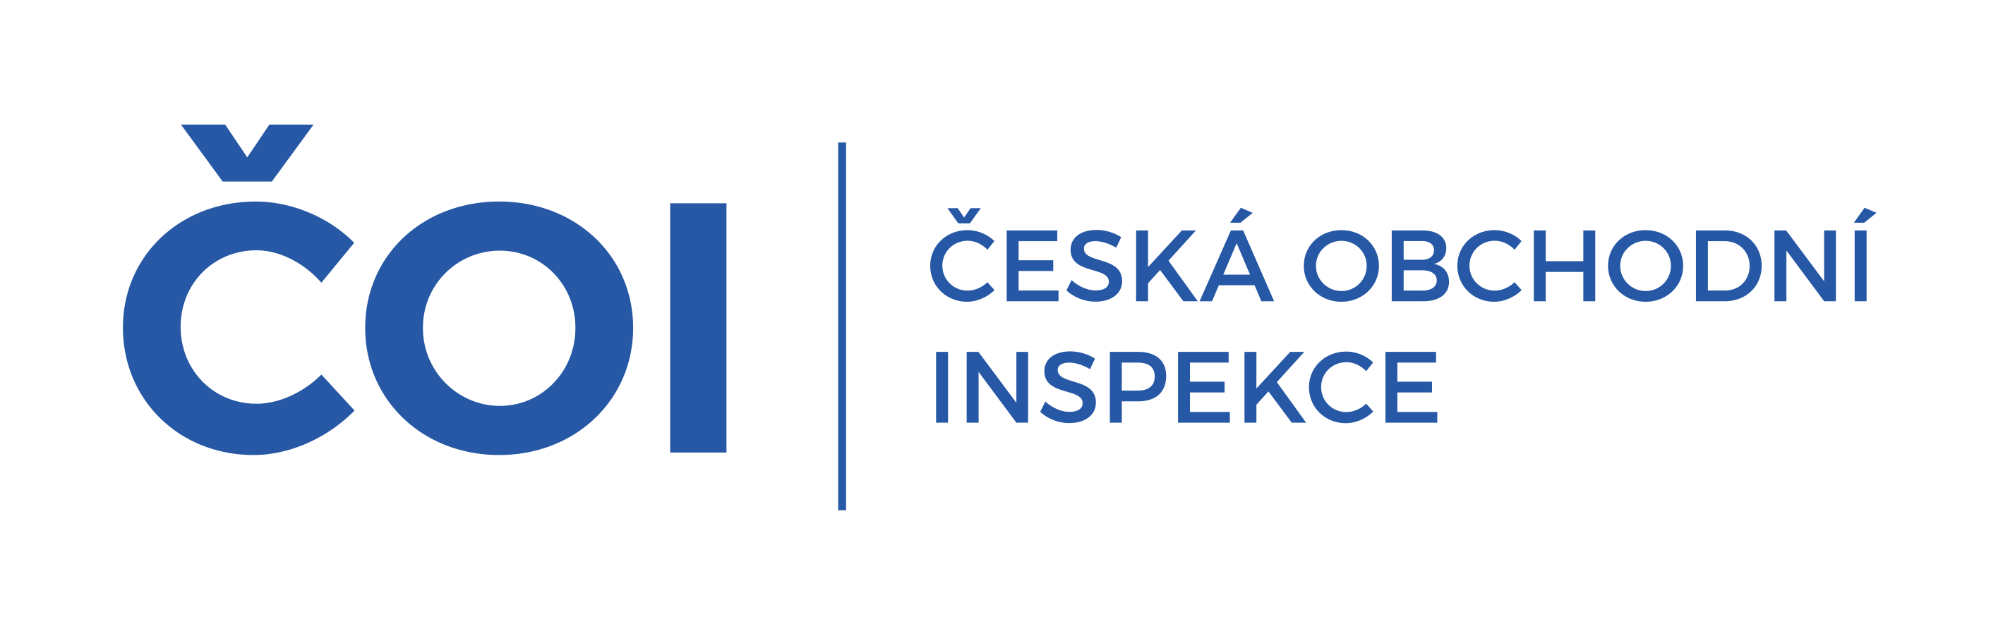 | PRESS RELEASE

CTIA joins initiative to reduce the impact of pyrotechnics in Prague
(Prague, 19 December 2024) The Regional Inspectorate of the Czech Trade Inspection Authority of Central Bohemian Region and the City of Prague has joined the initiative of the Prague 1 municipality and other institutions to reduce the use of fireworks during New Year's Eve celebrations in the city centre and reduce the risks of damage to health and property.
Decree No. 4/2017 Coll., on the use of pyrotechnic products in the capital city of Prague, has been in force for several years, regulating the rules for use especially in sensitive parts of the city.
The aim of the project, which the CTIA is joining, is to minimise the negative impact also in the area of prevention.
"We have joined the project of the Prague 1 municipality and we welcome the decision of some vendors not to sell fireworks in the city centre. Within the surveillance scope of the ČOI, we have already focused on inspecting vendors' compliance with their obligations when selling pyrotechnics, and our inspections will be intensive and will last until New Year's Eve. We recognize the high seriousness of the sale of pyrotechnic products to persons younger than the pyrotechnics act allows for each category, and therefore we will also cooperate with underage figures during our inspections," said the Director of the Regional Inspectorate of the Central Bohemian Region and the City of Prague, Karel Mojžíš.

