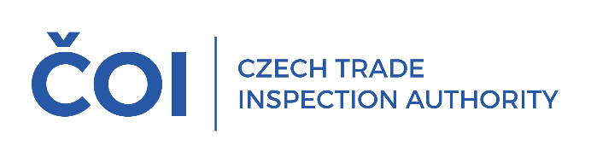
PRESS RELEASE

In December, all fuel sample inspected were compliant
(Prague, 22 January 2025) The Czech Trade Inspection Authority monitored the quality of fuels in December 2024. It took a total of 119 samples at petrol stations in the Czech Republic, including 44 samples of petrol, 60 samples of diesel, 1 sample of paraffinic diesel, 12 samples of LPG and 2 samples of CNG. All samples met the quality requirements.
Thus, compared to November 2024, there was an improvement from 0.9% to 0.0% in the number of non-compliant samples
Collected fuel samples by types – September 2024

Fuel type | Collected samples | In % | Noncompliant samples | % of fuel type
automotive petrol | 44 | 37.0 | 0 | 0.0
diesel fuel | 60 | 50.4 | 0 | 0.0
FAME | 0 | 0.0 | 0 | 0.0
diesel fuel blend | 0 | 0.0 | 0 | 0.0
diesel fuel B10 | 0 | 0.0 | 0 | 0.0
high FAME diesel fuel | 0 | 0.0 | 0 | 0.0
paraffinic diesel fuel | 1 | 0.8 | 0 | 0.0
LPG | 12 | 10.1 | 0 | 0.0
CNG, bio-CNG | 2 | 1.7 | 0 | 0.0
LNG, bio-LNG | 0 | 0.0 | 0 | 0.0
Ethanol E85 | 0 | 0.0 | 0 | 0.0
Total | 119 | 100.0 | 0 | 0.0

Biofuels in fuels
In the monitored period, the fatty acid methyl ester content of 60 was tested diesel fuel samples. The ethanol content of automotive petrol was inspected in 44 samples. The laboratory analyses did not show any exceedance of the permissible upper limit for the content of bio-ingredients in the samples of motor fuels monitored.

Conclusion
Compared to November, an improvement from 2.3% to 0.0% was detected in the automotive petrol samples collected and tested in December. Samples of FAME, diesel fuel blend, B10 diesel, high FAME diesel, bio-CNG, LNG, bio-LNG and E85 ethanol were not sampled in December 2024 due to fuel market developments.
Fuel quality inspection results by inspectorate:
Inspectorate | Petrol |  | Diesel |  | paraf.  Diesel |  | LPG |  | CNG |  | Total
Inspectorate | C | N | C | N | C | N | C | N | C | N | C |  | N
Central Bohemia and City of Prague | 7 | 0 | 8 | 0 | 0 | 0 | 0 | 0 | 0 | 0 | 15 | 0
South Bohemia and Vysočina | 6 | 0 | 8 | 0 | 1 | 0 | 0 | 0 | 0 | 0 | 15 | 0
Pilsen a Karlovy Vary | 6 | 0 | 8 | 0 | 0 | 0 | 6 | 0 | 1 | 0 | 21 | 0
Ústí a Liberec | 6 | 0 | 10 | 0 | 0 | 0 | 0 | 0 | 0 | 0 | 16 | 0
Hradec Králové a Pardubice | 6 | 0 | 10 | 0 | 0 | 0 | 6 | 0 | 1 | 0 | 23 | 0
South Moravian a Zlín | 6 | 0 | 8 | 0 | 0 | 0 | 0 | 0 | 0 | 0 | 14 | 0
Olomouc a Moravian-Silesian | 7 | 0 | 8 | 0 | 0 | 0 | 0 | 0 | 0 | 0 | 15 | 0
Total | 44 | 0 | 60 | 0 | 1 | 0 | 12 | 0 | 2 | 0 | 119 | 0
Legend: COLL = collected, N = noncompliant

