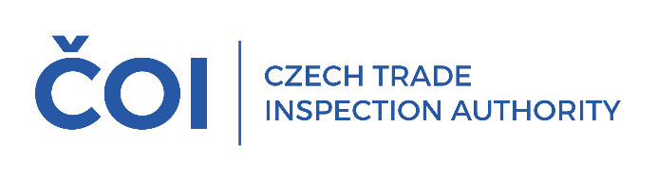
PRESS RELEASE
The Czech Trade Inspection Authority inspected bazaars and pawnshops. More than half of the inspections found violations of legal regulations
(Prague, 3 July 2025) The Czech Trade Inspection Authority carried out a total of 46 inspections of bazaars and pawnshops in the first quarter of this year. Violations of legal regulations within the scope of its supervision were found in 24 inspections (52.17%).
The aim of the event was to verify compliance with the obligations arising for operators of bazaars and pawnshops from Act No. 253/2008 Coll., on certain measures against the legalization of proceeds of crime and terrorist financing, Act No. 247/2006 Coll., on restrictions on the operation of pawnshops and certain other establishments during night time, Act No. 634/1992 Coll., on consumer protection and other legislation. A total of 46 inspections were carried out in the period from 2 January to 31 March 2025. Violations of legal regulations within the supervisory competence of the CTIA were detected in 24 inspections, which is 52.17% of the total number of inspections carried out.
Violations of Act No.253/2008 Coll., on certain measures against the legalization of the proceeds of crime and the financing of terrorism, were found in 12 cases, of which in 6 cases the obliged persons (within the meaning of this Act) failed to train employees in accordance with the requirements of this Act (Section 23), in 4 cases the obliged persons failed to identify the client (Section 7 of this Act) and in 2 cases they failed to carry out client checks (Section 9 of this Act).
At the same time, 27 cases of violation of any of the provisions of Act No. 634/1992 Coll., on Consumer Protection were detected during the inspections, of which the most frequent were:
- in 8 cases, the sellers did not indicate on the purchase document that the product was used or defective (§16(3));
- in 5 cases, the sellers did not properly inform the consumer of the scope, conditions and method of exercising the right of defective performance, together with information on where the claim can be made (§13(1));
- in 4 cases, breaches of the seller's obligation to properly inform the consumer of the price of the products and services offered (§ 12);
- in 4 cases the seller failed to inform the consumer about the out-of-court consumer dispute resolution body (§ 14(1));
- in 3 cases, the sellers did not issue a proof of purchase or the proof did not contain the information required by law (§16(1)).
Violations of other provisions of the Consumer Protection Act and other legislation were found in a smaller number of cases. Violations of Act No. 247/2006 Coll., on the restriction of the operation of pawnshops and certain other establishments at night, were not detected during the inspection operation.
On the basis of the detected violations of legal regulations within the supervisory competence of the CTIA, 23 fines with a total value of CZK 47,000 came into force in the period from 1 January 2025 to 31 March 2025. The results of the inspections confirmed the justification of the inspection action, as violations of legal regulations were detected in more than half of the inspected establishments (52.17%), which is a similar result to the previous year. The Czech Trade Inspection Authority will continue its control activities in this area in the following period.

