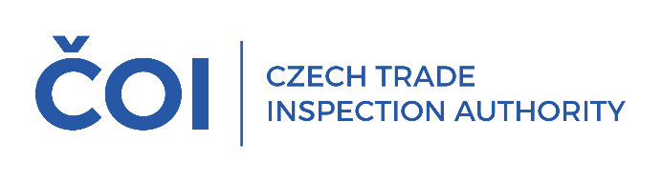
PRESS RELEASE

CTIA inspectors carried out 94 inspections during the 59th Karlovy Vary IFF, in 18 cases they detected the sale of alcohol to minors
(Karlovy Vary, 14 July 2025) During the 59th Karlovy Vary International Film Festival, inspectors of the Czech Trade Inspection Authority, Inspectorate of Pilsen and Karlovy Vary, carried out a total of 94 inspections. Deficiencies were found in 46 inspections, which is almost 49% of all inspections carried out. The inspectors detected the serving and sale of alcohol to persons under the age of 18 in 18 cases.
"We carried out a total of 94 inspections during the festival, almost two dozen more than last year. Deficiencies were found in 46 inspections, which represents almost half of all inspections. The most frequent deficiency this time was non-compliance with the declared measure or weight, which we found in 25 cases, the highest overcharge in this context was CZK 70, other overcharges ranged from CZK 50.40, CZK 45, CZK 33 and so on. In connection with checks on compliance with the Act on the Protection of Health from the Harmful Effects of Addictive Substances, as in previous years, we cooperated with figures under the age of eighteen. We detected the serving and selling of alcoholic beverages to persons under the age of eighteen in 18 cases during the festival, which represents almost forty percent of the checks carried out in cooperation with underage figures. In five cases, consumers were not told the price, and we found, among other things, the use of unverified measuring devices,“ said the Director of the Regional Inspectorate of the CTIA Pilsen and Karlovy Vary Ing. Jan Řezáč, MBA.
A total of 36 cases, more than three quarters of the inspections with findings, will be dealt with in administrative proceedings. In addition, 10 fines were imposed for minor deficiencies by on-the-spot order for a total of CZK 37,500.

Last year, 76 inspections were carried out as part of the 58th Karlovy Vary International Film Festival and deficiencies were detected in 40 inspections, of which 26 detected the sale of alcohol to persons under the age of 18.

