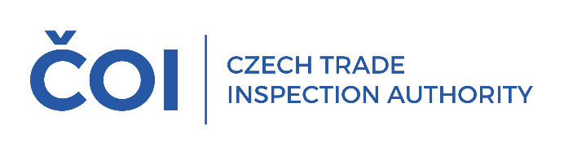
PRESS RELEASE

In the second quarter, the Czech Trade Inspection Authority inspected the obligations of sellers when providing discounts on product prices
(Prague, 31 July 2025) In the second quarter of this year, the Czech Trade Inspection Authority focused on the fulfilment of obligations arising from Act No. 634/1992 Coll., on Consumer Protection, in connection with the provision of discounts when offering and selling goods. Within the framework of the control action, it carried out a total of 221 inspections; violations of legal regulations were detected in 99 inspections, which is 44.80% of the total number of inspections carried out.
Inspections carried out between April 1 and June 30, 2025 focused on sellers across the entire market network, including online stores. The aim of the inspection action was to verify whether sellers, when providing discounts on product prices, inform consumers of the lowest price at which the product was offered before the discount was granted and whether this information is provided in accordance with the requirements of the legislation. The inspection also checked whether the price discounts were correctly calculated and whether the products were sold at the prices so determined.
The most frequent finding was a violation of Section 12a of the Consumer Protection Act, consisting in an incorrect method of calculating the discount on the price of the product or failure to state the lowest price at which the product was offered and sold in the 30 days prior to the discount. This obligation relating to the notification of the discount was infringed in a total of 36 cases.
The use of unfair commercial practices was detected in a total of 63 cases (Sections 4, 5 and 5a of the Consumer Protection Act), of which 29 involved an unfair commercial practice that could mislead the consumer about the price or the method of calculating the price or the existence of a specific price advantage and thus influence the consumer's purchasing decision, which he or she would not have made otherwise (Section 4(4) in relation to Section 5(2)(d)).
The next most frequent finding was a violation of Section 3(1)(c) of the Consumer Protection Act, which requires sellers to sell products and services at prices agreed in accordance with the price regulations and to charge these prices correctly, in 14 cases. In 13 cases, violations of Section 12 of the Consumer Protection Act were found, which concerns the obligation of the seller to inform the price of the products sold or services provided in accordance with the price regulations.
Violations of other legal regulations under the CTIA's supervisory jurisdiction were proven in 72 cases. These included violations of the Civil Code, the Control Act, the Prices Act, the End-of-Life Products Act, etc.
On the basis of violations of legal regulations within the supervisory competence of the Czech Trade Inspection Authority, detected in connection with the inspection action, a total of 112 fines in the total amount of CZK 5 674 000 came into force in the period from 1 April 2025 to 30 June 2025.
Discounts have long been one of the main areas on which the Czech Trade Inspection Authority focuses its inspection activities. The results of the second quarter inspections confirm that sellers continue to violate their legal obligations. These include in particular the failure to provide information on the lowest price at which the seller offered and sold the product in the 30 days prior to the discount, or incorrect information on this price.
Another common phenomenon used by retail chains is price tags in different colors with different texts and price comparisons, with the aim of prompting consumers to make quick purchasing decisions. Price tags give the impression of a discount, which can mislead consumers about the existence of a specific price advantage, which is not always provided despite the attractive price tag and is only a marketing tool.
In a number of cases, COI inspectors also assessed the way in which the price at which the product is actually offered is presented and various situations where unclear or vague price comparisons are presented to consumers. If such information does not provide consumers with sufficient information to make a proper purchase decision, it is classified as a violation of the prohibition of unfair commercial practices.
The Czech Trade Inspection Authority will continue to pay close attention to monitoring sellers' compliance with their obligations when providing discounts on product prices in the coming period.

