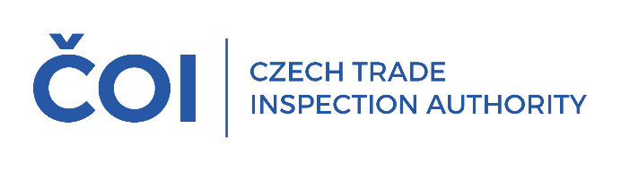
PRESS RELEASE
In the second quarter of this year, the Czech Trade Inspection Authority seized 8,683 counterfeit items
with a total value of more than CZK 35 million
(Report for the second quarter of 2025)
(Prague, September 3, 2025) In the second quarter of this year, the Czech Trade Inspection Authority continued to monitor compliance with the ban on offering for sale, selling, and storing products that infringe certain intellectual property rights. It carried out 149 inspections and found violations of the ban on offering for sale, selling, and storing products that infringe certain intellectual property rights in 68 inspections (45.64%).
All regional inspectorates of the Czech Trade Inspection Authority were involved in the inspection action focused on compliance with the prohibition arising from the provisions of Section 8 of Act No. 634/1992 Coll. on consumer protection. A total of 149 inspections were carried out between April 1 and June 30, 2025. Violations of the legal regulations supervised by the Czech Trade Inspection Authority were found in 103 inspections (69.13%), of which 68 inspections recorded violations of the prohibition on offering, selling, and storing products that infringe certain intellectual property rights, which represents 45.64% of the inspections carried out.
Based on violations of legal regulations identified during the inspection, a total of 109 fines amounting to CZK 1,878,000 were imposed between April 1, 2025, and June 30, 2025, of which 79 fines totaling CZK 1,802,000 were imposed in connection with violations of Section 8 of the Consumer Protection Act.
In addition to the sanctions, a total of 8,683 counterfeit items with a value calculated at the price of the originals amounting to CZK 35,330,708 (the prices of the originals are approximate) were seized and stored out of the reach of the inspected persons. The seized products were stored out of the reach of the inspected persons in accordance with the provisions of Section 7b of Act No. 64/1986 Coll., on the Czech Trade Inspection Authority. Products that do not comply with specific legal regulations and for which a final decision on their forfeiture or seizure has been made are subsequently destroyed or used for humanitarian purposes.
According to the method of sale, the highest number of violations in the monitored period was found in small shops and retail outlets, where 95 inspections were carried out, of which 57 resulted in findings (including 33 cases of violation of Section 8 of the Consumer Protection Act), and also in markets, street markets, and stalls, where 35 inspections were carried out, of which 34 found violations of legal regulations (including 33 cases of violations of Section 8 of the Consumer Protection Act). Three inspections were carried out on the websites of online stores, and one inspection with a finding of a violation of Section 8 of the Consumer Protection Act focused on the social network Facebook.
In terms of product range, intellectual property rights were most frequently infringed in the case of clothing and textile products. Of the total number of products taken, Nike, Guess, The North Face, Michael Kors, Louis Vuitton, and Tommy Hilfiger were the dominating brands in terms of the number of trademarks seized.

The share of individual product groups in the total volume of products seized on suspicion of infringement of intellectual property rights is shown in the following chart (the list contains more than 100 seized products in a given product group):
Chart 1: Share of product groups in the total volume of secured products

The share of selected trademarks in the total volume of seized products is shown in the following graph. Trademarks not included in the list appeared in fewer than 150 seized products.

Graph 2: Seized products by brand (more than 150 items)

