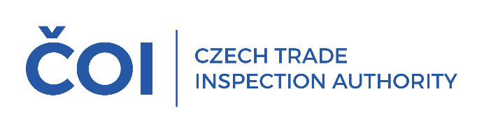
PRESS RELEASE
In the second quarter of this year, the CTIA inspected bazaars and pawnshops. Violations of legal regulations were found in almost 40% of the inspections
(Prague, 23 September 2025) The Czech Trade Inspection Authority carried out
a total of 63 inspections of bazaars and pawnshops in the second quarter of this year. Violations of legal regulations within the scope of its supervision were found in 25 inspections (39.68%).
The aim of the inspection action was to verify compliance with the obligations arising for the operators of bazaars and pawnshops from Act No.253/2008 Coll., on certain measures against the legalization
of proceeds from crime and the financing of terrorism, Act No.247/2006 Coll., on restrictions on
the operation of pawnshops and certain other establishments at night, Act No.634/1992 Coll.,
on consumer protection and other legislation. A total of 63 inspections were carried out in the period from 1 April to 30 June 2025. Violations of legal regulations within the scope of supervision of the CTIA were detected in 25 inspections, which is 39.68% of the total number of inspections carried out.
Violations of Act No.253/2008 Coll., on certain measures against the legalization of the proceeds of crime and the financing of terrorism, were detected in 8 cases, of which in 6 cases the obliged persons (within the meaning of this Act) did not carry out client identification (§ 7 of this Act), in 1 case the obliged person did not carry out a client check (§ 9 of this Act) and in 1 case did not train employees according to the requirements of this Act (§ 23).
At the same time, 32 cases of violation of any of the provisions of Act No. 634/1992 Coll.,
on Consumer Protection were found during the inspections, the most frequent of which were:
- in 10 cases, the sellers did not indicate on the proof of purchase that the product was used or defective (§16(3));
- in 8 cases, the sellers did not properly inform the consumer of the scope, conditions and method of exercising the right of defective performance, together with information on where the claim can be lodged (§13(1));
- in 7 cases, the seller did not inform the consumer about the out-of-court consumer dispute resolution body (§ 14(1));
- in 3 cases, the sellers did not clearly warn the consumer in advance about the sale of used or modified products or products with defects (§ 10);
- in 2 cases, a breach of the seller's obligation to properly inform the consumer of the price of the products and services offered (§ 12);
- in 1 case, the seller breached the obligation to sell products and services at prices agreed in accordance with price regulations and to charge prices correctly (Article 3(1)(c));
- in 1 case the sellers did not issue a proof of purchase or the proof did not contain the statutory information (§16(1)).
Violations of certain provisions of Act No. 89/2012 Coll., the Civil Code, relating to the obligations of sellers, were found in 5 cases and in 4 cases violations of Act No. 542/2020 Coll., on end-of-life products were found. Violations of Act No. 247/2006 Coll., on the restriction of the operation of pawnshops and certain other establishments at night, as amended, were not detected during the inspection action.
On the basis of the detected violations of legal regulations within the supervisory competence of the CTIA, 26 fines with a total value of CZK 55,500 came into force in the period from 1 April 2025 to 30 June 2025. The results of the inspections confirmed the justification of the control action, as violations of legal regulations were detected in almost 40% of the inspected establishments (39.68%) in the second quarter. The Czech Trade Inspection Authority will continue its control activities in this area in the following period.

