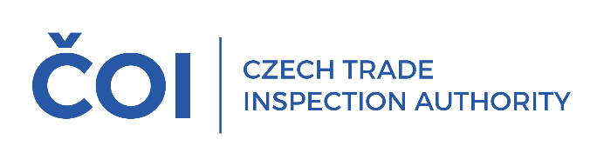
PRESS RELEASE
Inspections of solar panels and accessories revealed deficiencies in all products inspected
(Prague, 24 October 2025) The Czech Trade Inspection Authority verified whether the products supplied to the domestic market meet the requirements set out in the law
as part of an international control action focused on solar panels and accessories. It carried out a total of 13 inspections of 12 operators and found deficiencies in all the products inspected.
The inspection action was carried out with the participation of four regional inspectorates
of the CTIA - Southern Bohemia and Vysočina Regions, Regions of Hradec Králové and Pardubice, Southern Moravia and the Region of Zlín, Moravian-Silesian and Olomouc Regions.
The aim of the inspection action was to verify whether solar panels and accessories supplied
to the domestic market meet the technical requirements set out in Government Regulation
No.118/2016 Coll., on conformity assessment of electrical equipment intended for use within certain voltage limits when supplied to the market, as well as Government Regulation No. 117/2016 Coll.,
on conformity assessment of products with regard to electromagnetic compatibility when supplied
to the market, Government Regulation No. 481/2012 Coll., on the restriction of the use of certain hazardous substances in electrical and electronic equipment, and Acts No. 22/1997 Coll., on technical requirements for products, and No. 90/2016 Coll., on the assessment of the conformity of specified products when they are placed on the market. The products are also covered by the relevant technical standards.
A total of 13 inspections were carried out on 12 operators (1 manufacturer, 1 importer
and 10 distributors). Violations of the legislation were found in all 12 operators inspected.
A total of 8 products were checked, inverters, microinverters and optimizers. Deficiencies were found in all 8 products inspected.
Four product types were taken for technical testing and three product types were assessed
as non-compliant following testing. In all cases, a high risk was identified based on risk analysis.
For this reason, in all three cases it was decided to ban the product from the market. The remaining product type was not tested due to the impossibility to put the product into service in the test facility.
On the basis of the detected violations of legal regulations within the supervisory competence
of the CTIA, sanction measures were imposed on the audited persons in the form of fines, in 3 cases
in injunction proceedings in the total amount of CZK 12,000 and in 4 cases in administrative proceedings in the total amount of CZK 49,000.
The results of the inspection revealed deficiencies in all the products inspected, both technical
and administrative. For example, the manufacturer or importer was not indicated on the product;
the manufacturer's contact address was not given; instructions and safety information were missing
or not accompanied by instructions and safety information in the Czech language; or complete technical data were missing.
In view of these findings, the Czech Trade Inspection Authority will continue to pay attention
to inspections of these products in the coming period.

