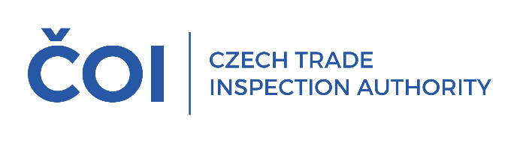
PRESS RELEASE
BLACK FRIDAY 2025
Consumer advice for safer shopping
(Prague, November 5, 2025) The term "Black Friday" has been used in recent years as a synonym for discount promotions in general, its use is no longer limited in time and from the consumer's point of view it indicates a discount. The increased activity of consumers and retailers during the pre-Christmas shopping period or the post-Christmas and seasonal sales also brings increased risks in terms of sales integrity. For example, distance selling is also used during this period by consumers who are otherwise inexperienced in this type of selling. The CTIA
is therefore paying increased attention to inspections of bricks-and-mortar shops and internet sellers. However, prevention is equally important, and consumers themselves can significantly minimise the risks through their awareness and responsible approach.
Useful information and recommendations can be found at www.coi.gov.cz
or www.evropskyspotrebitel.cz. Here are some of them:
- Make a list of priorities (for example, a classic "shopping list"), don't buy things you don't need just because they're on sale.
- Compare prices from multiple retailers, a discount from one may not mean the best price
on the market.
- Ask about the terms of the discount, whether it is conditional on e.g. membership of a loyalty programme, signing up to a mobile app, quantity of products purchased, etc.
- Ask about the previous price. A seller who declares a discount on the price of a product must inform the consumer of the lowest price at which the product was offered and sold
in the 30 days prior to the discount. Exceptions to this obligation include goods with a short expiry date.
- No information other than the current price and the lowest price at which the product was offered and sold in the 30 days before the discount is granted need to be included in the information about the discount on the price of the product.
- The price listed on the product applies at the time of purchase. We recommend that you request proof of payment from the seller and check the accuracy of the items billed.
- If you are buying from an online retailer, you should also check the reviews of consumer organisations and consumers.
- Before you take any binding action, make sure that the seller provides contact details (name, address, e-mail, business registration number and telephone number for correspondence), where the e-shop operator is based and familiarise yourself
with its terms and conditions. If the e-shop does not have them, or if important identifying information such as the operator's name and address, contact details, email address
or telephone number is missing from the page, choose another e-shop instead.
- It is important to know who you are entering into a contractual relationship with. Whether it is the operator of the e-shop and where it is based, or whether you are using the services
of an online marketplace where the provider may be someone other than the seller.
- It is better to pay by card or other online means with a guarantee from the payment intermediary. Money is more likely to be recovered if necessary, but this is usually difficult when paying by bank transfer.
- False pressure may also be created by information, for example, about the limited availability of goods, which may not be true.
- When concluding contracts over the phone, the offer made during the call must be confirmed by the trader to the consumer in text form. The consumer is only bound
by the offer once he or she has agreed electronically or by signing a confirmation of the offer
in a document.
- Anonymous e-shops pose a serious risk to consumers and in this context we recommend that consumers use the list of risky e-shops on the CTIA website to check whether their chosen
e-shop is not on this list.
- Information on how to check an unknown seller can also be found
at www.evropskyspotrebitel.cz/podvod.
- Czech entities can be checked in the Commercial Register /www.justice.cz/ or the Trade Register /www.rzp.cz/, and entities based in EU countries at www.e-justice.europa.eu.

