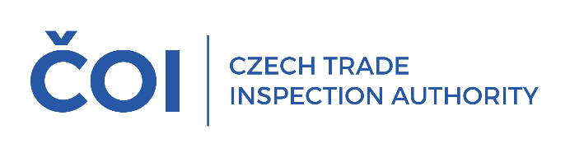
PRESS RELEASE
Safety starts with the purchase. As of 1 December,
the amendment to the Pyrotechnics Act brings changes
to the conditions for the procuring
and handling of pyrotechnics in shops and online stores

(Prague, 27 November 2025) The safety of consumers and the prevention of damage to health
and property were the main reasons for the preparation of the amendment to Act No. 206/2015 Coll., on pyrotechnic products and their handling (hereinafter referred to as the "Act"), which introduces new rules for the placing and supply of pyrotechnic products on the market and their handling with effect from 1 December 2025.
The amended text of the Act is based on Directive 2013/29/EU of the European Parliament
and of the Council on the supply of pyrotechnic articles on the market, while regulating the supervisory responsibilities of the involved market surveillance authorities, the State Mining Administration
and the notified body.
From 1 December 2025, stricter conditions for the purchase of pyrotechnics in shops and online stores will apply. The amended law sets out clear rules for the safe handling of pyrotechnics, regulates the possibilities of sanctions and measures in situations where pyrotechnic products do not comply
with safety requirements or may otherwise endanger the health or safety of persons or other public interest.
The competences of the Czech Trade Inspection Authority will continue to cover pyrotechnic products of categories F1, F2, T1 and P1 in the marketing, supply and storage of pyrotechnic products.
The control of pyrotechnic products of categories F3, F4, T2 and P2, including their sale
and storage, falls within the competence of the Czech Mining Authority or the District Mining Authorities.
The offer of fireworks will undergo the biggest changes in the sale of pyrotechnics online:
- sellers are required to verify the age of the buyer in a verifiable way, for example via Bank Identity or MojeID (MyID), and the same conditions apply to the handover of purchased pyrotechnics;
- picking up pyrotechnics via vending machines is excluded.
Compliance with the basic requirements for the safety of pyrotechnic products and their control through verification of the conformity assessment process, including verification of the registration
of pyrotechnic products with individual notified bodies that participated in the conformity assessment process before placing products on the market, will also be part of the Czech Trade Inspection Authority's inspections.
All these conditions are aimed at protecting the public from unprofessional and dangerous handling
of pyrotechnics, especially during the holiday and celebration period when their use increases significantly. Sellers and consumers are therefore advised to remember that safety starts
with the purchase.
Further details on the amendment can also be found on the MIT website.

