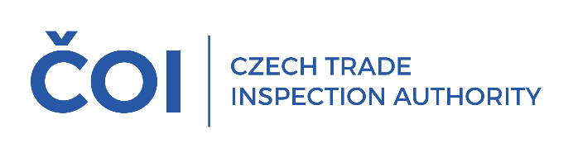
PRESS RELEASE
In the third quarter of this year, the Czech Trade Inspection Authority inspected the obligations of sellers when providing discounts on product prices
(Prague, 11 December 2025) In the third quarter of this year, the Czech Trade Inspection Authority focused on the fulfilment of obligations arising from Act No.634/1992 Coll., on Consumer Protection, in connection with the provision of discounts when offering and selling goods. Within the framework of the inspection action, it carried out a total of 181 inspections; violations of legal regulations were detected in 83 inspections, i.e. 45.86% of the total number of inspections carried out.
Inspections carried out between 1 July and 30 September 2025 focused on sellers across the entire market network, including online stores. The aim of the inspection action was to verify whether sellers, when providing discounts on product prices, inform consumers of the lowest price at which the product was offered before the discount was granted and whether this information is provided in accordance with the requirements of the legislation. The inspection action also checked whether the price discounts were correctly calculated and whether the products were sold at the prices so determined.
The most frequent finding was a violation of Section 12a of the Consumer Protection Act, consisting in an incorrect method of calculating the discount on the price of the product or failure to state the lowest price at which the product was offered and sold in the 30 days prior to the discount. This obligation relating to the notification of the discount was infringed in a total of 45 cases.
The use of unfair commercial practices was detected in a total of 32 cases (Sections 4, 5 and 5a of the Consumer Protection Act), of which 20 involved unfair commercial practices that could mislead the consumer about the price or the method of calculating the price or the existence of a specific price advantage and thus influence the consumer's purchasing decision, which he would not otherwise have made (Section 4(4) in relation to Section 5(2)(d)).
The next most frequent finding was a violation of Section 3(1)(c) of the Consumer Protection Act, which requires sellers to sell products and services at prices agreed in accordance with the price regulations and to charge these prices correctly, in 14 cases. In 17 cases, violations of Section 12 of the Consumer Protection Act were found, which concerns the obligation of the seller to inform the price of the products sold or services provided in accordance with the price regulations.
Violations of other legal regulations under the CTIA's supervisory authority were proven in 34 cases. These included violations of the Civil Code, the Control Act, the Act on the Protection of Health against the Harmful Effects of Addictive Substances, the End-of-Life Products Act, etc.
A total of 87 fines with a total value of CZK 7,490,000 came into force in the period from 1 July 2025 to 30 September 2025 on the basis of infringements of legal regulations within the scope of the Czech Trade Inspection Authority's supervision.
Discounts have long been one of the main areas on which the Czech Trade Inspection Authority focuses its inspection activities. The results of the third quarter inspections confirm that sellers continue to violate their legal obligations. In particular, the failure to provide information on the lowest price at which the seller offered and sold the product in the 30 days prior to the discount.
The Czech Trade Inspection Authority will continue to pay close attention to monitoring sellers' compliance with their obligations when providing discounts on product prices in the coming period.

