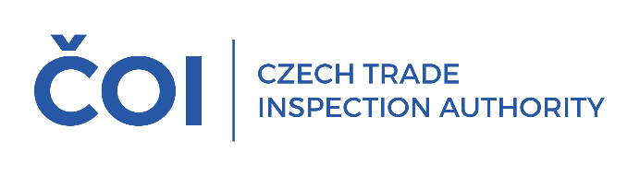
PRESS RELEASE
During the pre-Christmas discount promotions, inspectors from the Czech Trade Inspection Authority inspected online retailers and traditional brick-and-mortar stores
(Prague, January 12, 2026) Last fall, the Czech Trade Inspection Authority launched a special inspection action focused on Black Friday-type discount events. The inspections took place in brick-and-mortar stores and online shops. The aim of the inspections was to verify sellers' compliance with their legal obligations to inform consumers about discounts and to prevent deceptive practices that could mislead consumers.
The inspections responded to increased consumer interest in shopping during discount events such as Black Friday, when there is typically an increase in marketing messages emphasizing discounts and special offers. During this period, the online environment significantly influences the way consumers make decisions and can contribute to the underestimation of certain risks. When shopping online, visual stimuli and the speed of the purchasing process play a particularly important role, often reducing the time spent on careful consideration of a purchase. Compared to brick-and-mortar stores, impulse purchases are therefore more common in the online environment, yet consumers lack physical contact with the goods and the decision itself is often a matter of a few clicks.
The inspections therefore focused primarily on compliance with the legal obligation to indicate the lowest price at which the product was offered and sold in the last 30 days prior to the discount being granted, and on checking compliance with the prohibition of unfair commercial practices. This obligation applies to both brick-and-mortar stores and online shops and applies to all forms of discount advertising — price tags, flyers, shop windows, and online presentations.
We currently have preliminary results from this extraordinary inspection, as inspections of online stores are more time-consuming. A European price monitoring tool was also used to inspect online stores, which was used to monitor 19 online stores and approximately 380 products. We are currently evaluating the results of this monitoring. In addition, another 20 online stores were inspected.
A total of 77 inspections were carried out in brick-and-mortar stores. More time-consuming inspections involving longer monitoring of discount developments are currently in progress. Here too, violations of consumer protection law can be expected in some cases.
Preliminary results therefore indicate several violations of consumer protection law. Specifically, in 10 cases, this involved unfair commercial practices that could mislead consumers about the price or method of calculating the price or the existence of a specific price advantage, thereby influencing the consumer's decision to make a purchase that they would not otherwise have made (provision of § 4(4) in conjunction with § 5(2)(d)). Six cases concerned a violation of Section 4(4) in conjunction with Section 5(1), consisting in the provision of factually incorrect and therefore false information, which may lead consumers to make a purchase decision that they would not otherwise have made. In seven cases, a violation of Section 12 of the Consumer Protection Act was found, which concerns the seller's obligation to provide information in accordance with pricing regulations on the price of products sold or services provided. Furthermore, in 3 cases, there was a violation of Section 12a, consisting in the failure to provide information on the lowest price at which the product was offered and sold in the 30 days prior to the application of the discount.
The results of the extraordinary inspection will be presented after a comprehensive evaluation.
The Czech Trade Inspection Authority will continue to conduct intensive inspections of discount sales, especially during the current period of post-Christmas sales. We carry out inspections in brick-and-mortar stores and online shops. The aim of the Czech Trade Inspection Authority is to ensure that discount promotions are conducted in accordance with the law and that consumers are always provided with accurate and complete information.

