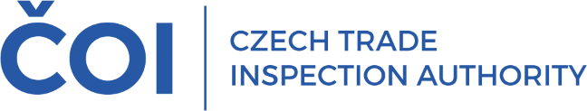
PRESS RELEASE

CTIA inspected textile products and imposed more than 130 fines totalling nearly one and a quarter million crowns

(Prague, April 28, 2026) The Czech Trade Inspection Authority (ČOI) has evaluated its inspections of textile products. Between June and November 2025, it carried out a total of 1,148 inspections and identified breaches of legal regulations in 464 of them. The results of the inspection activity confirmed that deficiencies generally arise from incorrect labelling of textile products, but also from other issues related to the sale of textile products, which are regulated, for example, by the Act on Consumer Protection.
Between June 5 and November 14, 2025, the Czech Trade Inspection Authority carried out 1,148 inspections to verify compliance with the obligations imposed on economic operators by Act No. 634/1992 Coll., on Consumer Protection, as well as Regulation (EU) No. 1007/2011 of the European Parliament and of the Council on the names of textile fibres and the related labelling of the material composition of textile products, and other legal regulations governing the sale of textile products. It identified deficiencies in 464 inspections (40.4%).
A total of 1,061 inspections were conducted in ordinary shops, 41 at online sellers (e-shops, online marketplaces), 25 at distributors, 17 at marketplace sellers, 2 at manufacturers, and 2 at importers. As of the date of publication of this press release, 7 inspections were still in progress.
Breaches of the requirements of Regulation (EU) No. 1007/2011 of the European Parliament and of the Council were identified in 171 inspections. The most common breaches involved non-compliance with the requirements set forth in Article 15, namely, the obligation to label textile products, and Article 16, namely, the use of textile fibre names and information on material composition.
There were 304 breaches of Act No. 634/1992 Coll., on Consumer Protection, during inspections. The most common breaches involved Section 4 concerning the use of unfair commercial practices and deceptive conduct, as well as breaches of Section 16, where the seller failed to provide a proof of purchase containing the required product information, and breaches of Section 11, where the seller failed to provide information in the Czech language when such information was provided in writing.
Within the inspection activity, 35 samples of textile products were collected from retail outlets for laboratory testing. The testing laboratory verified the accuracy of the labelling of the textile product samples with regard to information on material composition. Of the total of 35 tested textile product samples, 10 samples failed to meet the requirements.
Within the inspection activity during the period mentioned, the Czech Trade Inspection Authority imposed 135 fines totalling 1,220,500 CZK.
Based on the results of the inspection activity, the Czech Trade Inspection Authority included the textile products inspection activity in its 2026 surveillance program. The inspection activity is currently underway.

